Semkan SaaS Operation Instructions

1

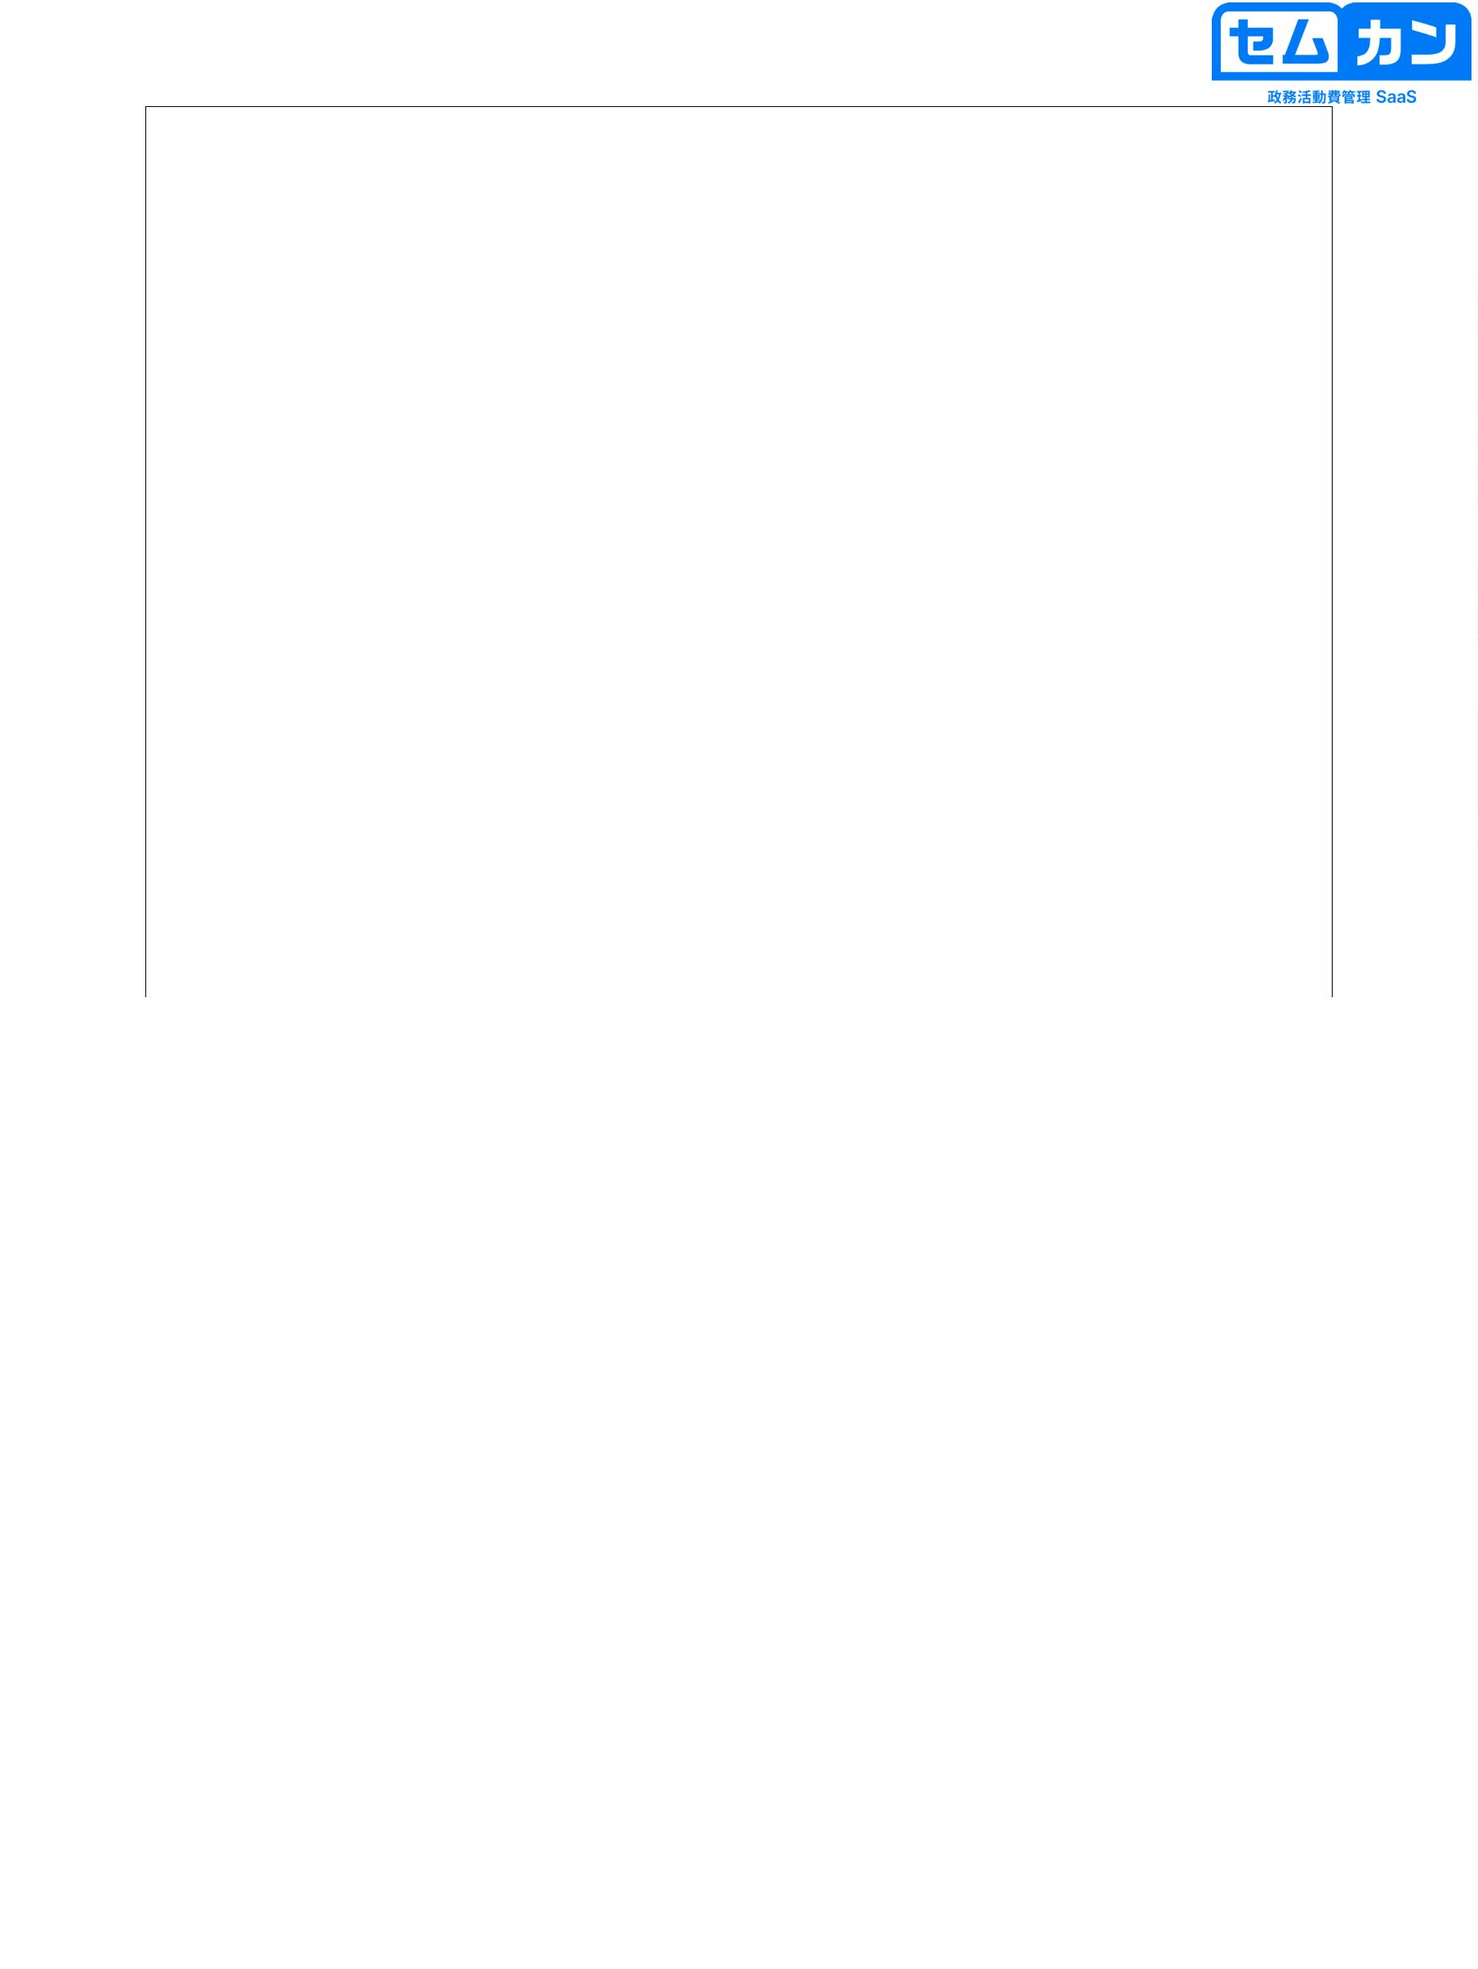

What we're going to do today

• Log in

• One-time password (two-factor authentication)

• Register a budget

• Expenditure Registration & Semkan Camera

• Creation and use of templates

• Revert and delete

• Personalization

• CSV output

• Other operations

2

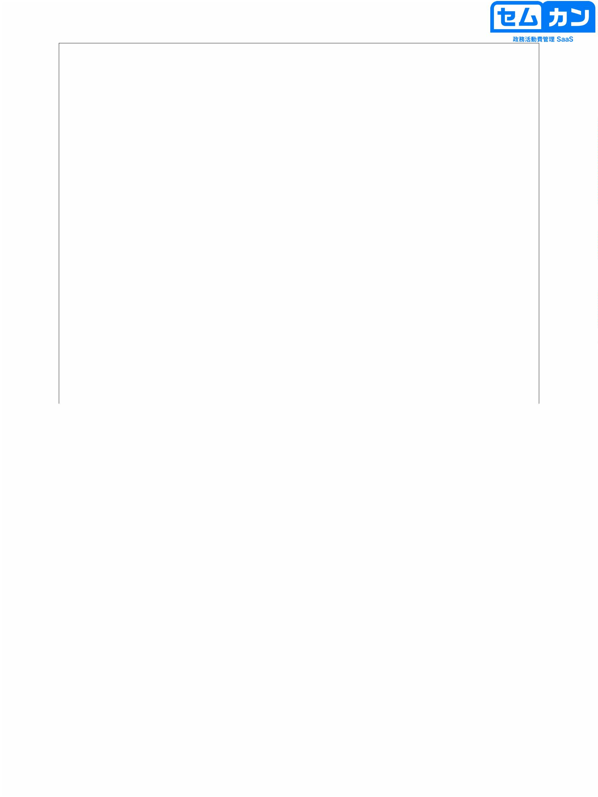

Balancing security and simplicity

security

Simplicity

• Two-factor authentication

• Password

→ Changeable

One-time via email

Password issuance

• 20-digit login ID

→ Changeable (October)

Implementation)

• 20-digit login ID

• Incorrect password

→ 1 second, 2 seconds, 4 seconds, 8 seconds...

3

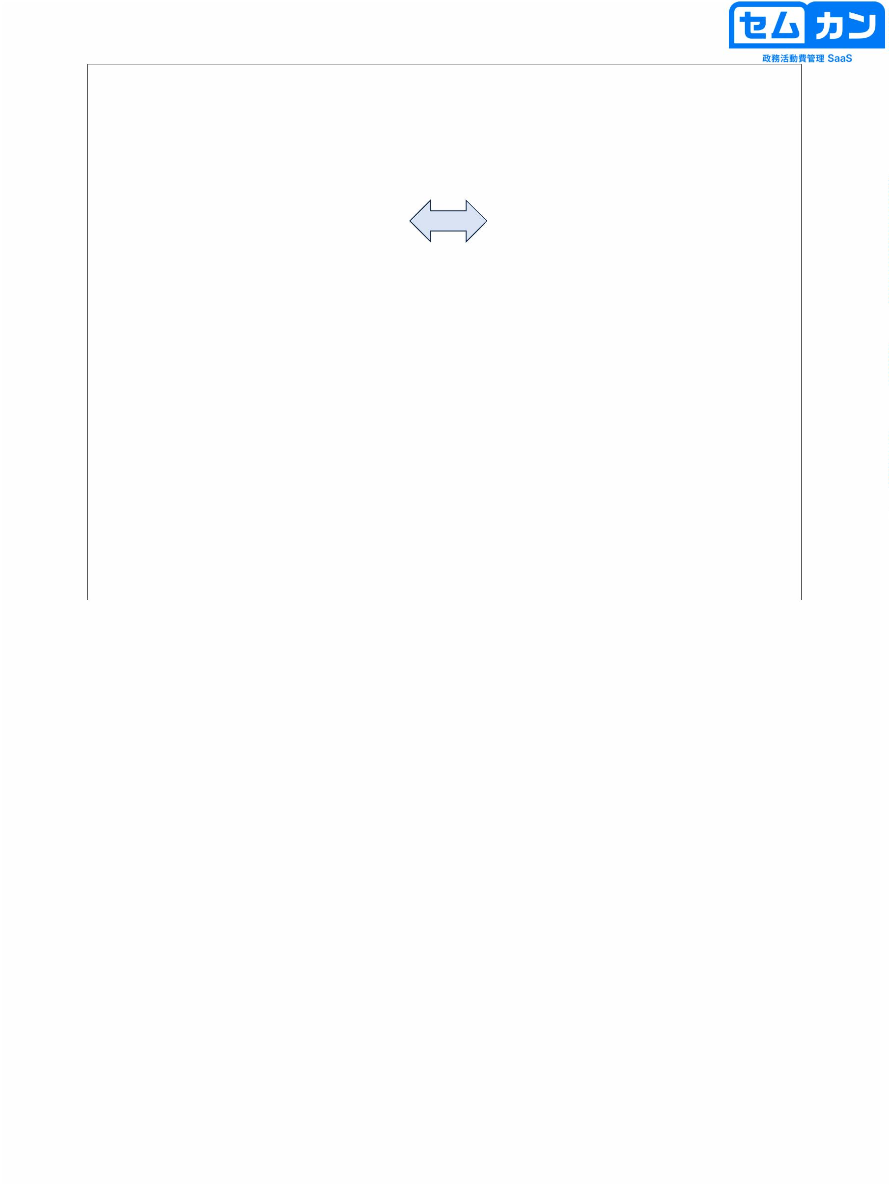

Semkan Camera

Same ID and password

Log in and link your data

browser

application

4

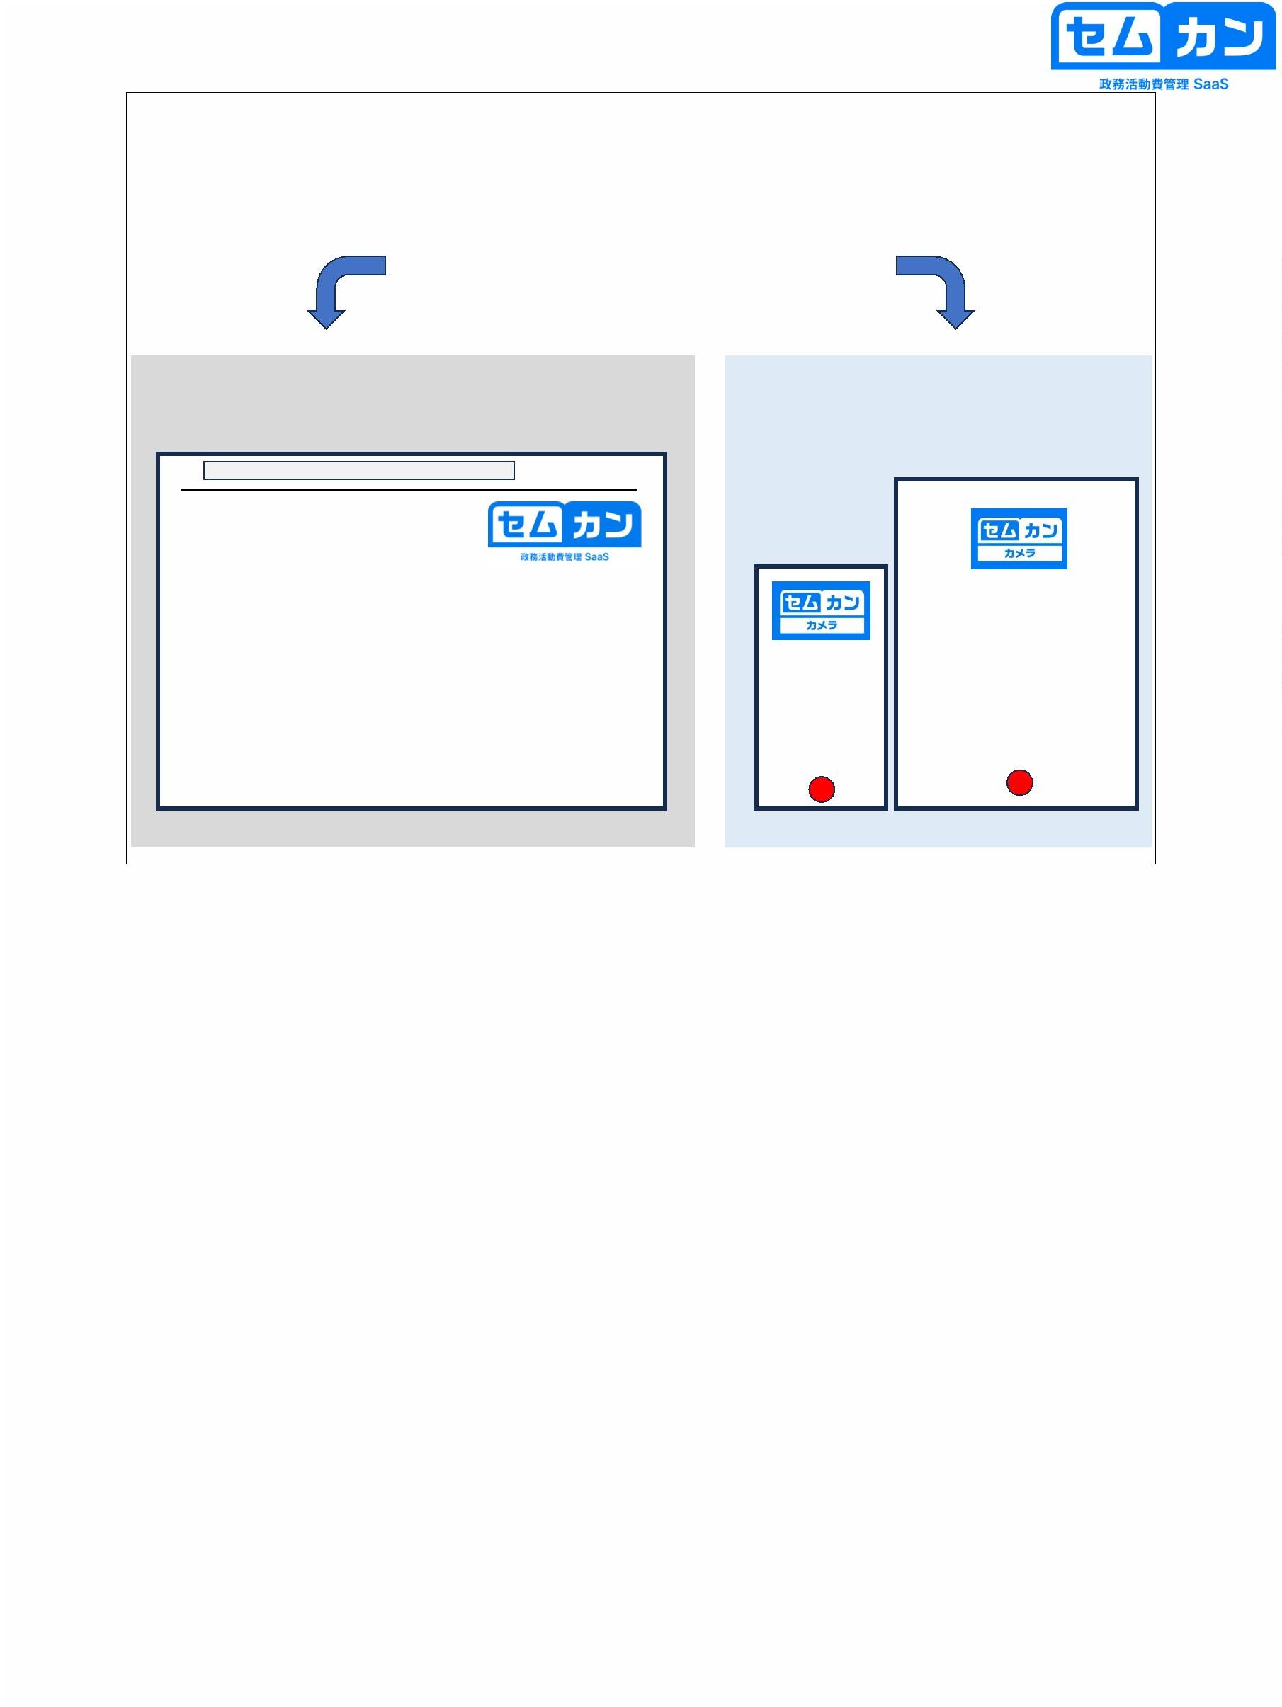

Semkan Operating Instructions

(For Congressional Accounts / PC / Tablet Version)

June 18, 2024 edition

Able Computer Inc.

5

5

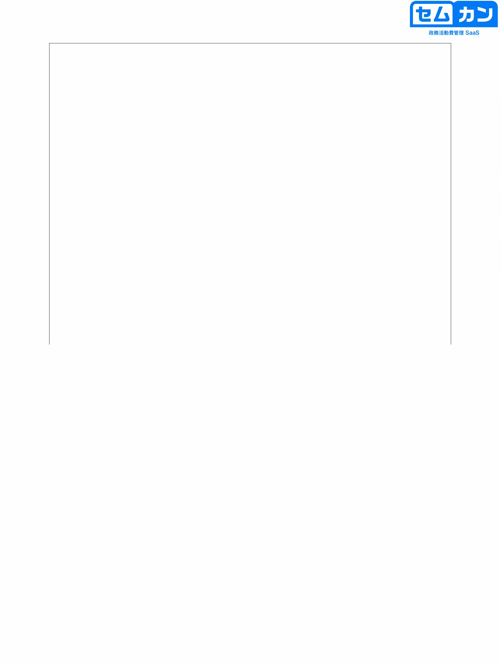

table of contents

1. Before You Begin

2. One-time password setting

3. Overview of Overall Functions

4. Add as an app

5. Create a budget

p.3

p.7

p.11

p.20

p.23

p.26

p.41

p.46

p.54

p.56

p.61

p.65

6. Register expenditures

6-2. Use of Template

6-3. Use of Semkan Camera

7. Application for Confirmation

8. Pull back

9. Amendment & Re-application

10. Done

6

6

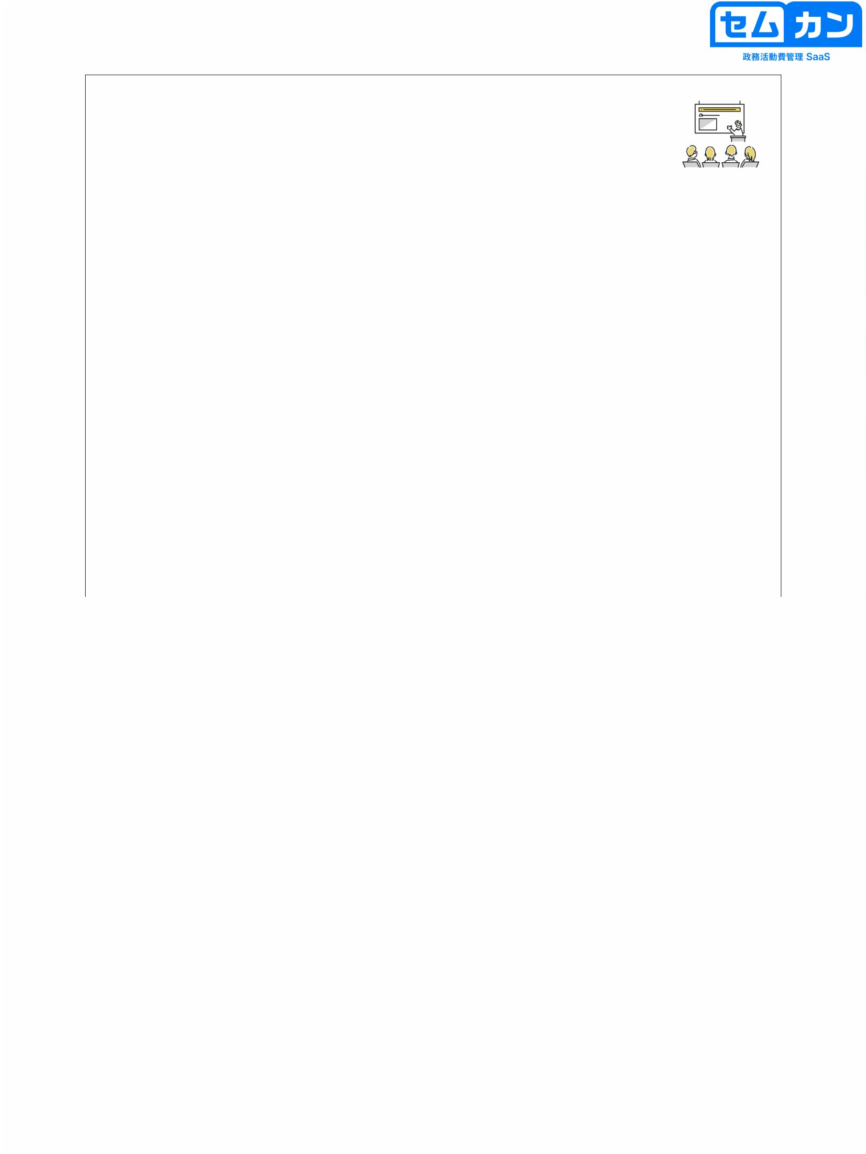

1. Before You Begin

7

7



About Login

8

• Semkan is a web service used in a browser

• Enter the URL below on your device

https://app.semkan.jp/login

• Once you log in with your ID and temporary password, your personal page will be displayed and you will be able to use it..

8

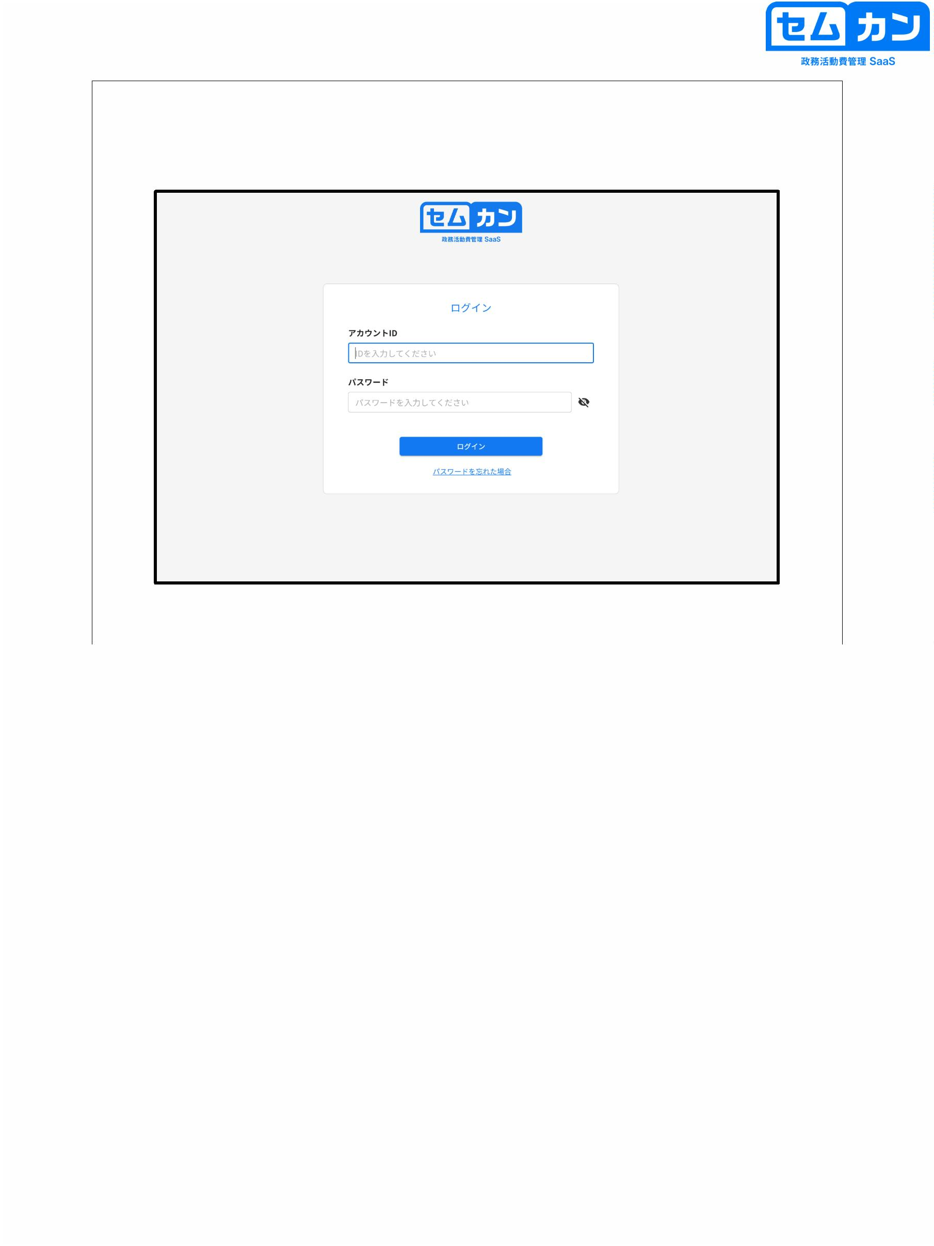

About Login

9

• Enter ID, temporary password, and enter a new password

It will be on the screen

• Enter your new password and submit it

9

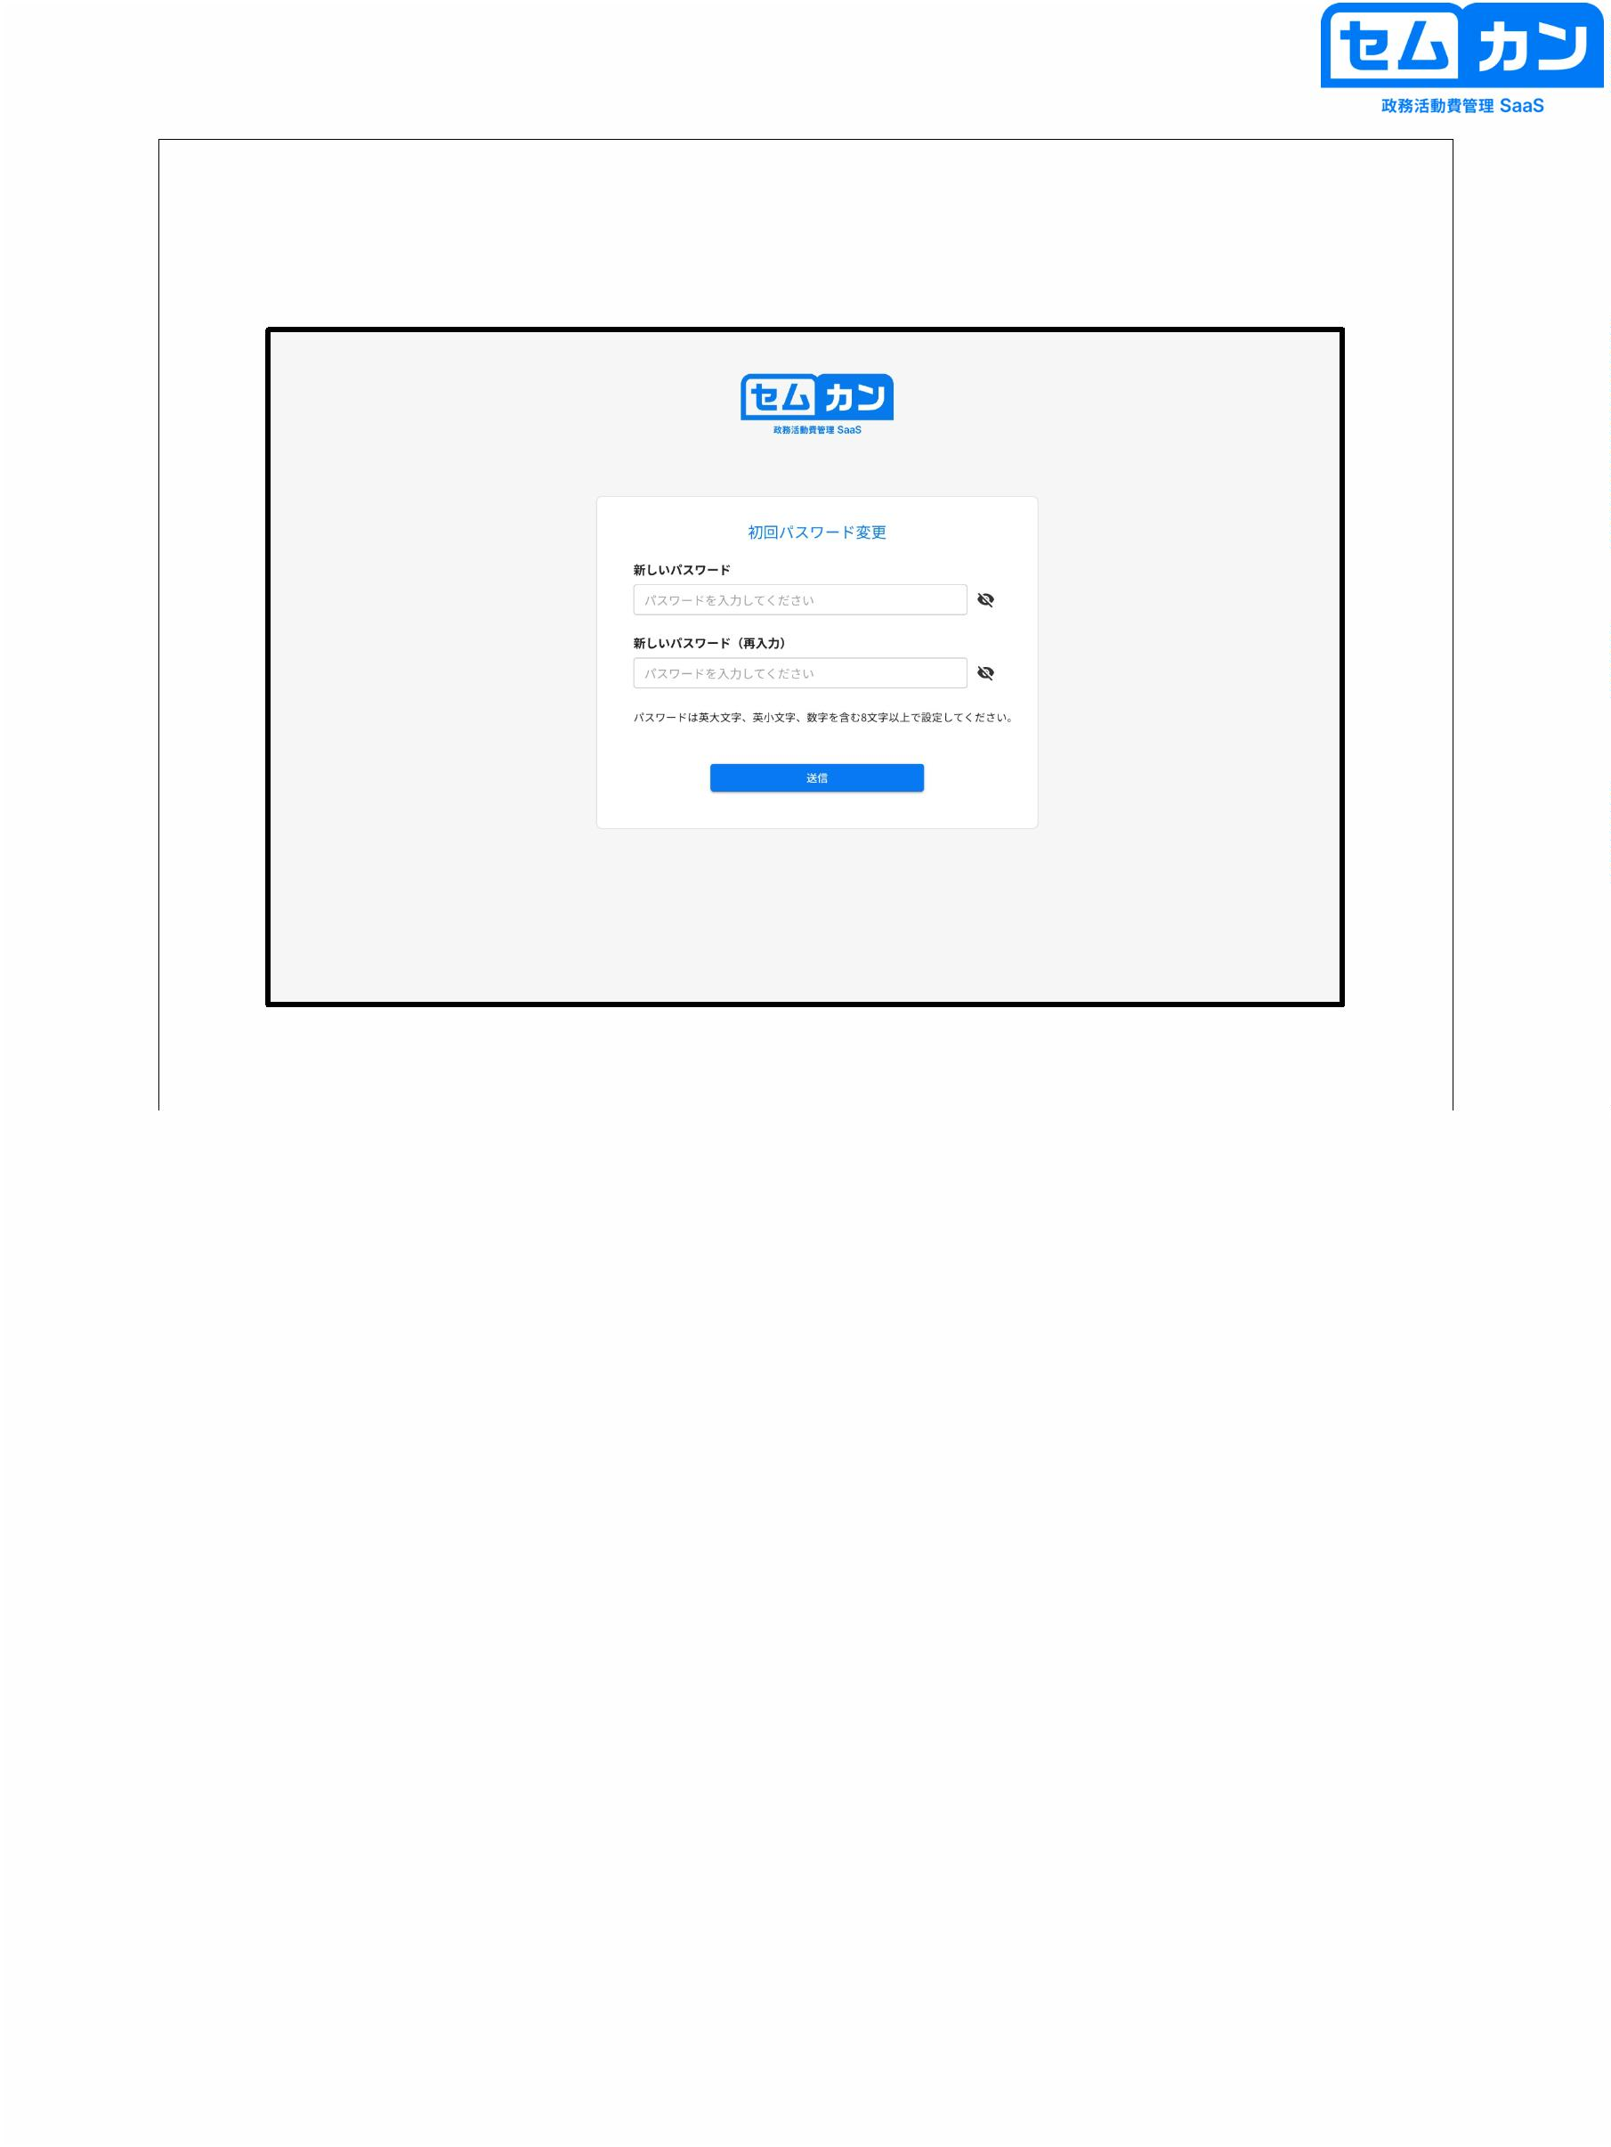

About Login

10

• Your new password will be reflected and you will be able to log in

10

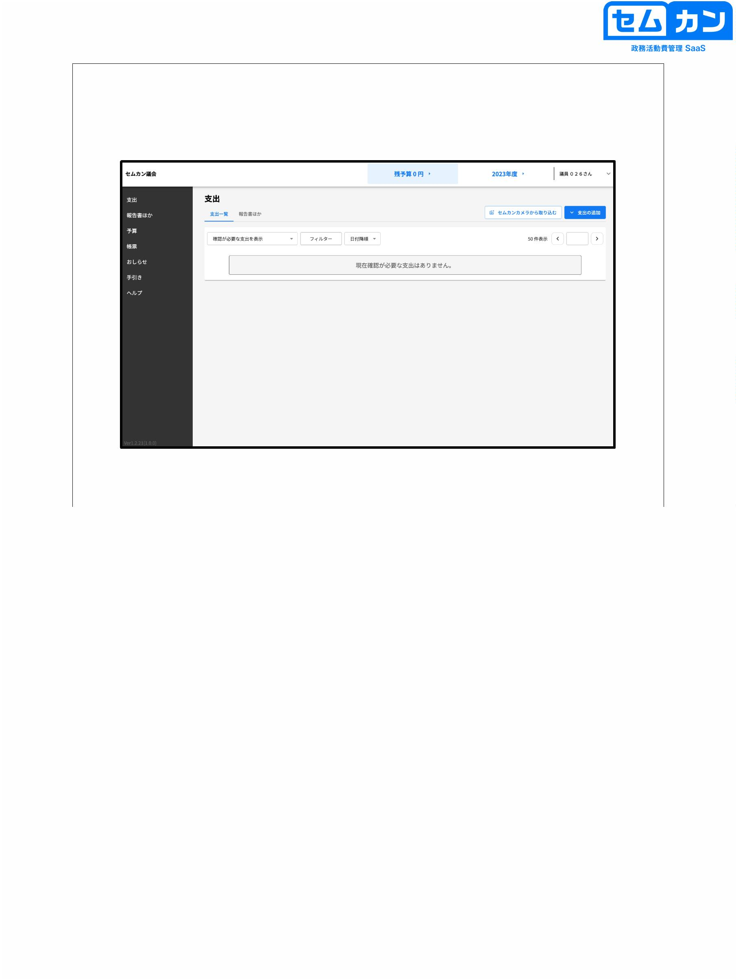

2. One-time password setting

Don't set it up yet at this time

(If you turn on this function before registering your email address, you will not be able to log in.)

11

11



One-time password setting

①

②

12

(1) Click "V" next to the registered name

(2) Click "Personal Settings"

12

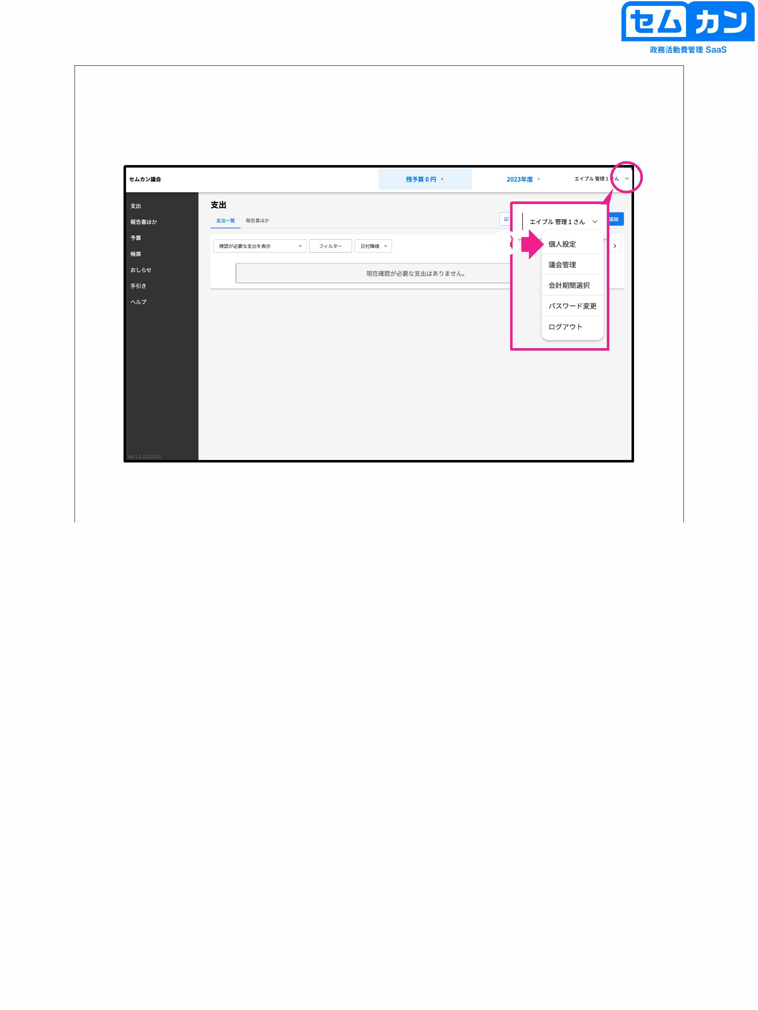

One-time password setting

①

②

13

(1) In your personal settings, click "Enable two-factor authentication" in "MFA settings"

(2) Click "Register"

\* From the next login, a one-time password will be required.

13

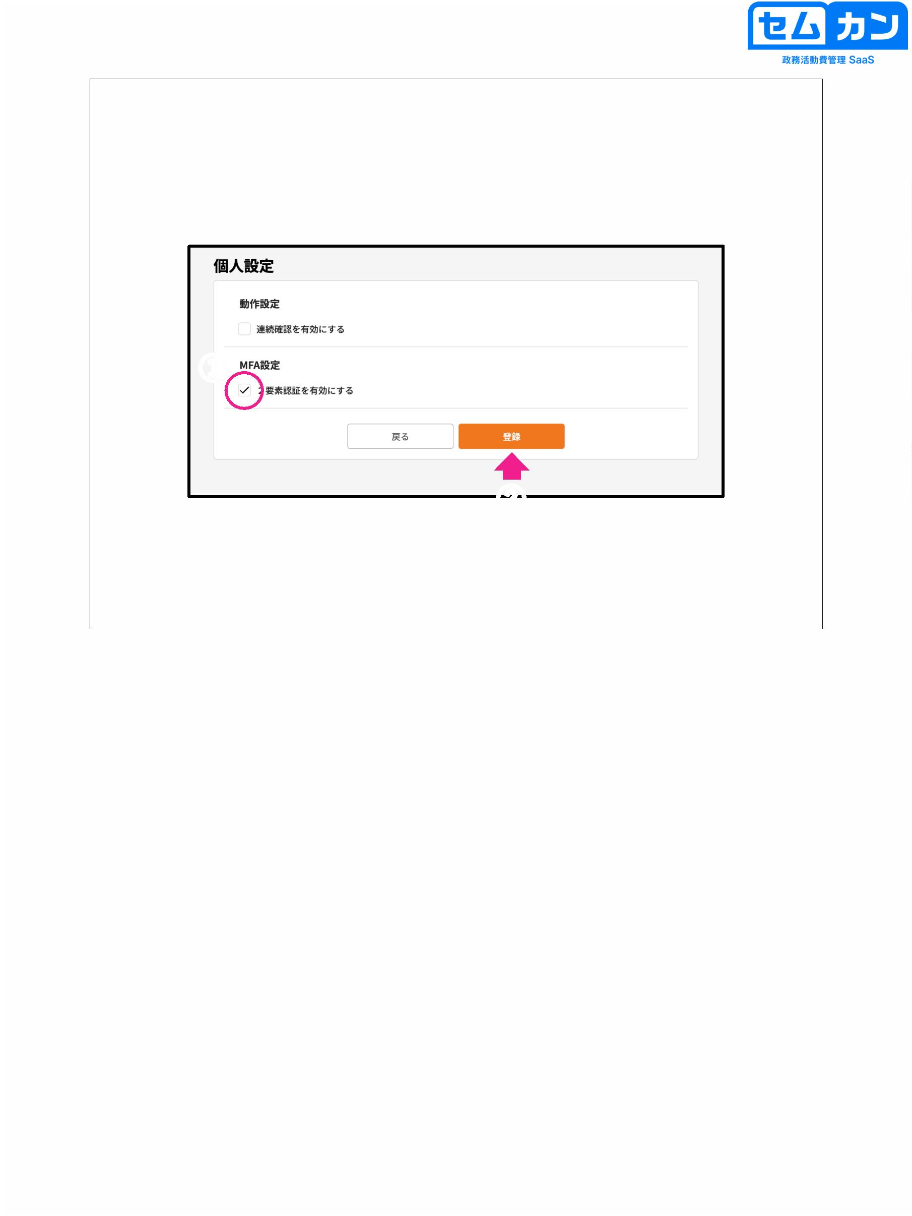

Next Login

①

②

③

14

(1) Enter your account ID.

(2) Enter your password

(3) You will be asked for a one-time password, so please register.

Please check your email address and "Semkan System"

Enter the one-time password sent from and click "Send"

Press to log in

14

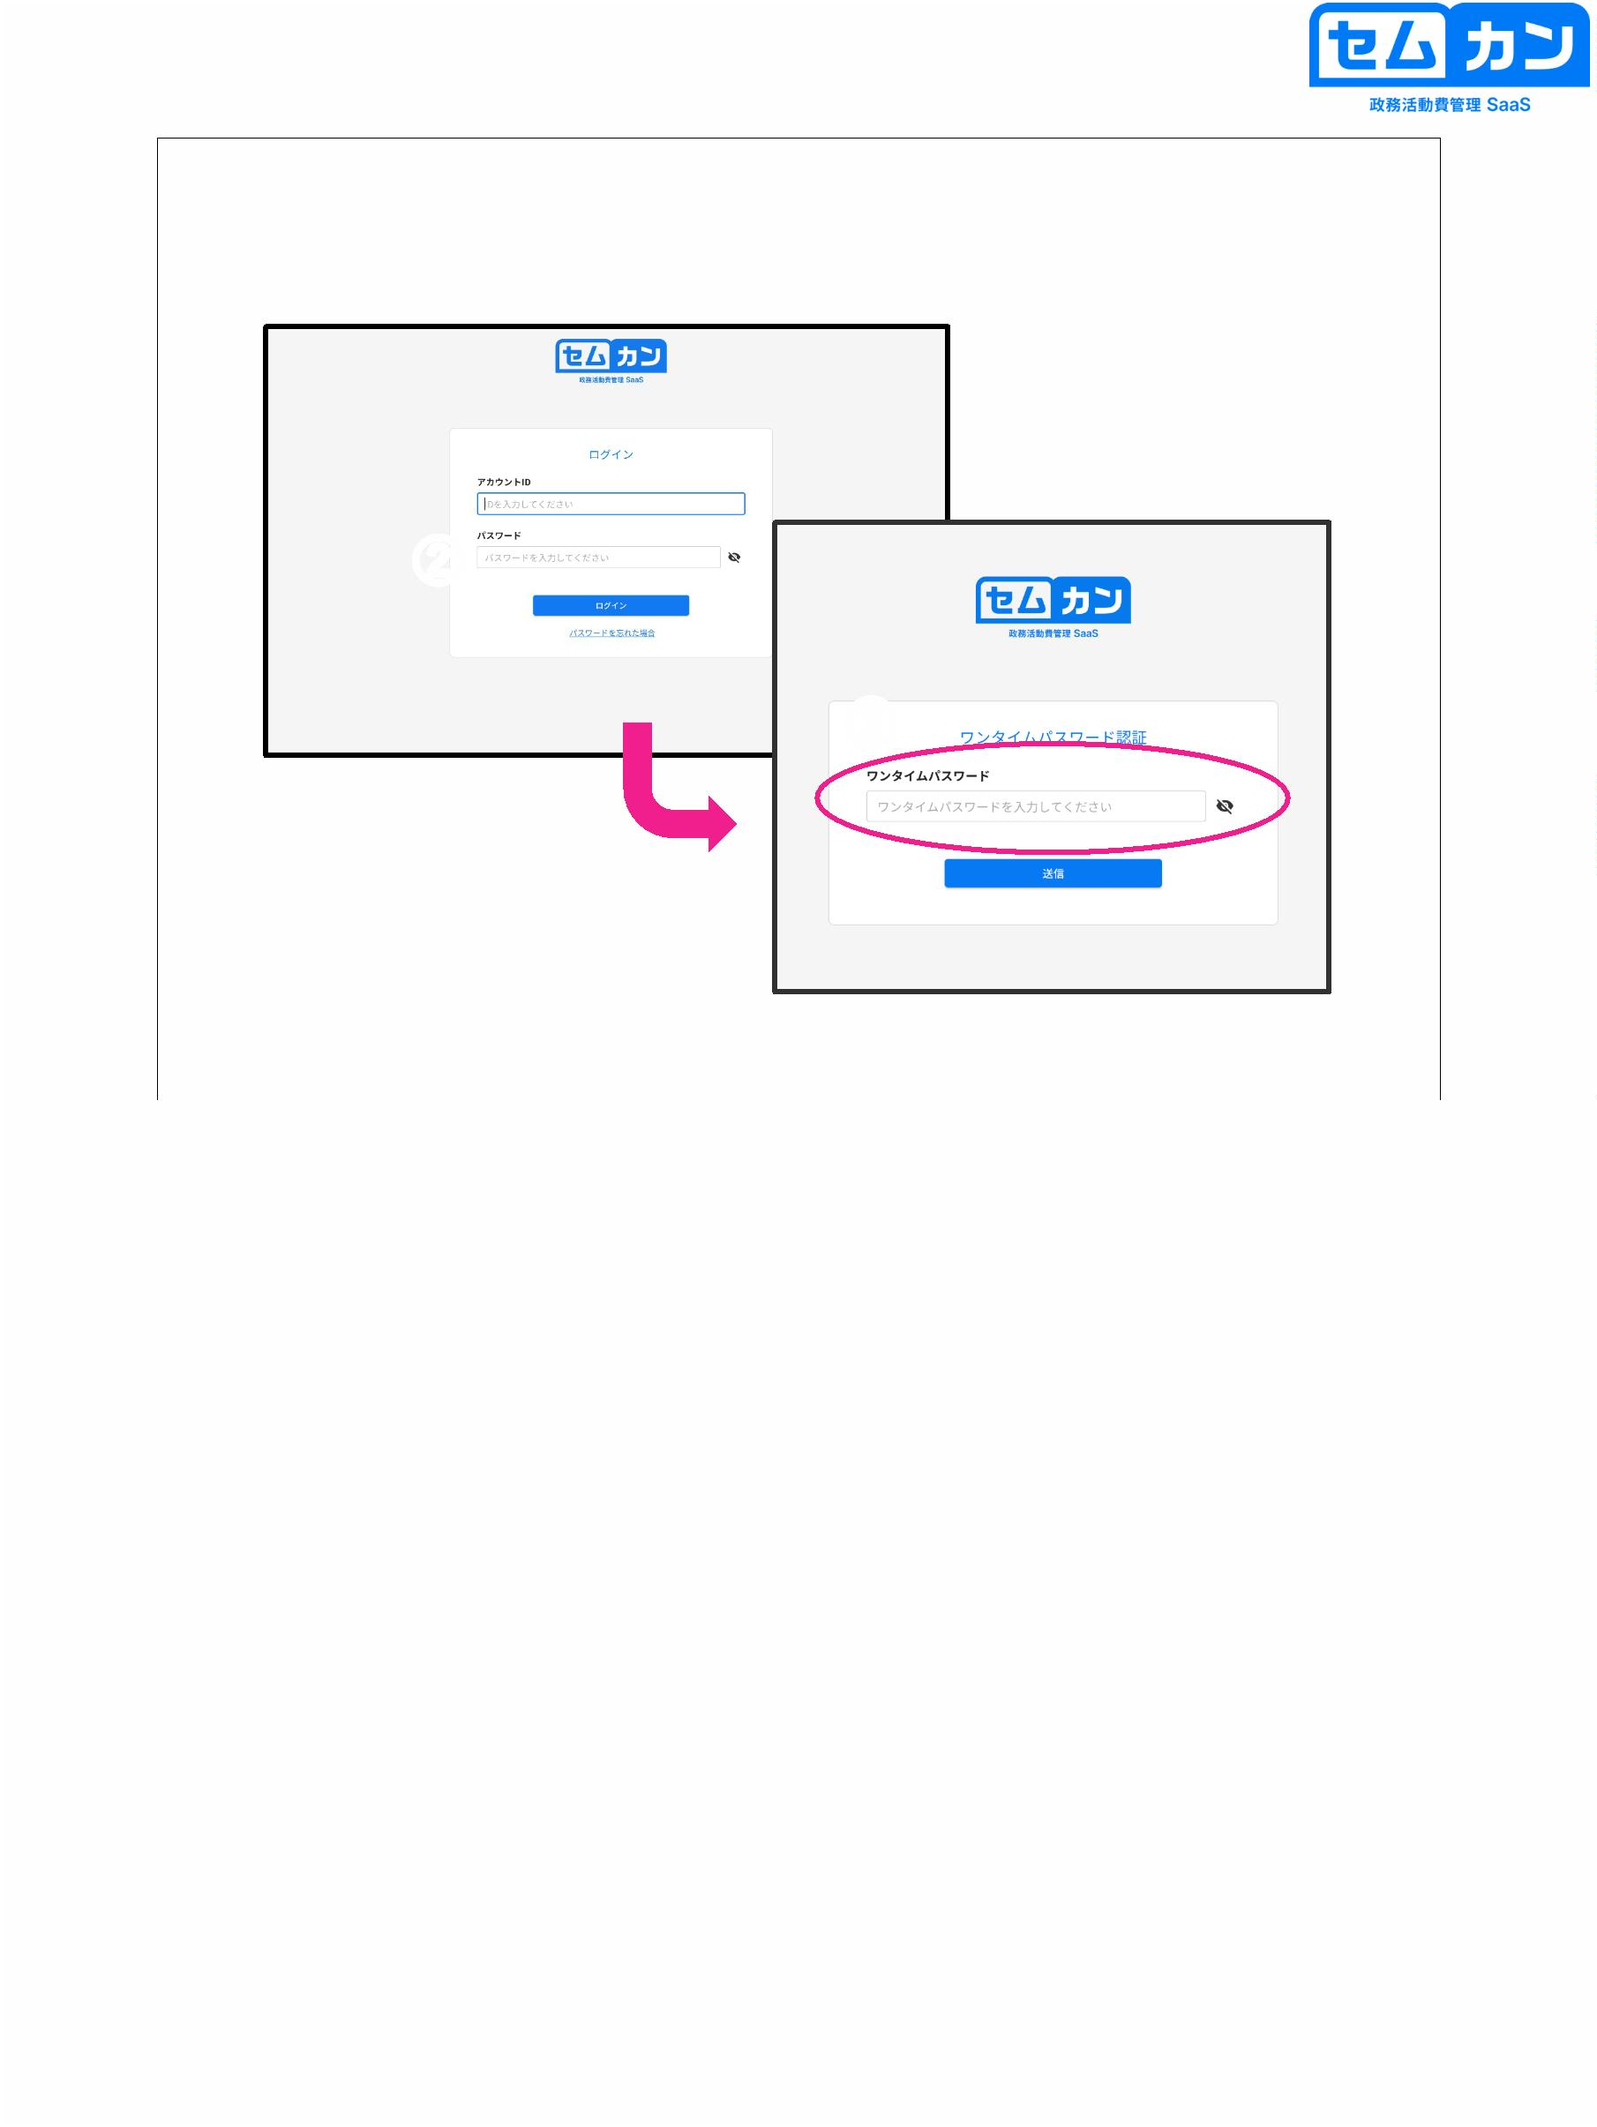

3. Overview of Overall Functions

15

15



Login screen

16

• Semkan is a web service used in a browser

• Enter your ID and password to log in and you'll be sent to your own page

will be displayed and you will be able to use it

16

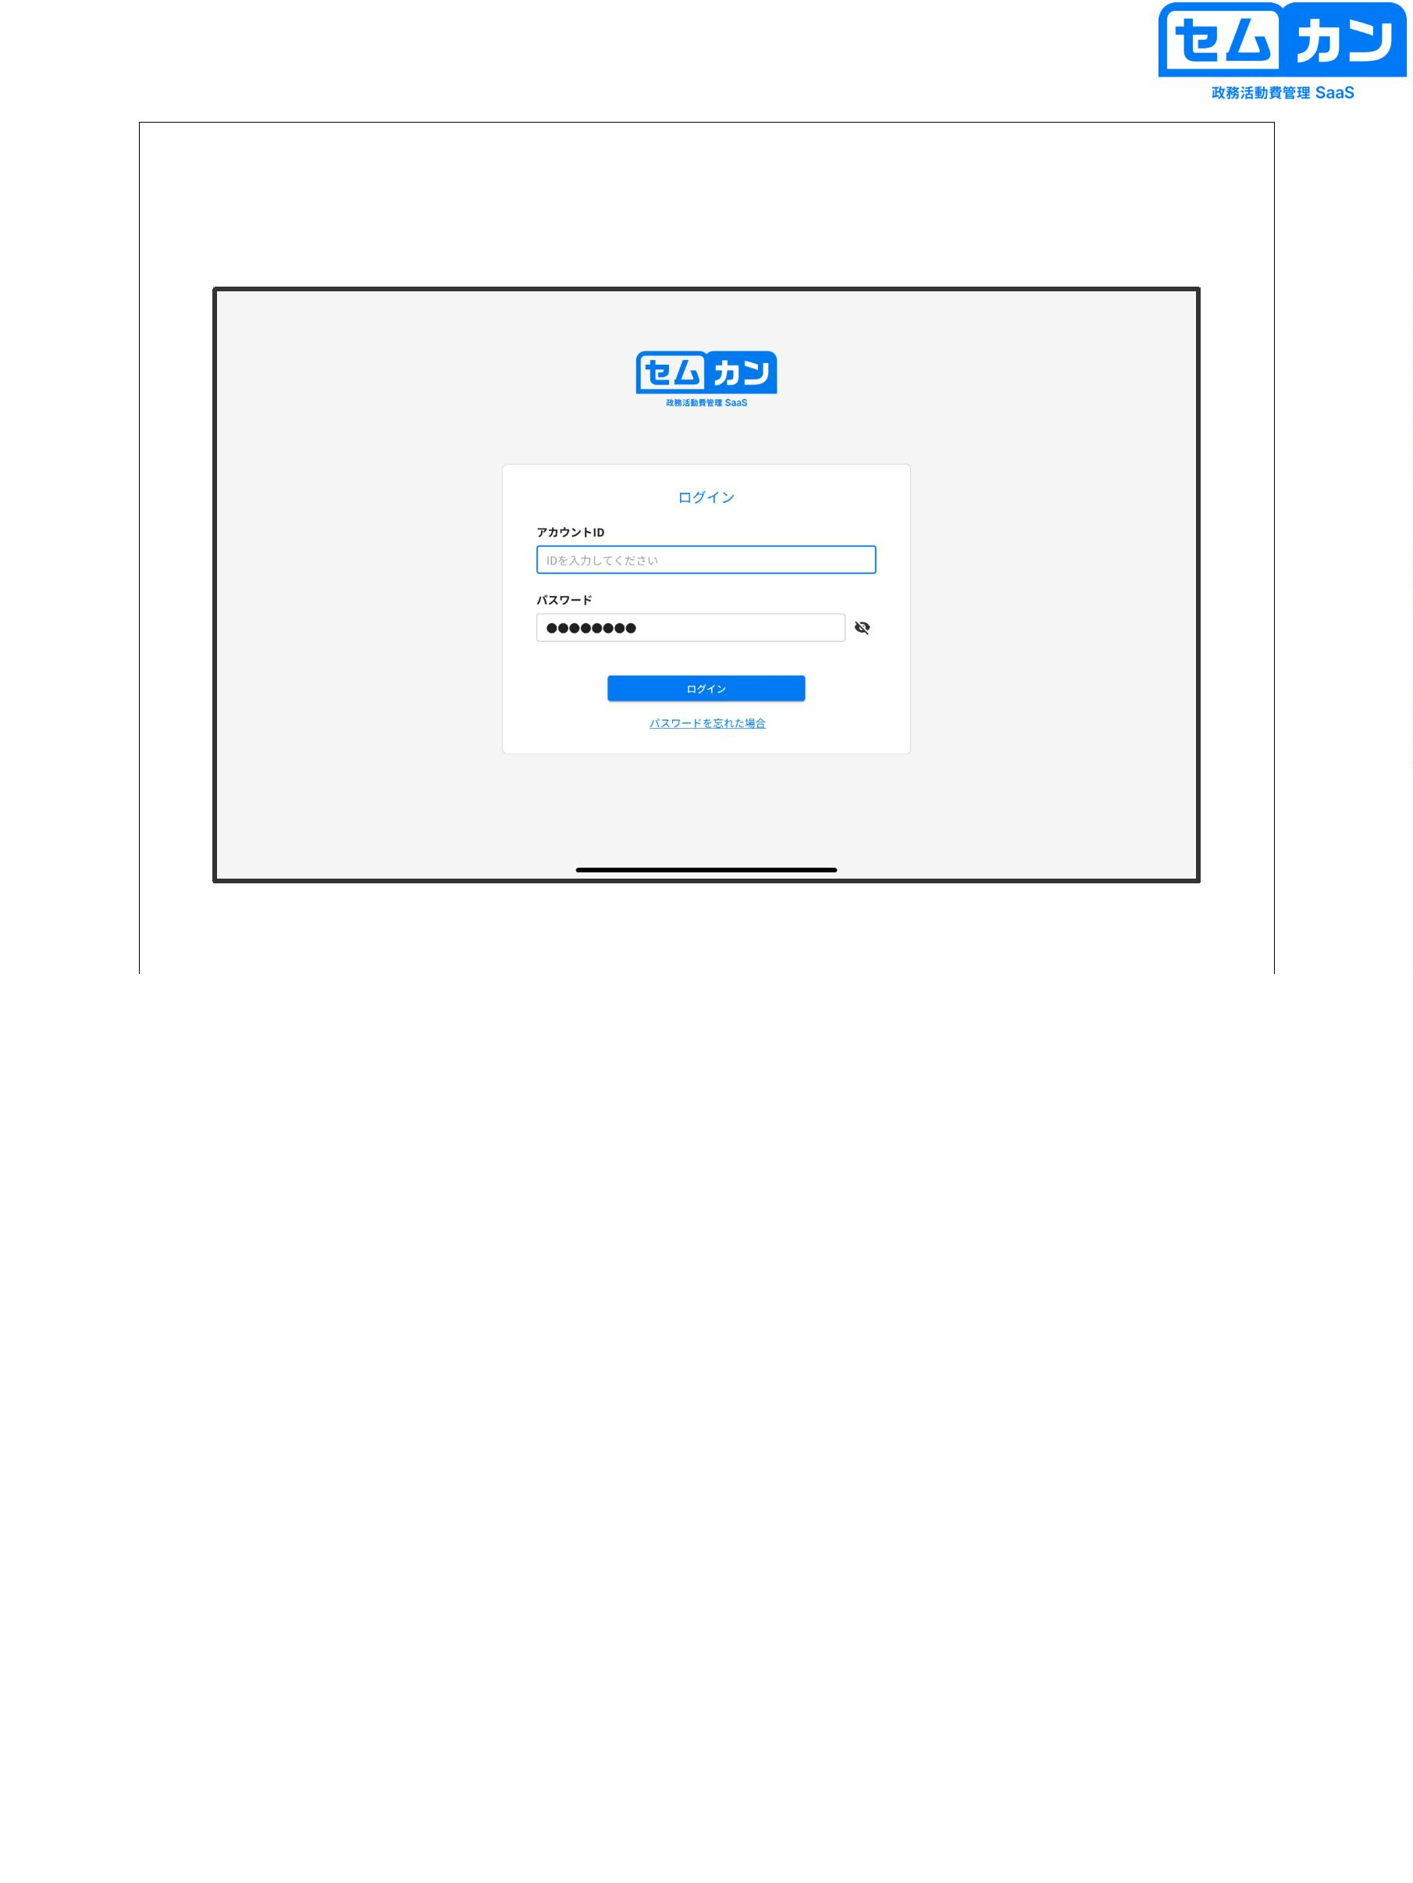

home screen

①

②

③

(4)

17

(1) Click to display the menu

(2) The balance or total amount of expenditure is displayed

(Individually selectable)

(3) You can check and select the fiscal year

(4) Click to set various items

Personal settings: Set (2) to "Balance" or "Total Expenses"

You can choose to

Parliamentary Choice: You can choose a Parliament (depending on which you belonged in the past)

When it is necessary to work in the parliament of (use)

Fiscal Period Selection: You can select the fiscal year

Change Password: You can change your password.

Logout: Log out

17

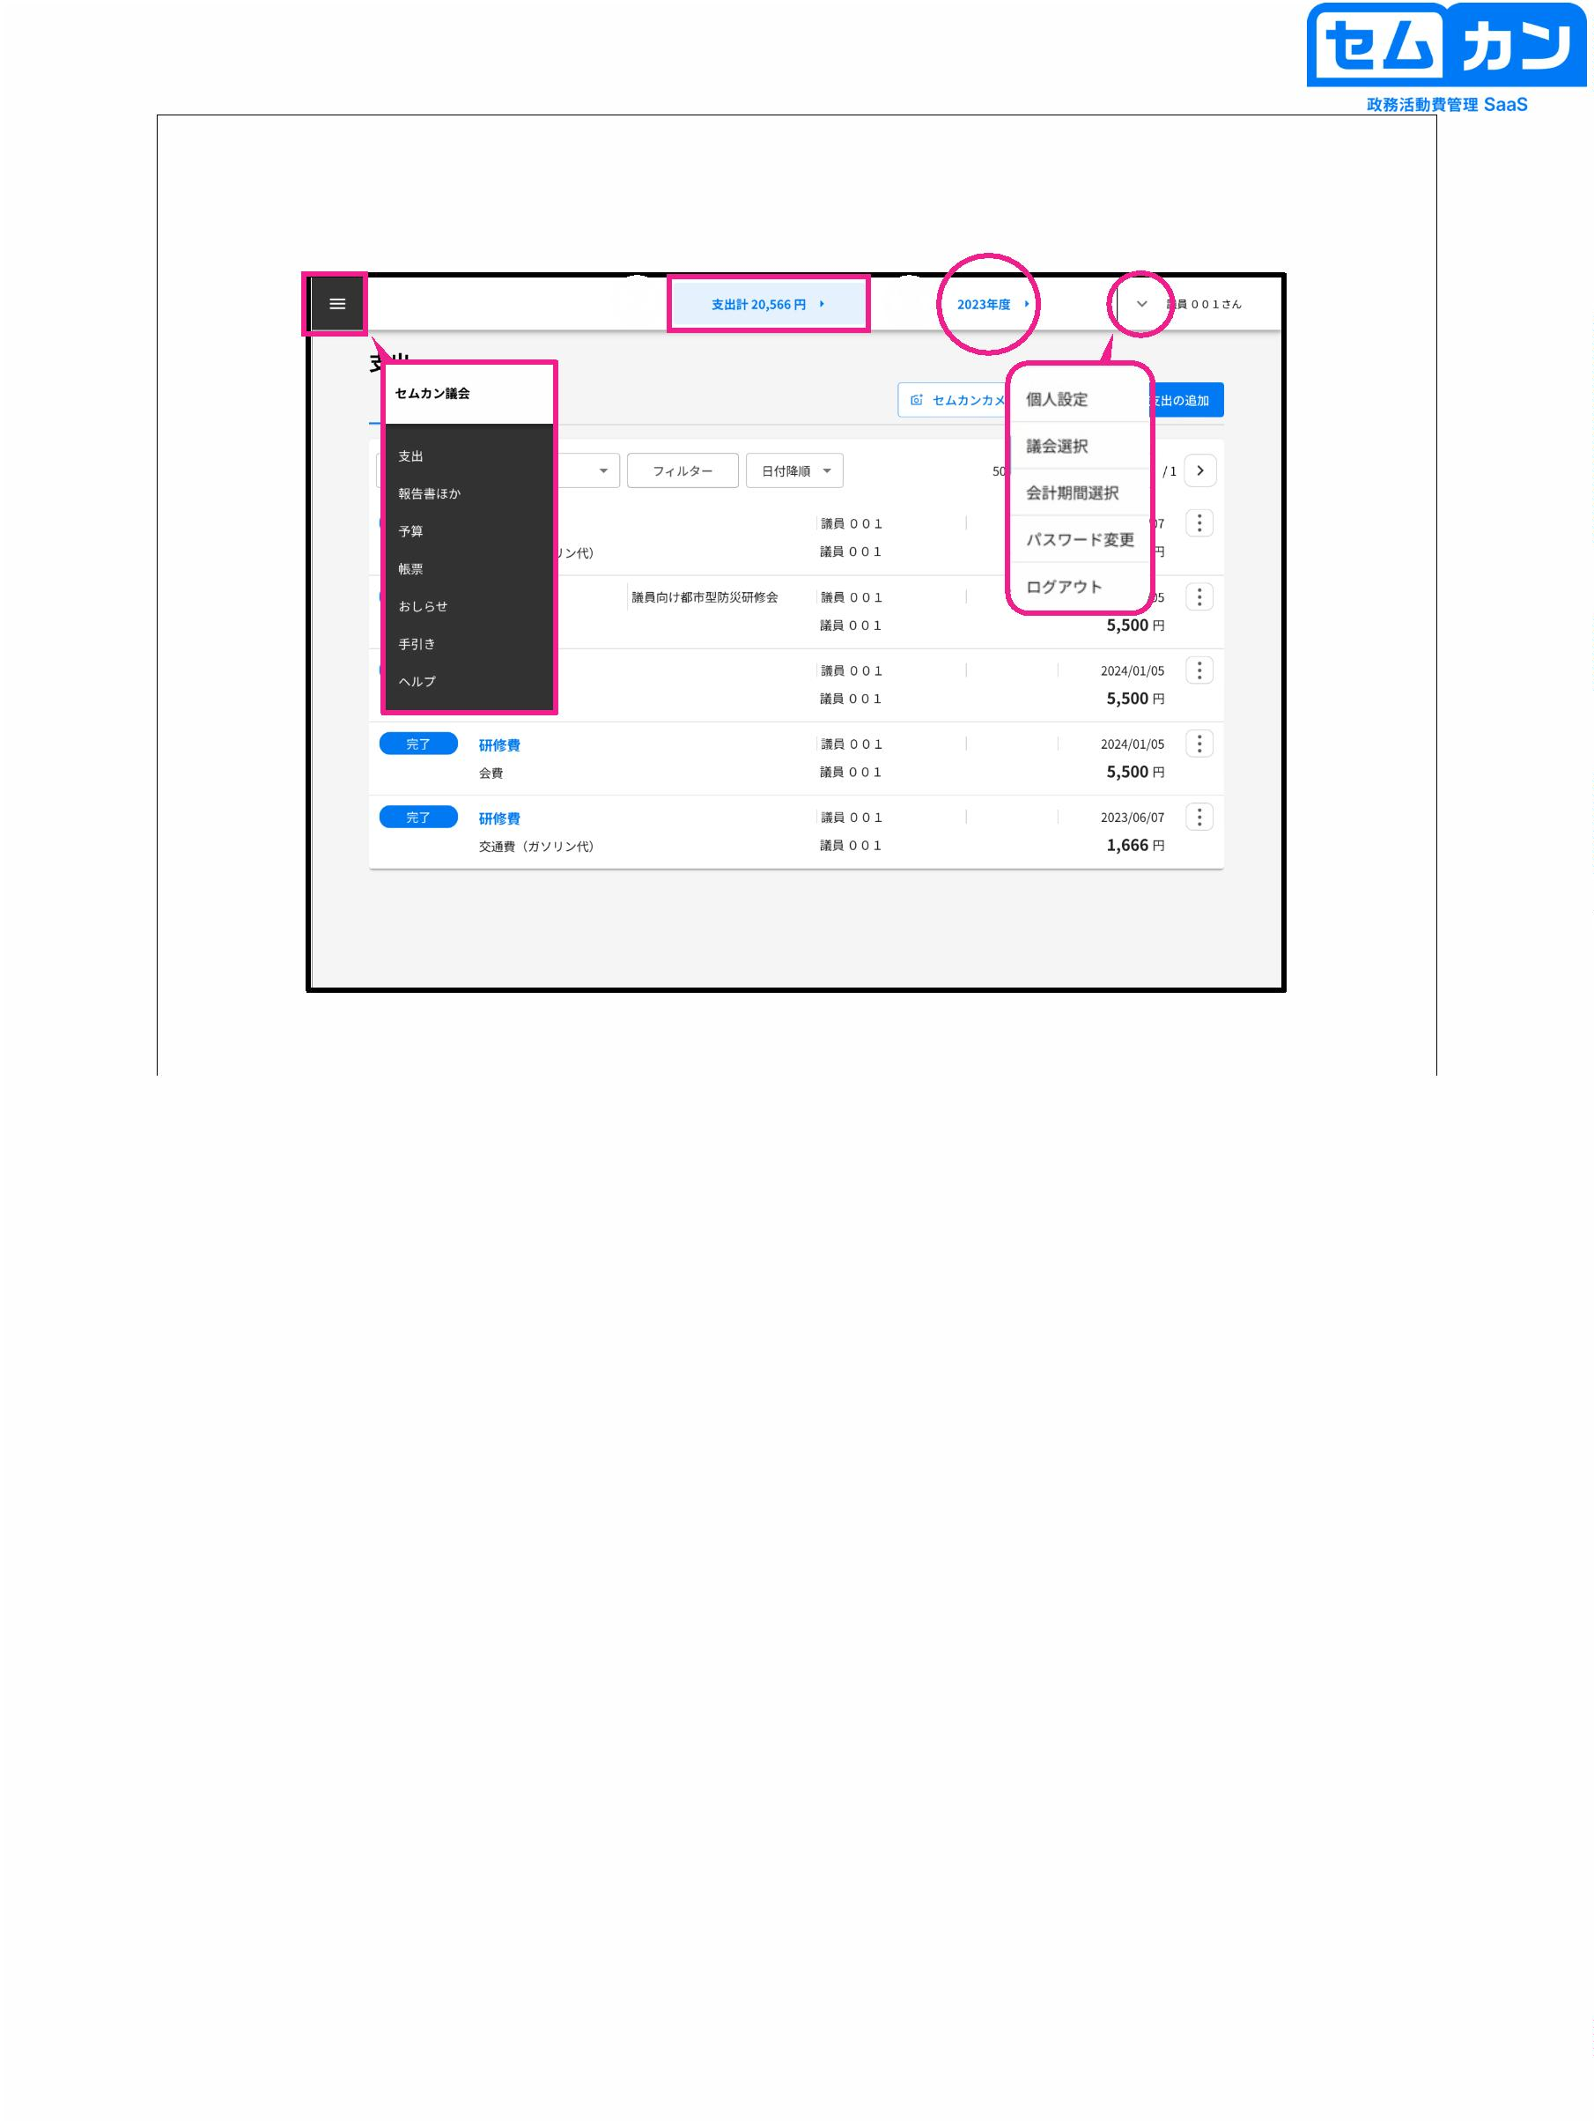

home screen

⑤

(4)

② ③

①

⑥

18

(1) View all expenditures: All data entered

View spending that needs to be reviewed:

Data that you need to review and correct

(2) Described in the next slide

(3) Sort by "Date ascending" or "Date descending"

(4) You can check the data imported by the Semkan camera.

Select the data you want to link and click "Execute"

(5) You can select "Create from Template" or "Create New"

(6) Past records can be switched < or >

18

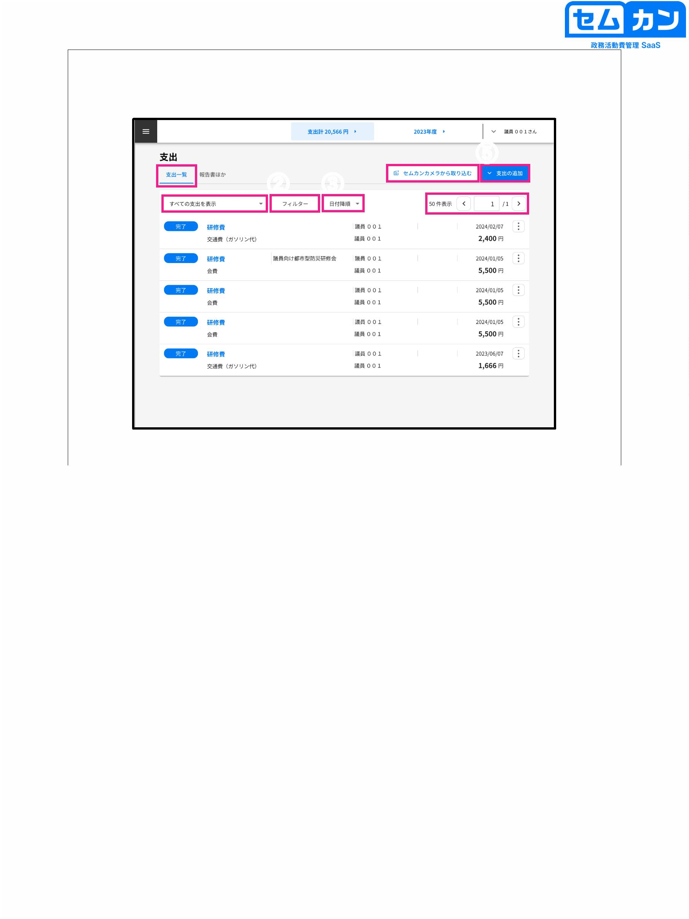

home screen

Main status buttons

Data in progress

Data that needs to be reviewed and corrected

All secretariat staff have been checked.

Expenditures not allocated to political activities

19

•

•

"Expense item", "Expense detail", "Status", "Month", "Creator"

You can put on a ruta

The status description is as follows

u A button that can be entered by the member himself

→ after selecting "Show spending that needs to be reviewed"

"Creating" > "Incomplete"

u Button in the approved state

→ "Done"

u. Expenditures not allocated to political activity expenses

→ "Exclusion of appropriation"

19

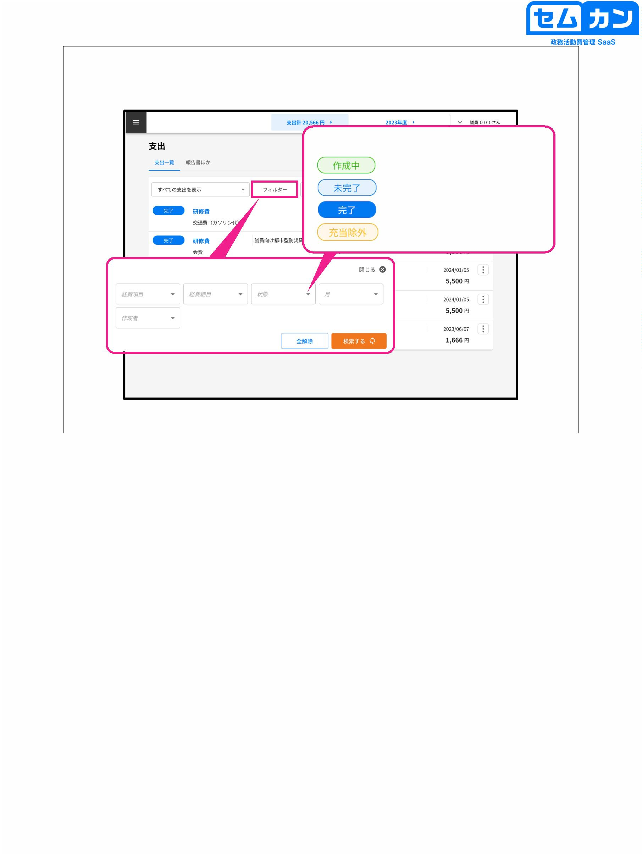

home screen

② ③

①

20

(1) View all expenditures: All data entered

View spending that needs to be reviewed:

Data that you need to review and correct

(2) Filter for each registered document

(3) Sort by "Date ascending" or "Date descending"

20

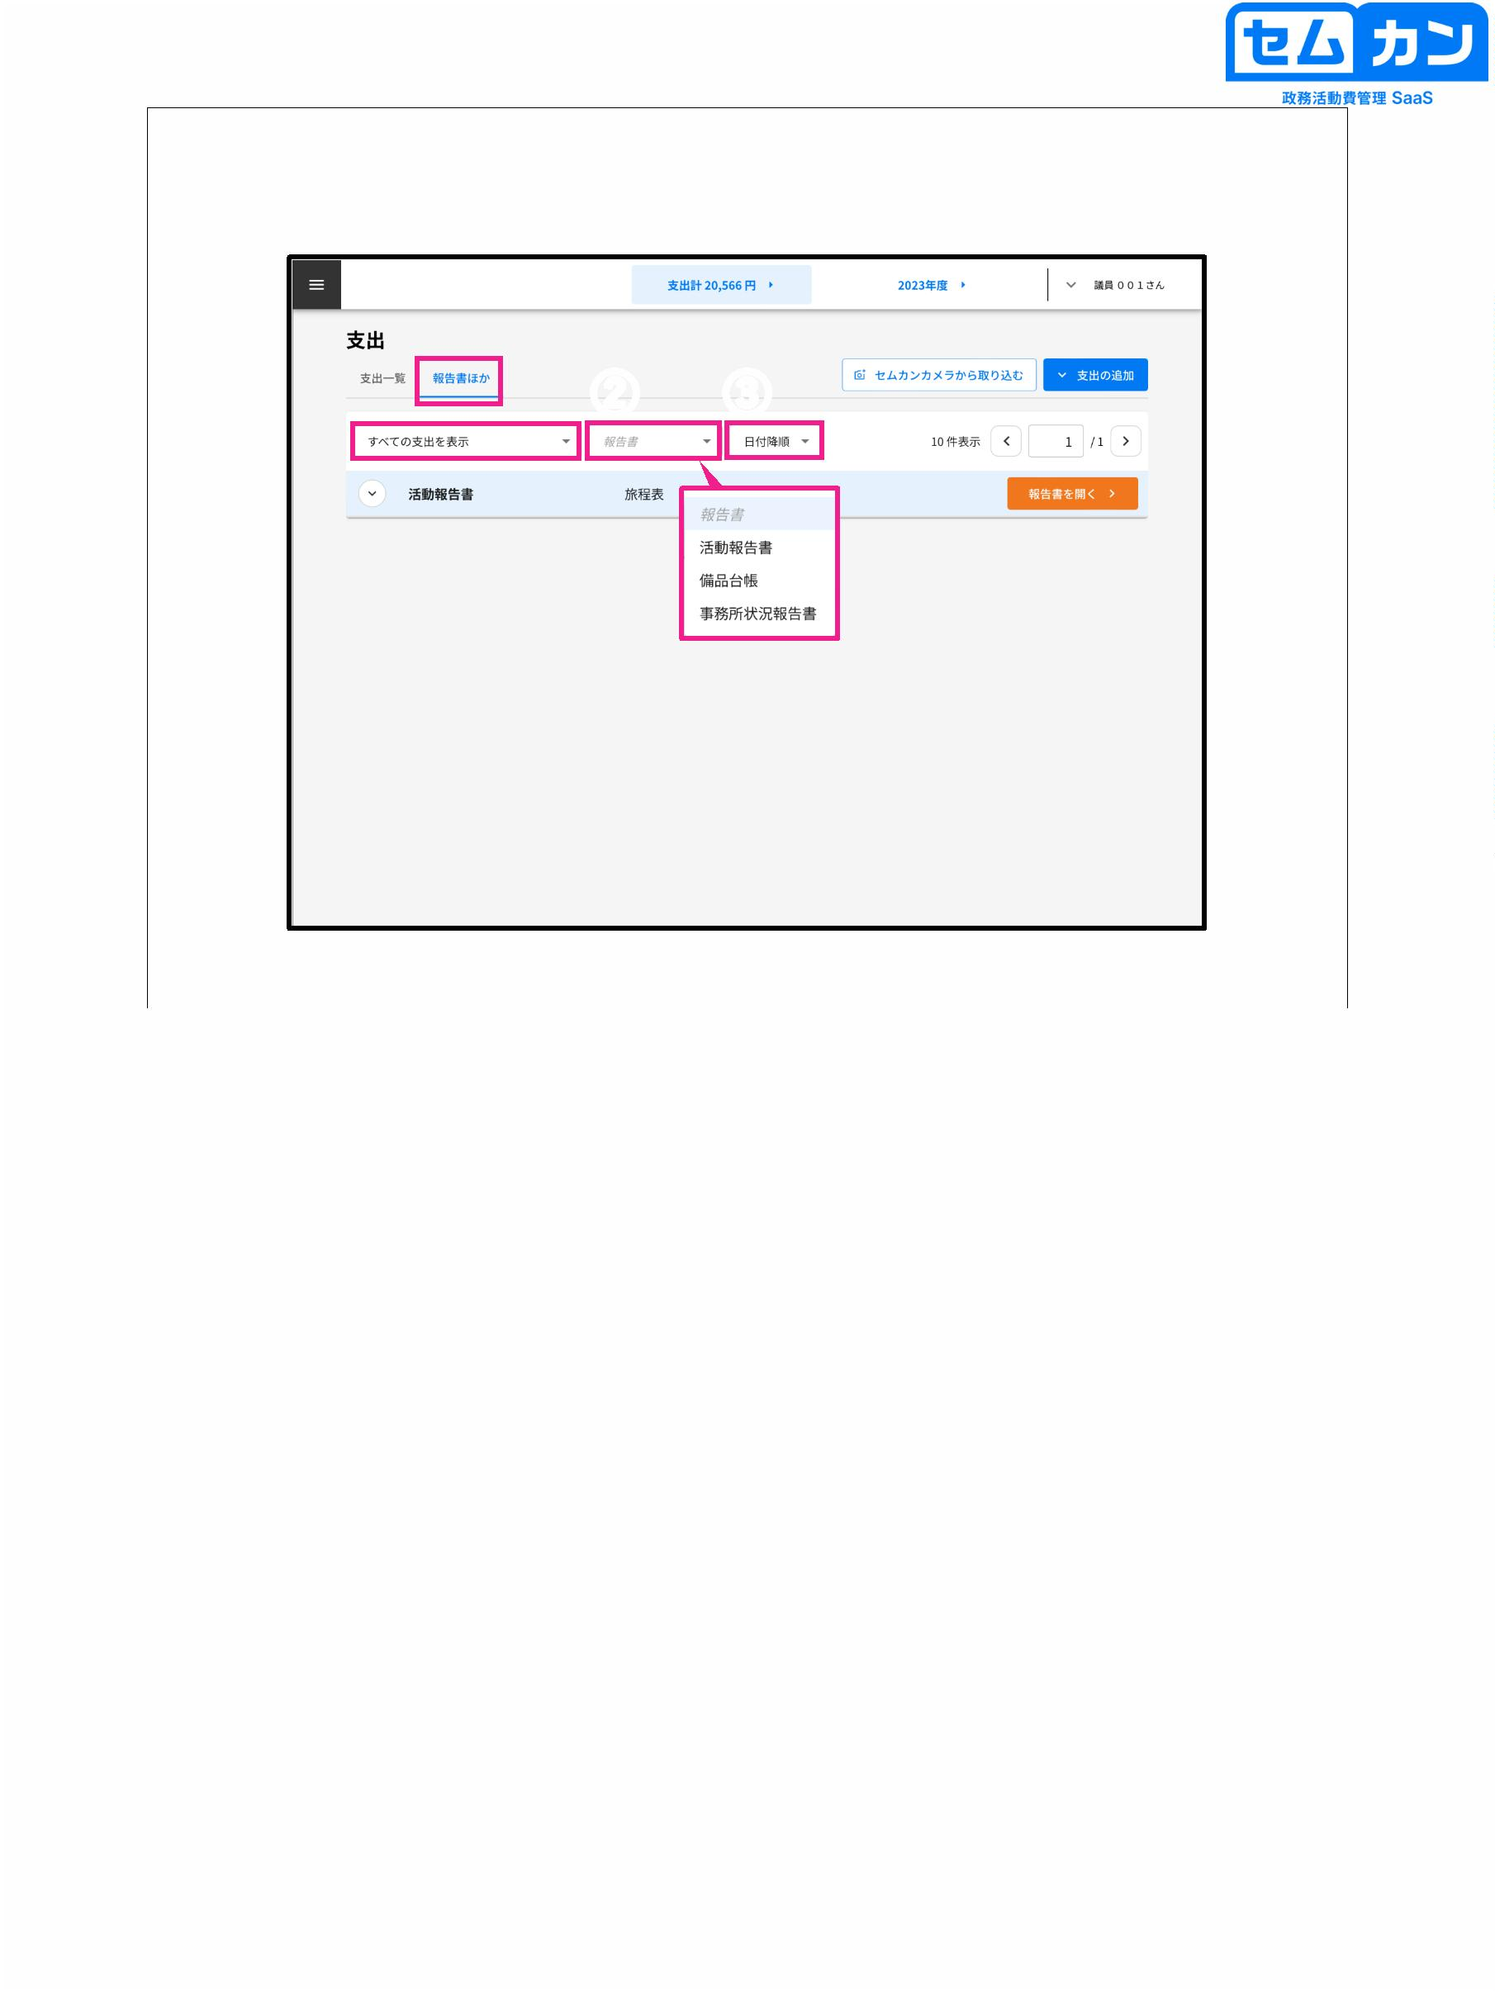

Expenditure screen

①

②

21

(1) During creation, the created expenditure is listed on the "Expenses" screen.

The current procedural status is displayed

Past records can be switched < and >

(2) Click "⁝" to change the details of expenditure

When you click on it, the item will be displayed, so depending on the purpose

Please select

\* You can switch between descending and ascending date order.

21

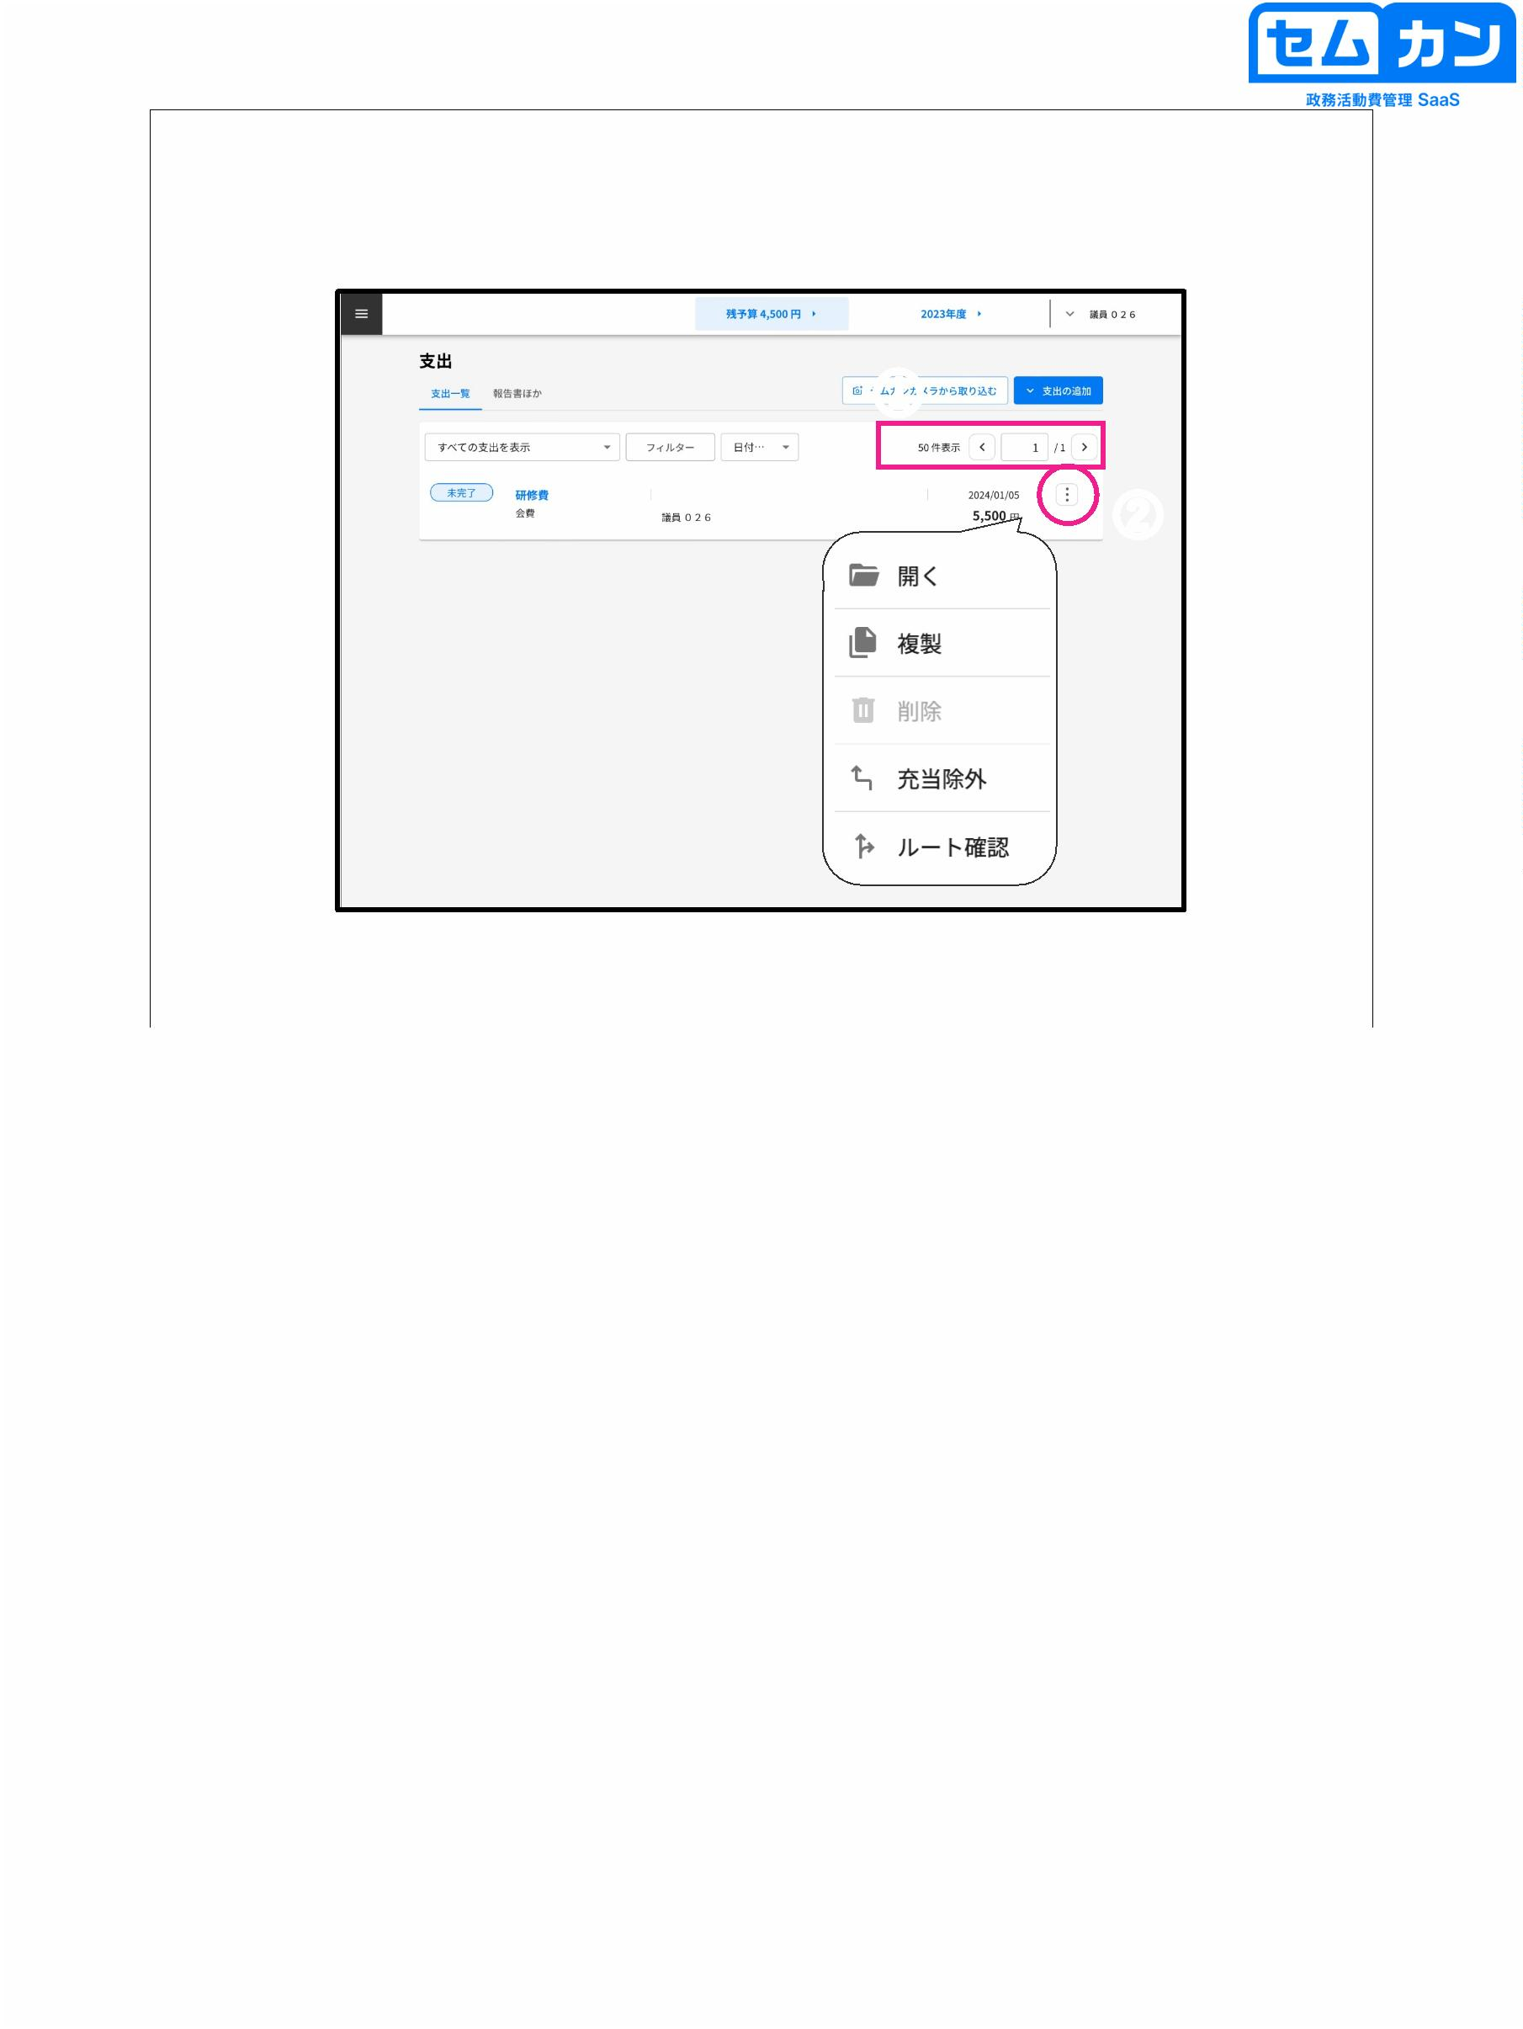

Budget screen

①

②

Personal name

Personal name

22

(1) Income is listed in "Budget"

Past records can be switched < and >

(2) If you want to change your income, click "⁝"

When you click on it, the item will be displayed, so depending on the purpose

Please select

\* You can switch between descending and ascending date order.

22

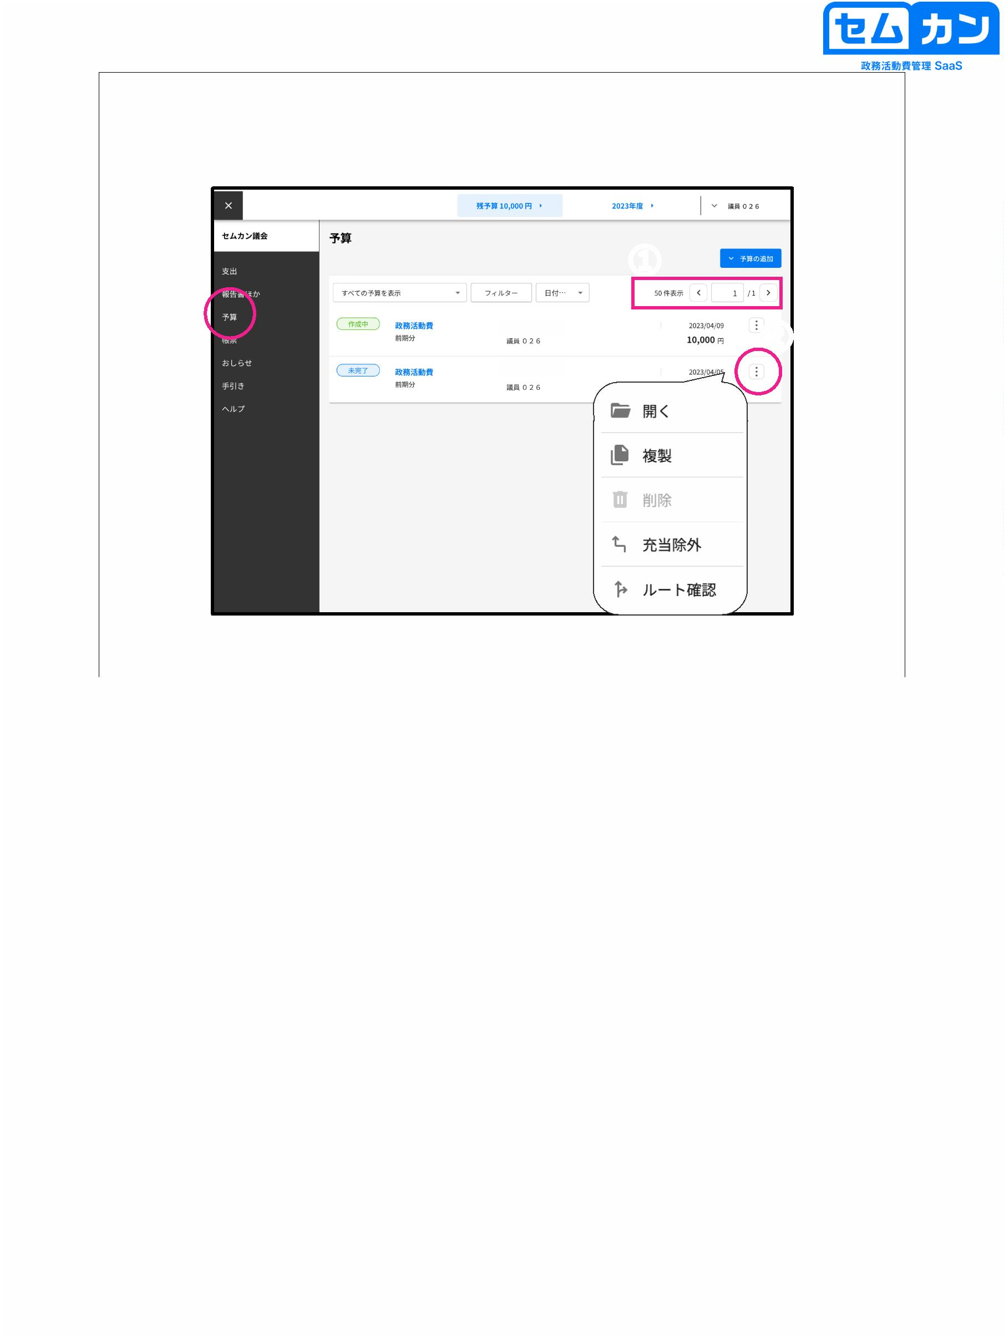

Report and other screens

①

②

23

(1) The report can be selected as a pre-registered report.

I can

(2) Click "Add Report" to upload a new report.

It is also possible to load

23

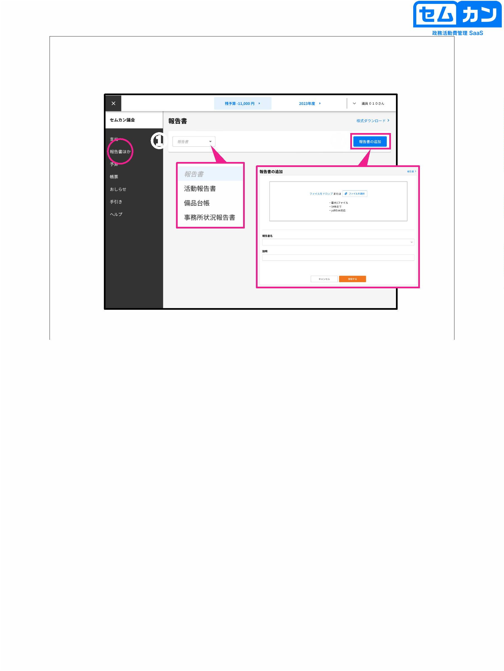

4. Add as an app

24

24



Add to the home screen as an app

On a tablet

①

②

(3) Home Screen

(4)

25

• Make your site an application and add an icon to your home screen

I will

\* Data caused by reloading or accidentally pressing the "Back" button

will not be updated (deletion of the description)

(1) Select the (1) mark at the top of the site.

(2) Select "Add to Home Screen"

(3) Select "Add"

(4) Semkan will be added to the list of apps on the home screen.

Enter Semkan from

25

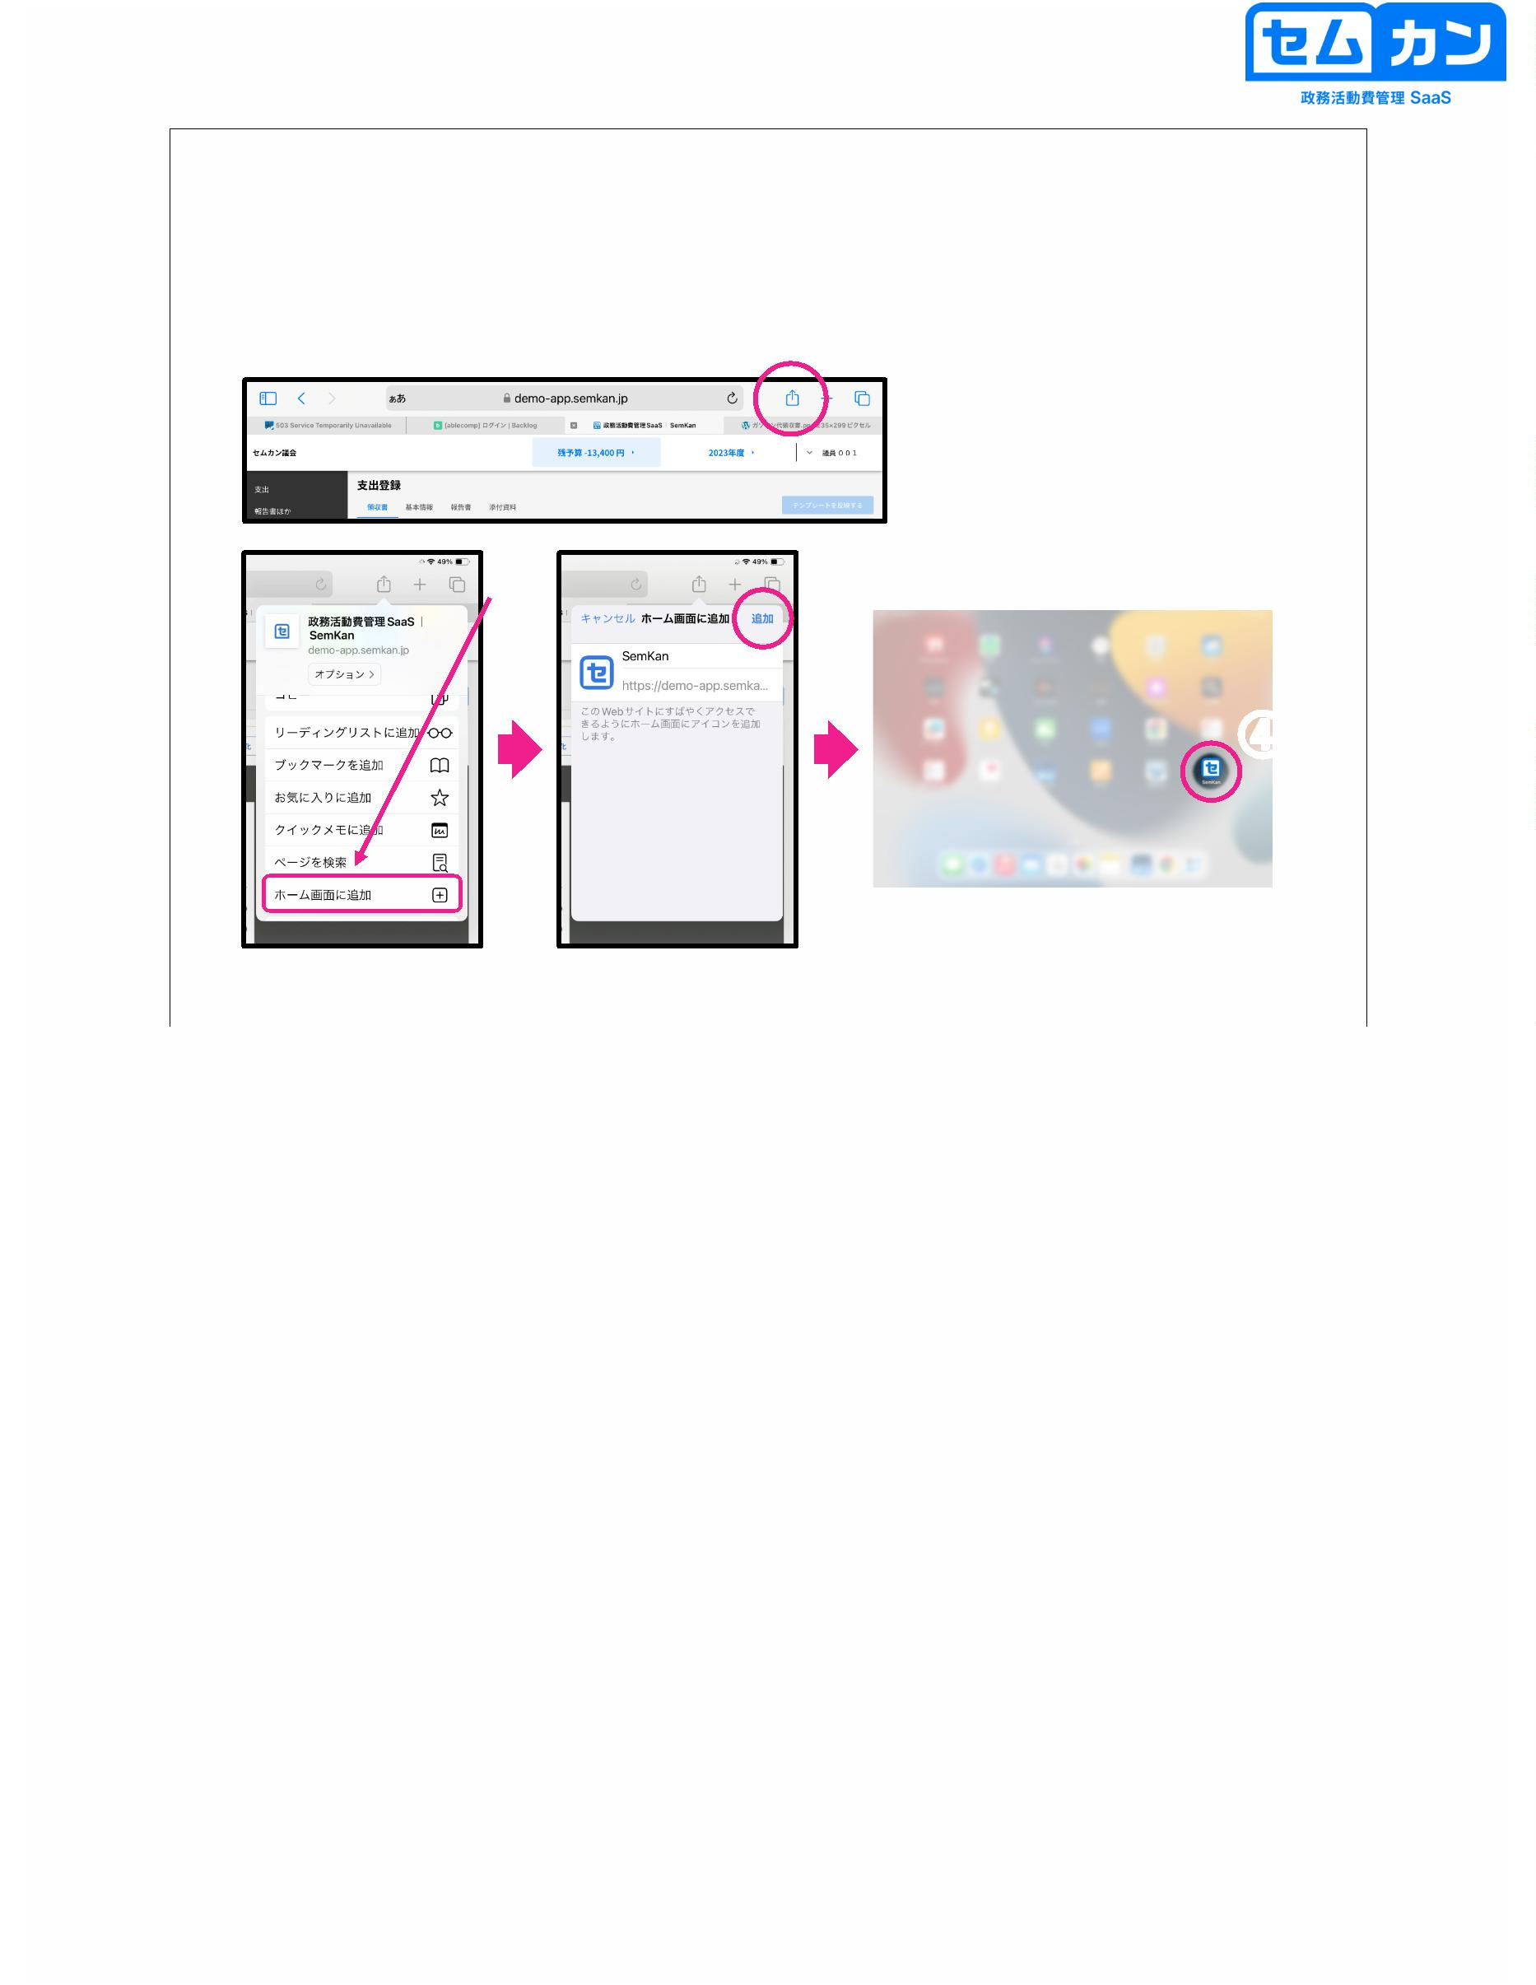

Add as an app

On PC

①

②

③

(4)

26

• Applicationize your site and add icons

\* Data caused by reloading or accidentally pressing the "Back" button

will not be updated (deletion of the description)

(1) At the top of the site, click "...Select the "" mark

(2) Select "App" and select "Install Political Activity Expense Management App"

Select "Le "

(3) Select "Install"

(4) The applicationized Semkan will open.

Semkan will be added as an app, so from there Semkan

Please enter

26

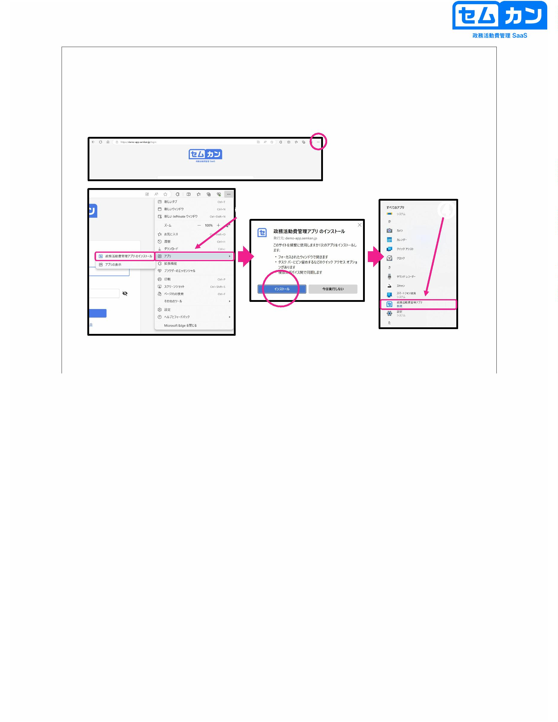

5. Create a budget

27

27



Budget screen

①

②

28

(1) Click "Add Budget" to add a new budget item.

(2) Click "New"

\* "Create from template" is when registering the same items

It is a convenient function

28

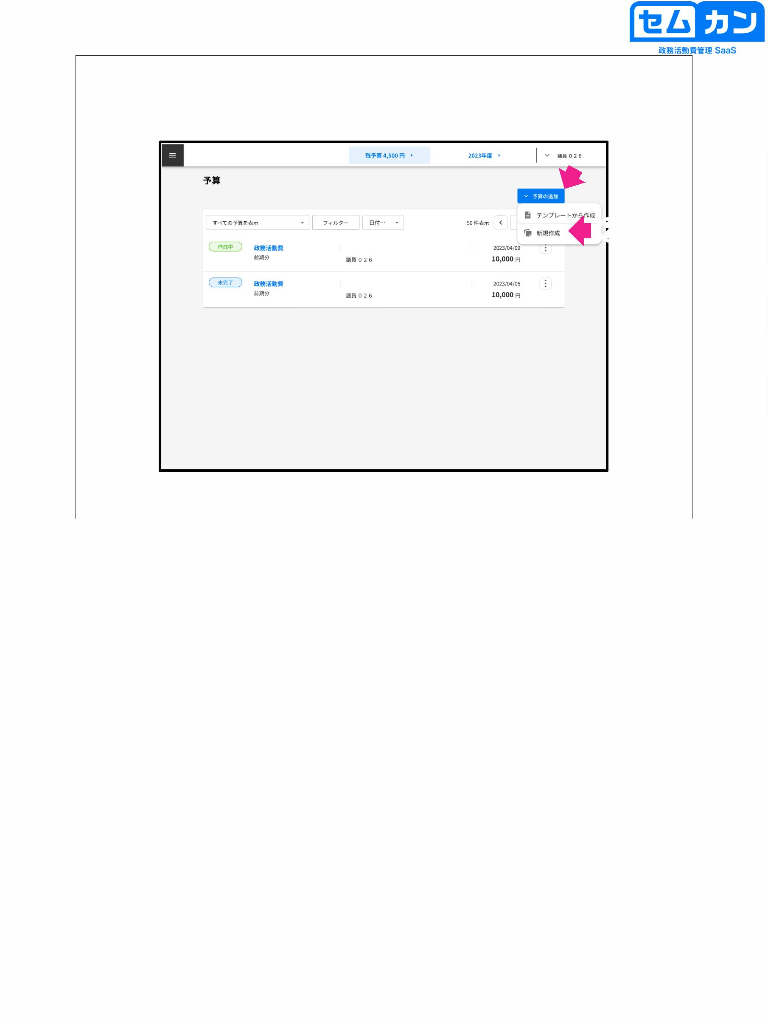

Budget screen

Expenses for political activities

Others, etc.

①

②

First Semester

Late minutes, etc.

③

29

(1) Register each item

There are mandatory (items, details, dates, amounts) and optional (description) items

\* When you click "Calendar Mark", the calendar is displayed in the table.

Indicated

(2) Attachments can be registered in PDF, JPEG, and PNG formats

"Drop File" and "Select File" will save the image to

(10 attachments can be attached, and the total capacity is up to 50 MB)

(3) Save data by "Temporary storage" and "Confirmation application"

Shortfile: Saved to your budget as "In progress"

Confirmation application: Budget data is sent to the secretariat, and the parliamentary tab

It will be saved as "incomplete" in the let

29

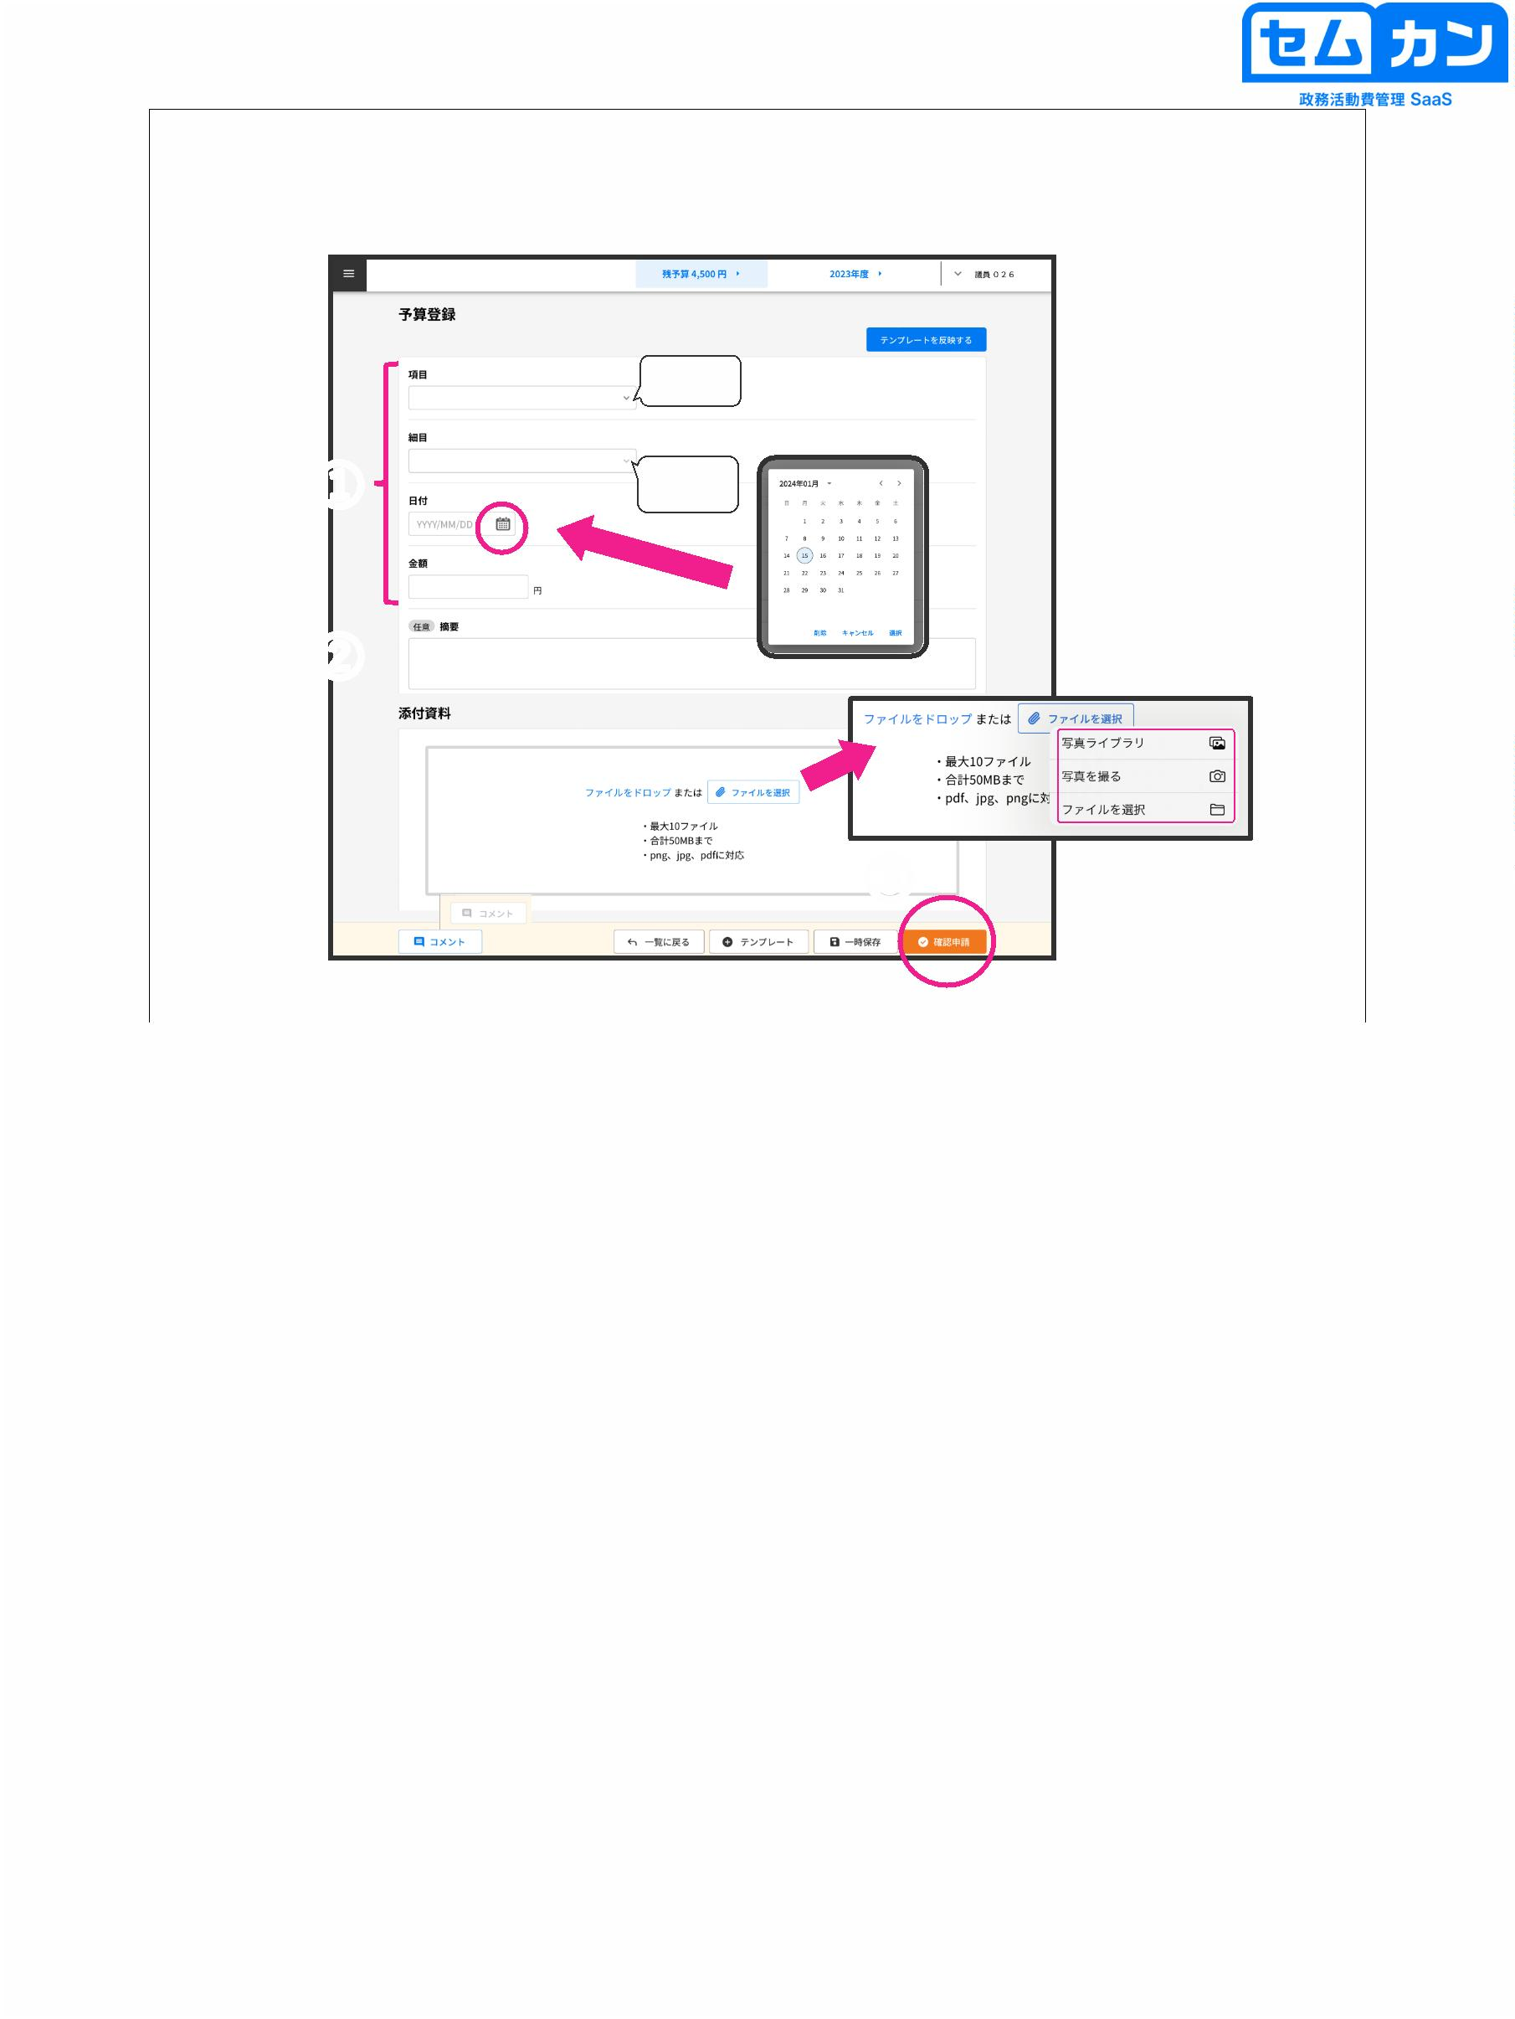

6. Register expenditures

30

There are two ways to add spending

(1) Register by entering all items directly

(2) Register using templates (You can easily register frequently used items by registering them in templates) Example: Newspaper bills, utility bills

(3) Register using Semkan Camera

30



Expenditure screen

①

②

31

■ How to register by entering directly

(1) Click "Add Expense" to register a new expenditure

(2) Click "New"

31

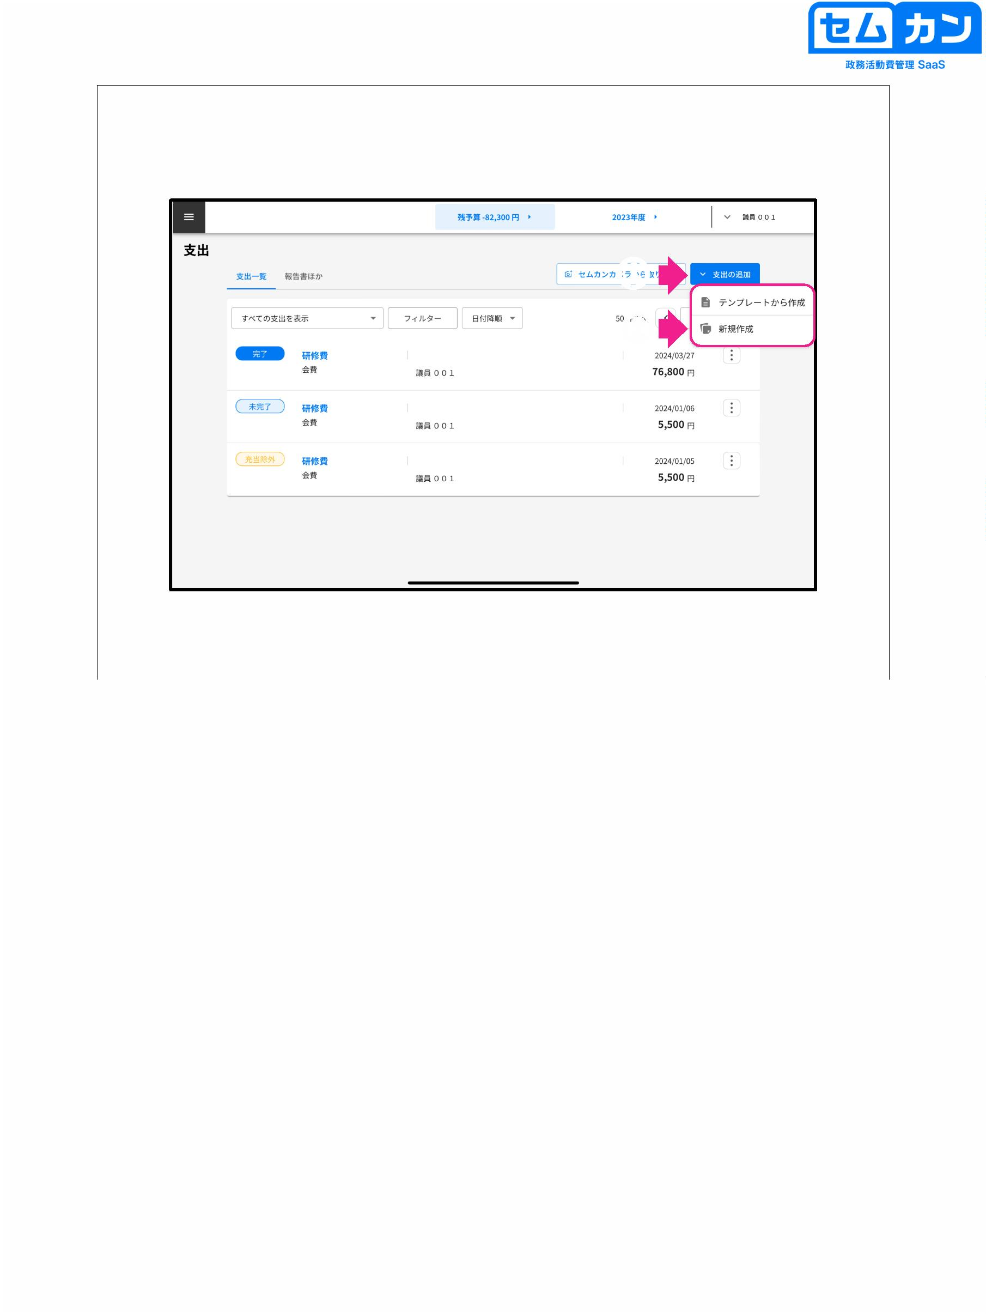

Add a receipt

Add basic information

Add a report

Add attachments

(1) Contents of the item

①

②

③

(4)

(2) Details

Transportation Expenses

Accommodation Costs

Souvenir fee

Entrance Fees

other

32

(1) Select an item from the pull-down menu.

(Items vary depending on each parliament.)

(2) Detailed items can also be selected from the pull-down menu according to each item.

(3) Select "I have a receipt"

\* If you do not have a receipt, select "No receipt" and set the "Reason" to

I will describe

(4) Receipts can be registered in PDF, JPEG, and PNG formats

"Drop File" and "Select File" will save the image to

Please select

(10 attachments can be attached, and the total capacity is up to 50 MB)

32

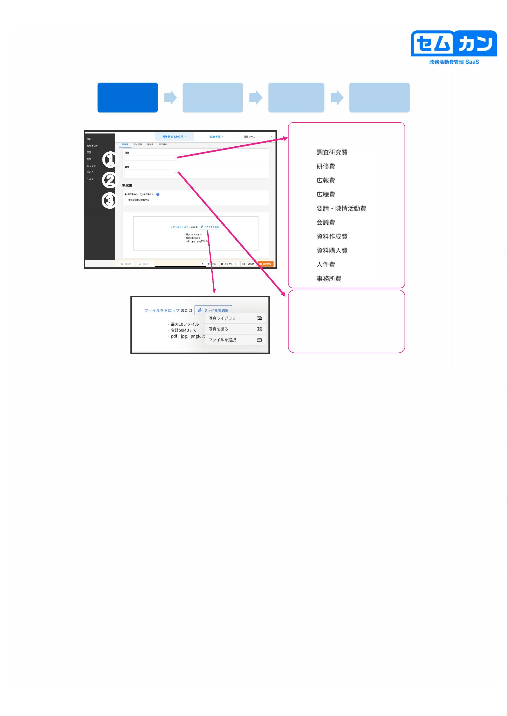

Add a receipt

Add basic information

Add a report

Add attachments

Select a file

Photo Library

Select the receipt image stored on the tablet terminal and click "Add"

photograph

Take a picture and click "Use Photo" \* "Reshoot" will start the camera again

Select a file

Since the folder in the tablet terminal opens, select the data to be stored

33

• When importing a receipt image with "Select File"

How to operate

33

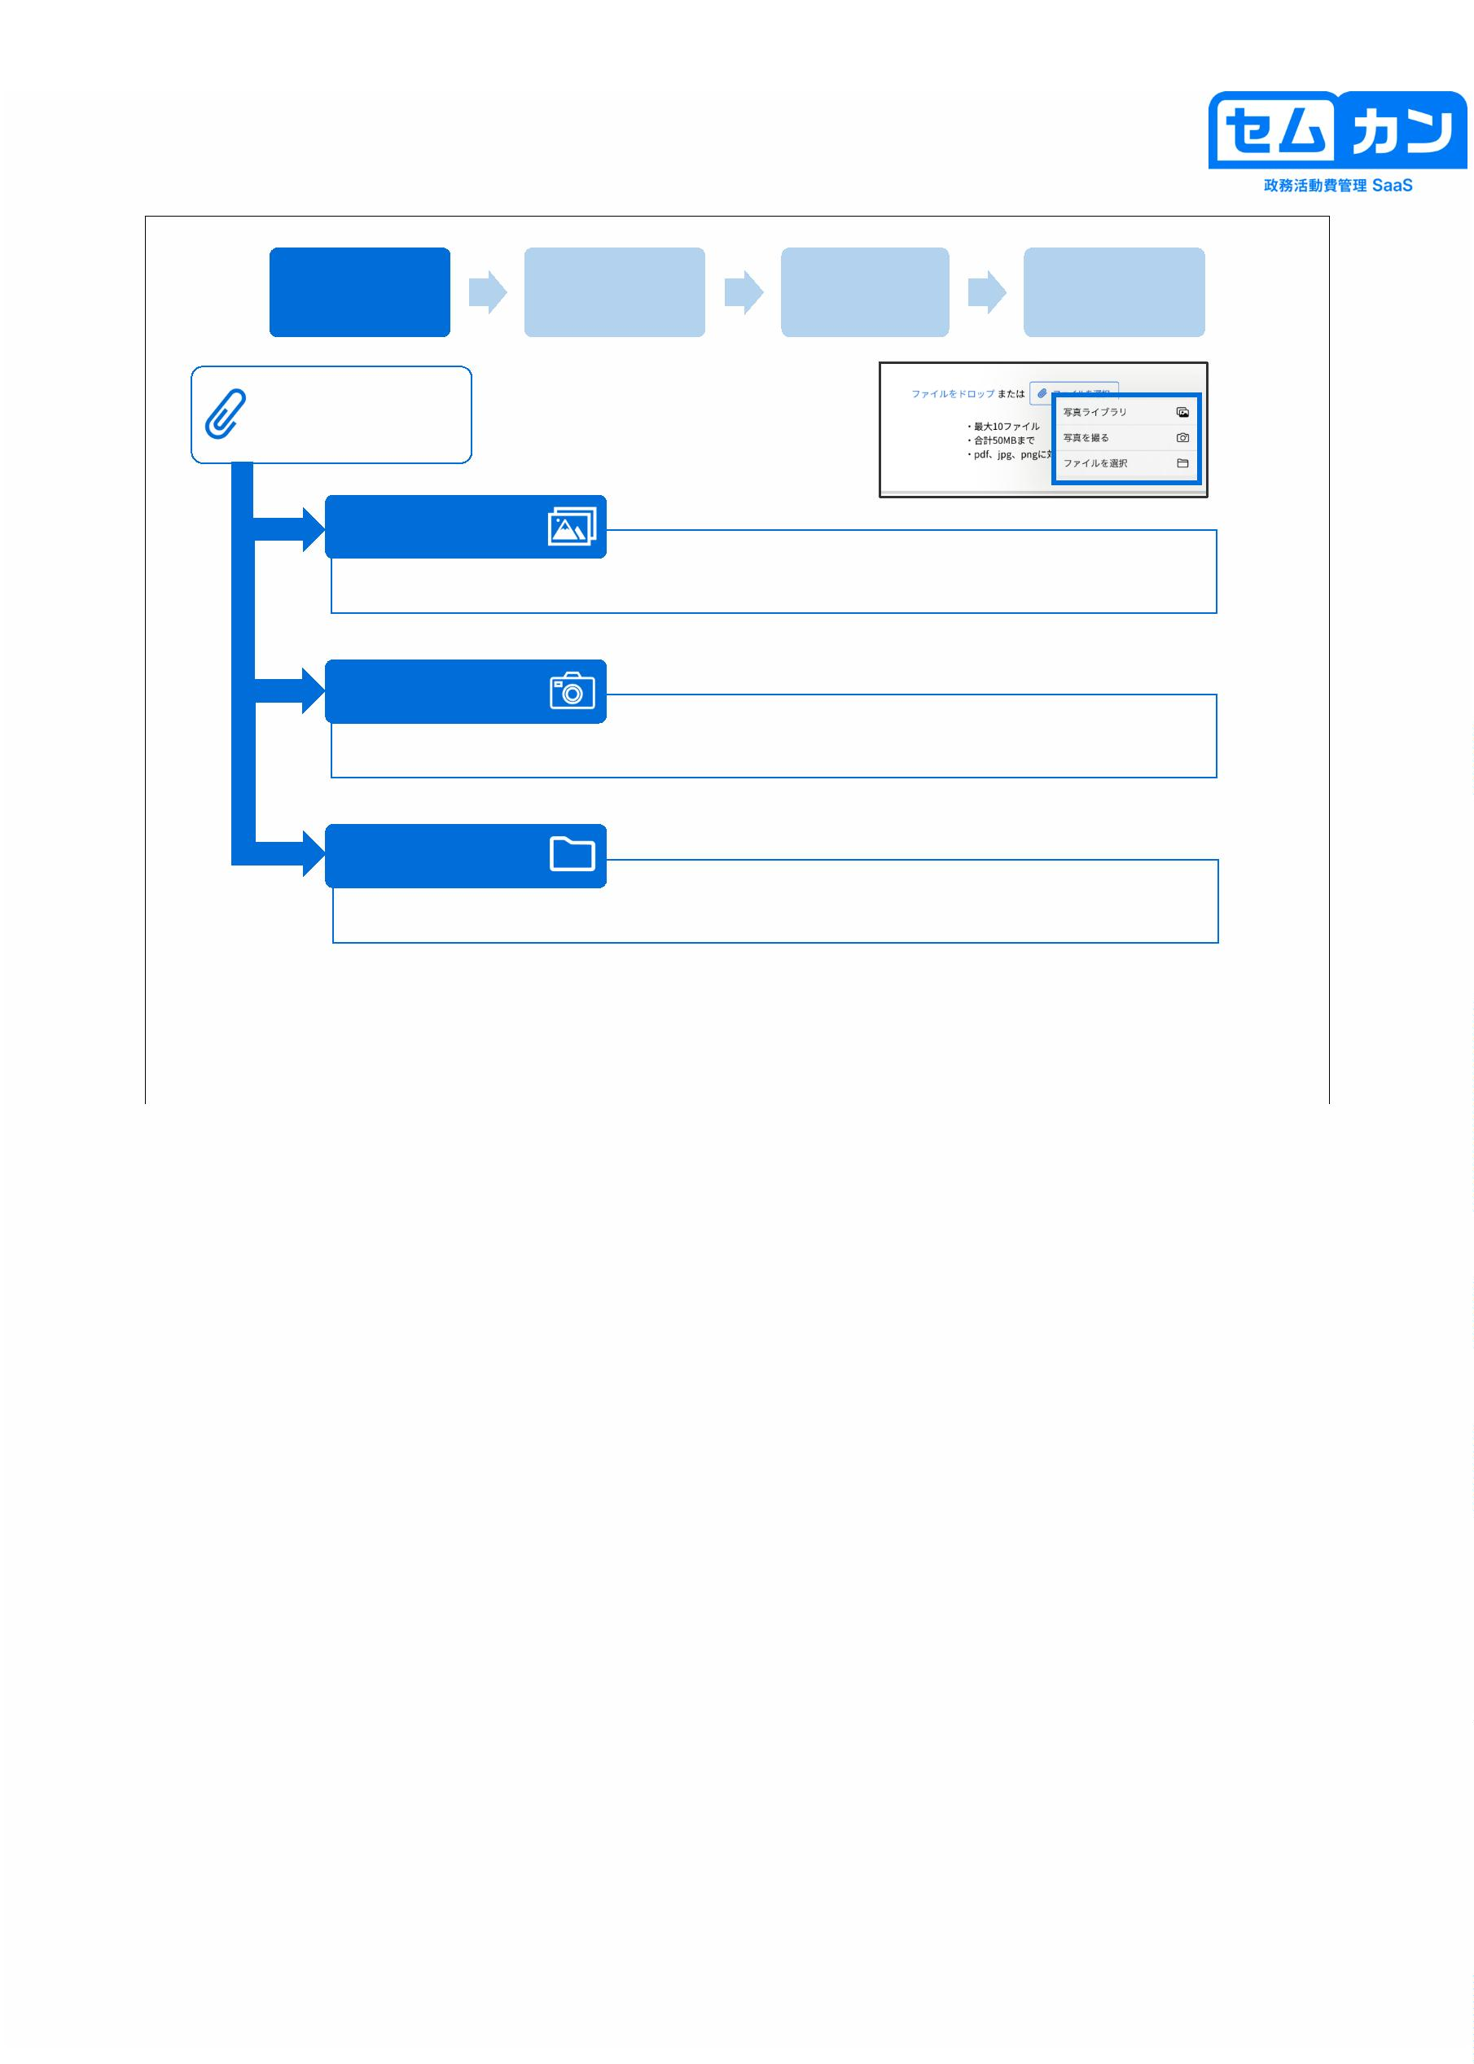

Add a receipt

Add basic information

Add a report

Add attachments

(Rotate)

①

②

③

34

(1) Click "Rotate"

(2) Adjust the slope of the receipt

When fine-tuning the left and right sides, the angle of "5 degrees" is greatly changed.

If so, click "90 degrees" to adjust

(3) When you are done making changes, click "Save"

34

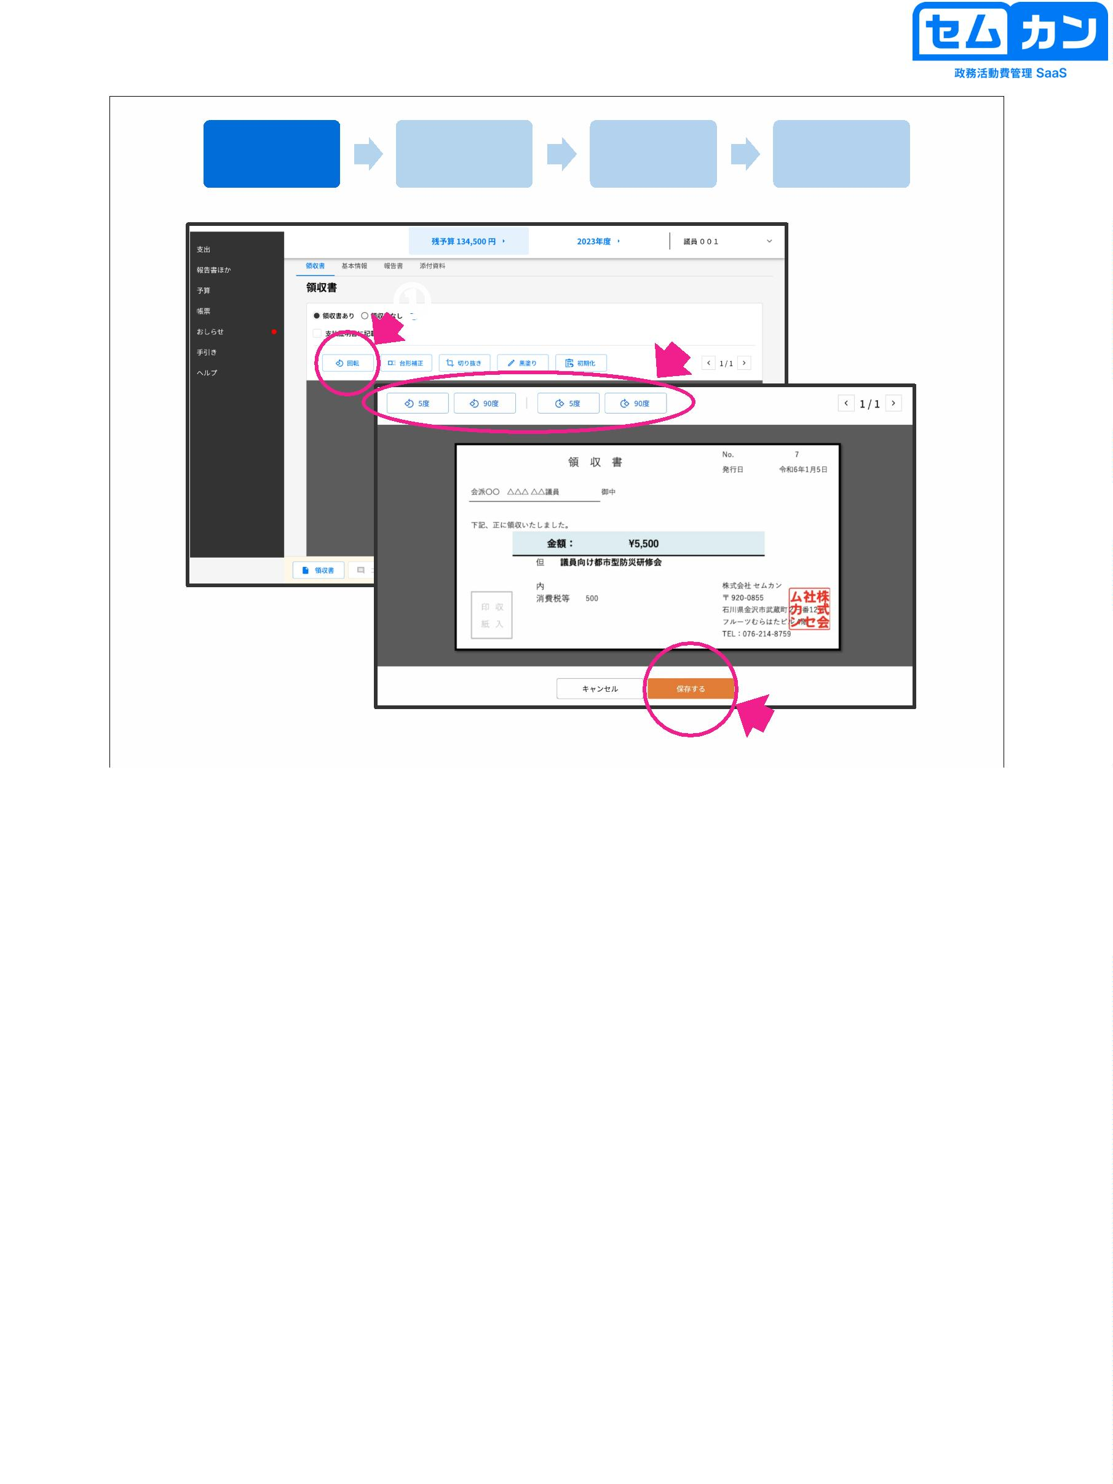

Add a receipt

Add basic information

Add a report

Add attachments

(Keystone correction)

①

②

③

35

(1) Click "Keystone Correction"

(2) Correction is possible with 8 "●" places in the image

(3) When you are done making changes, click "Save"

35

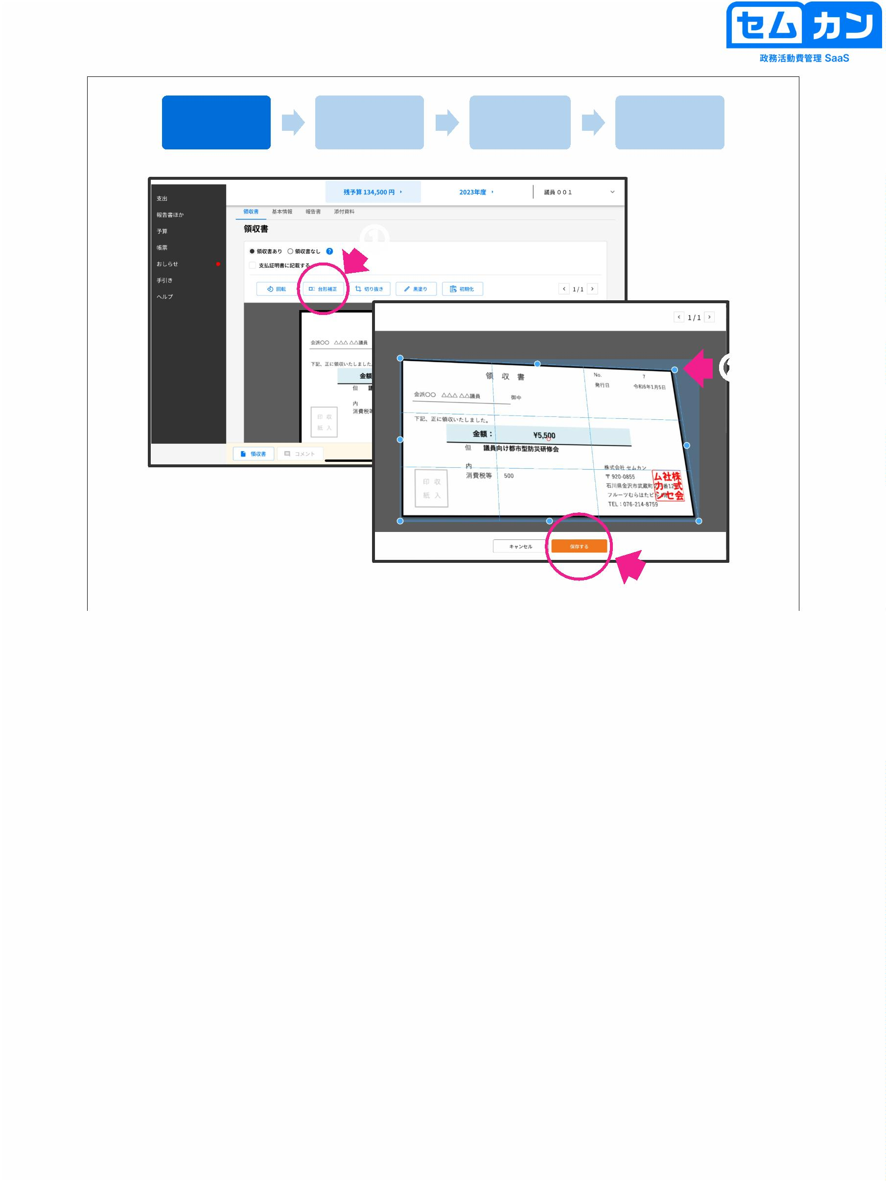

Add a receipt

Add basic information

Add a report

Add attachments

(Crop)

①

②

③

36

(1) Click "Crop"

(2) Correction is possible with "■" in 8 places on the image

(3) When you are done making changes, click "Save"

36

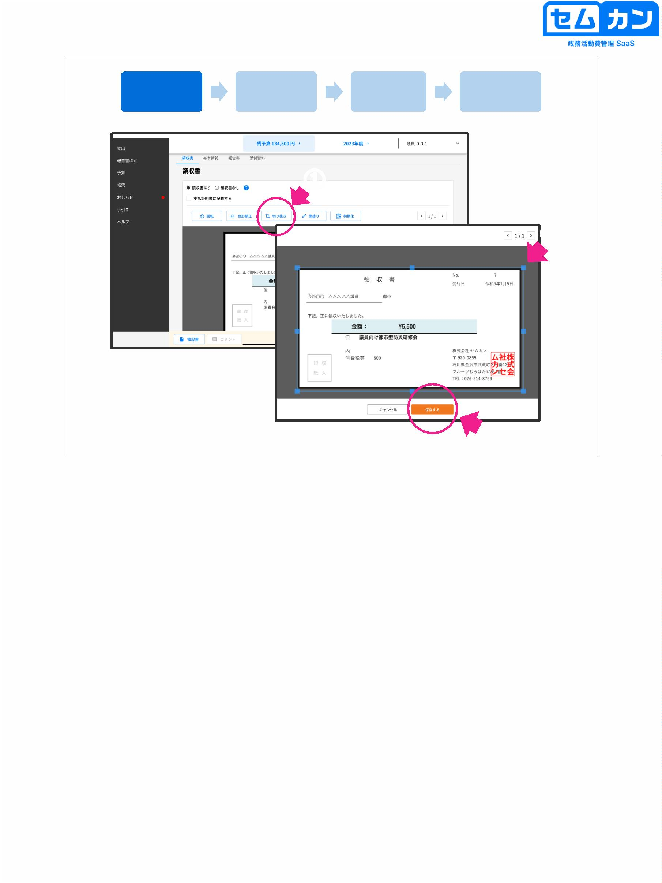

Add a receipt

Add basic information

Add a report

Add attachments

(blacked out)

①

From the top left, tap your finger or

Finger range with a pen

decide

②

When released, it is painted black

Is

③

(4)

37

(1) Once you have selected the receipt, click "Paint Black"

② 「●」「◼」Select the shape to fill with

(3) Select the area you want to paint black.

(4) When you are done with the changes, click the Save button

37

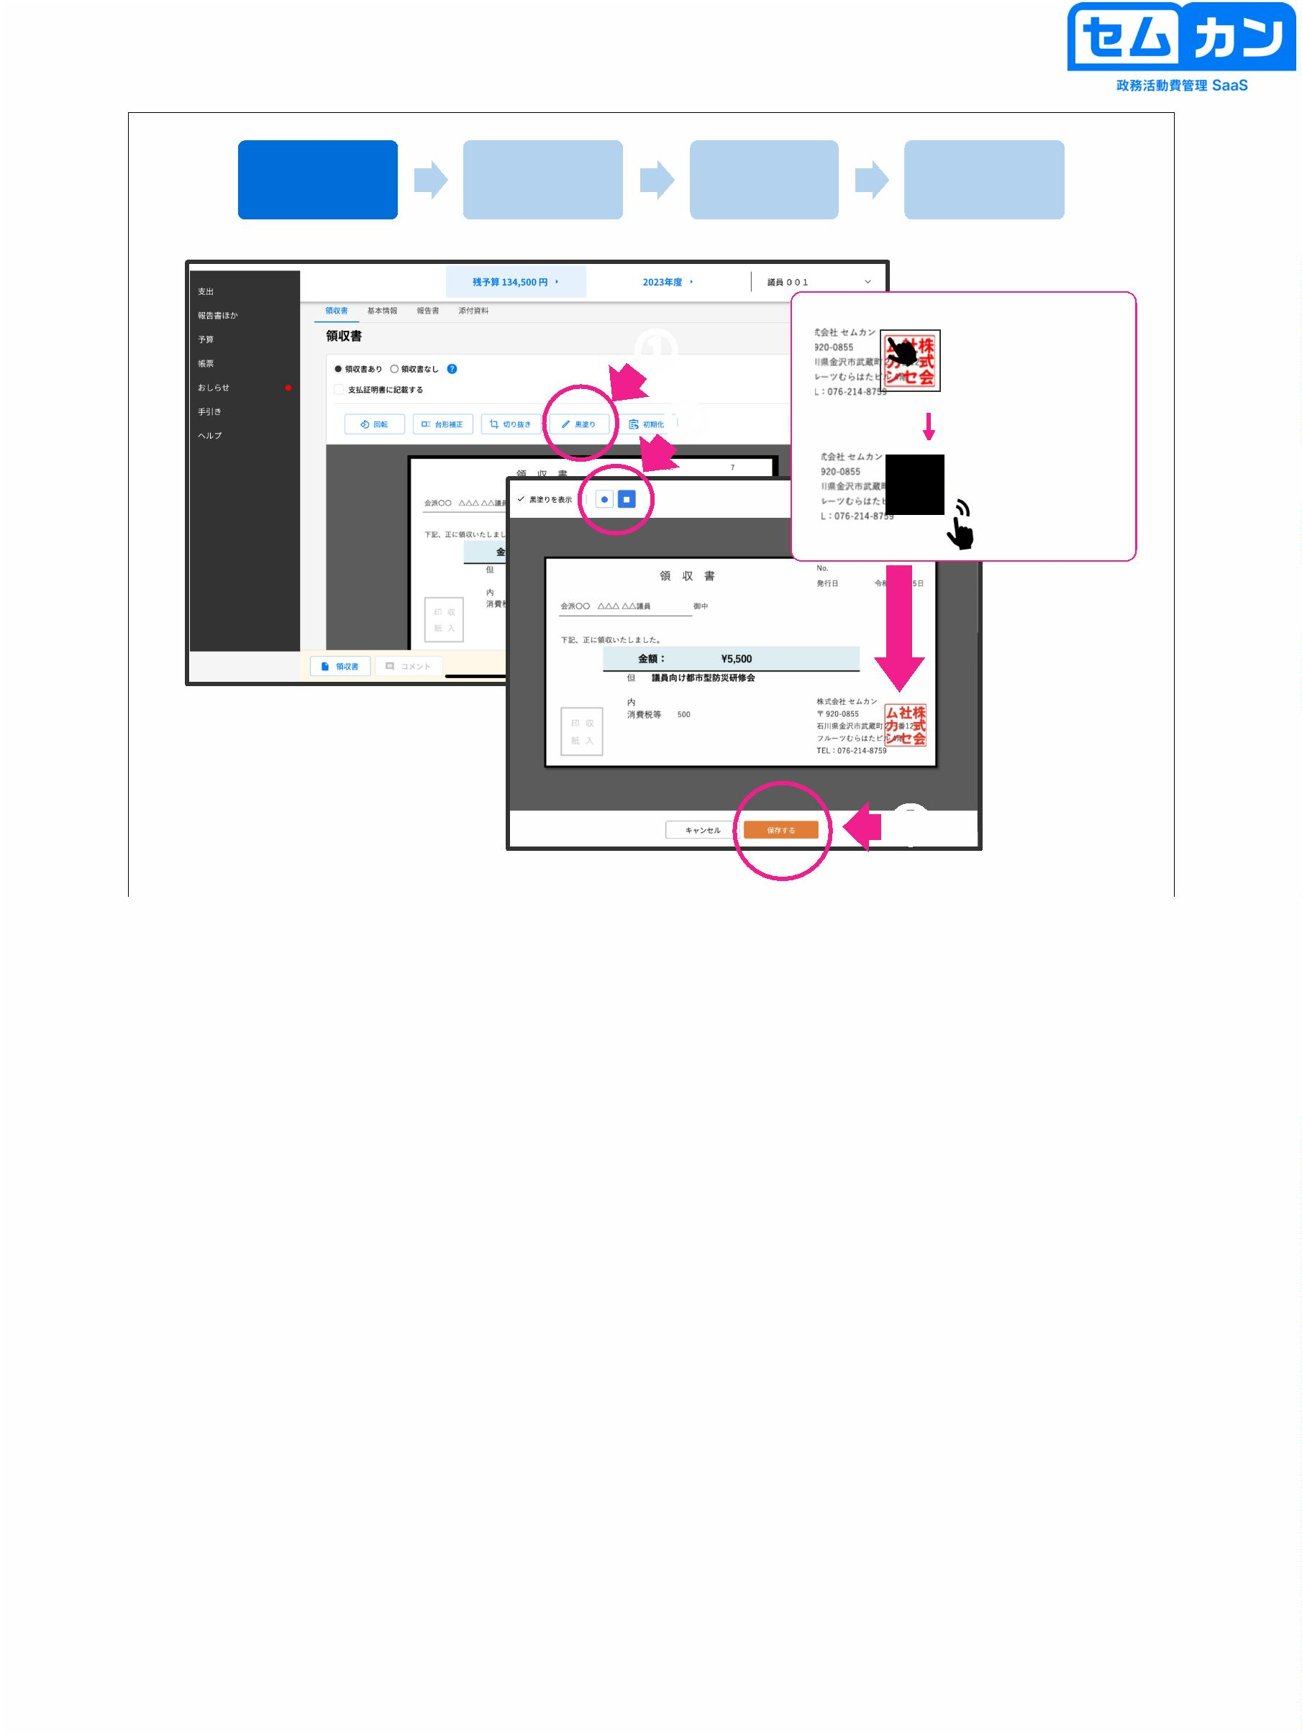

Add a receipt

Add basic information

Add a report

Add attachments

(Initialization)

①

②

38

(1) Click "Initialize"

(2) Click "Execute" to start the work you have been editing for the first time.

It will be periodized

38

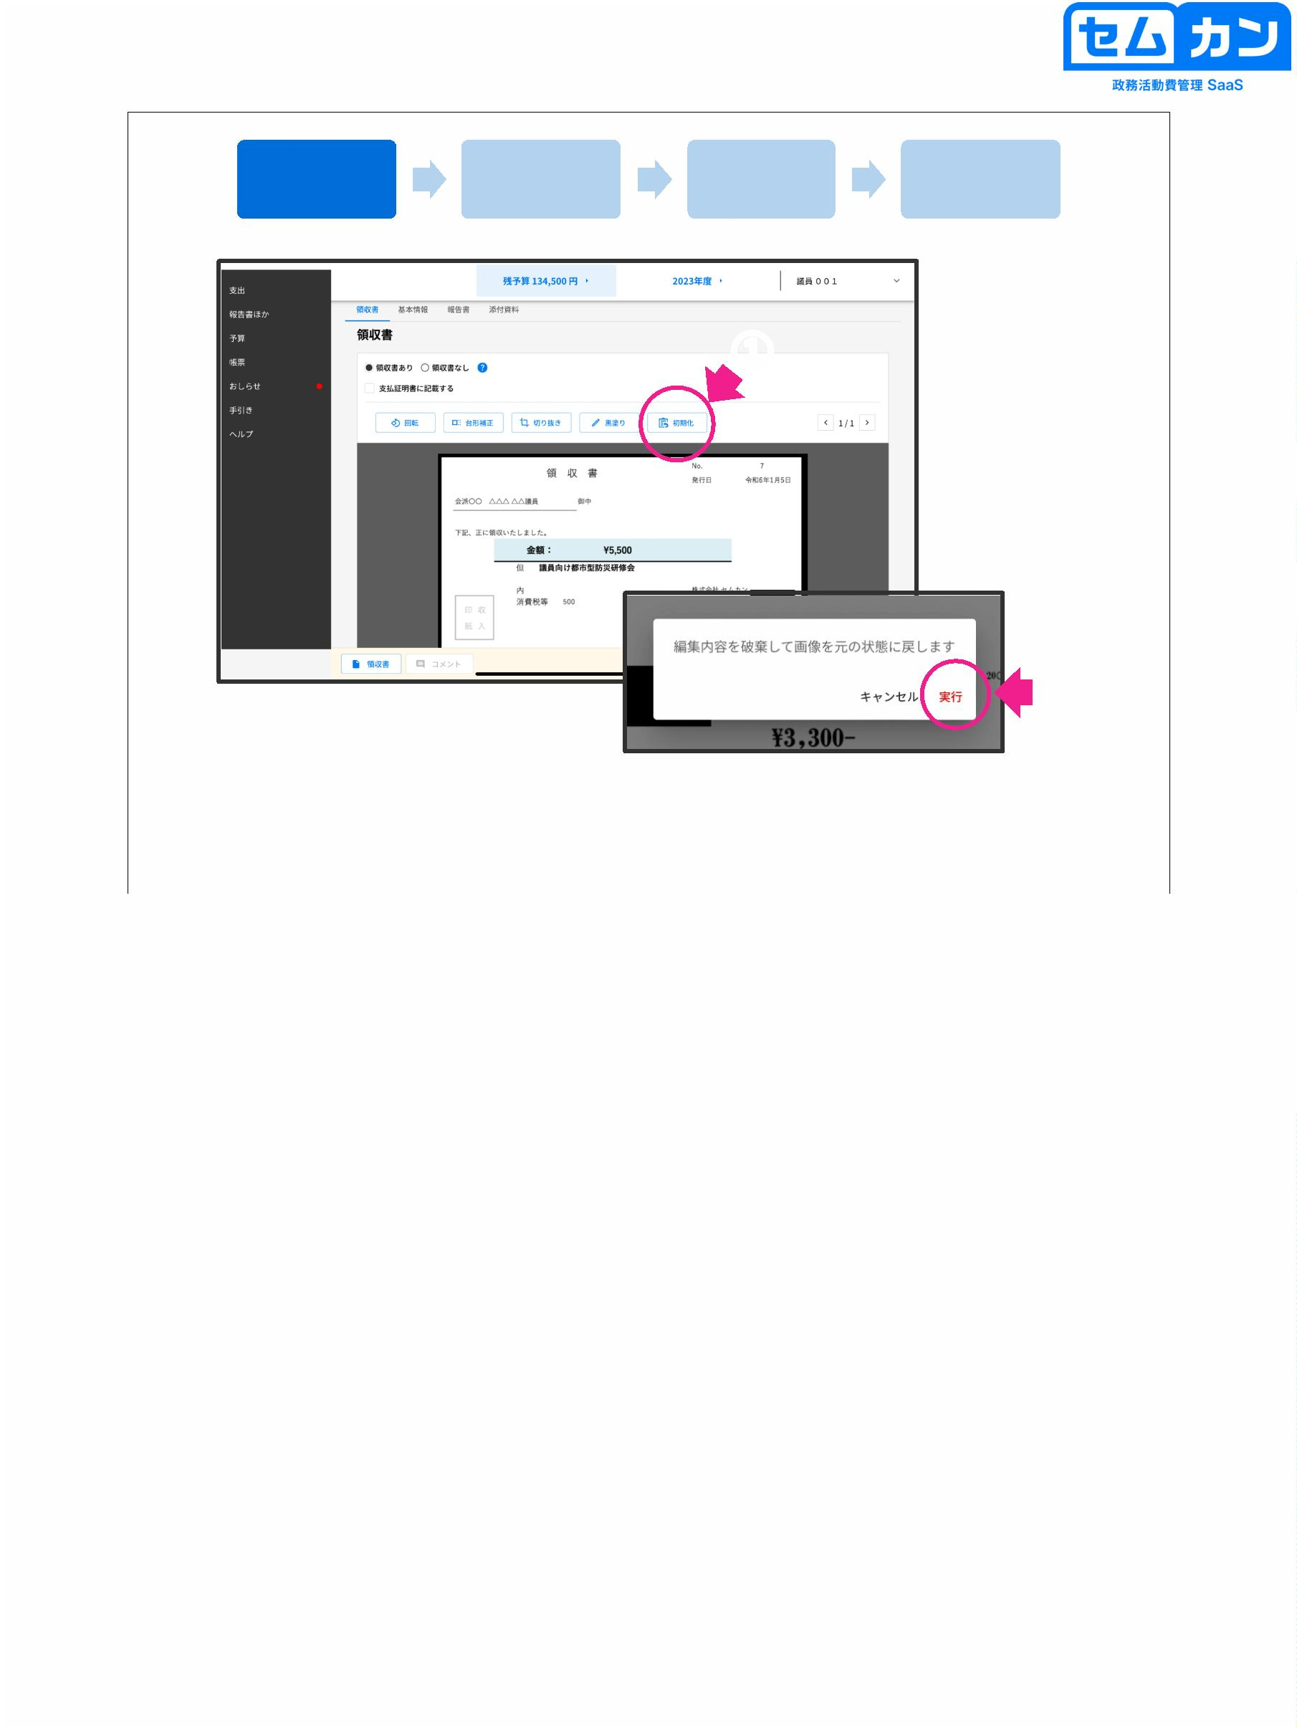

Add a receipt

Add basic information

Add a report

Add attachments

39

•

•

Click on "Basic Information"

All items except those listed as "optional" are mandatory

\* Date: Click "Calendar Mark" to open the calendar

is displayed

\* When using the Semkan camera, the read data has already been entered.

(Date, Amount, Payment, Description)

39

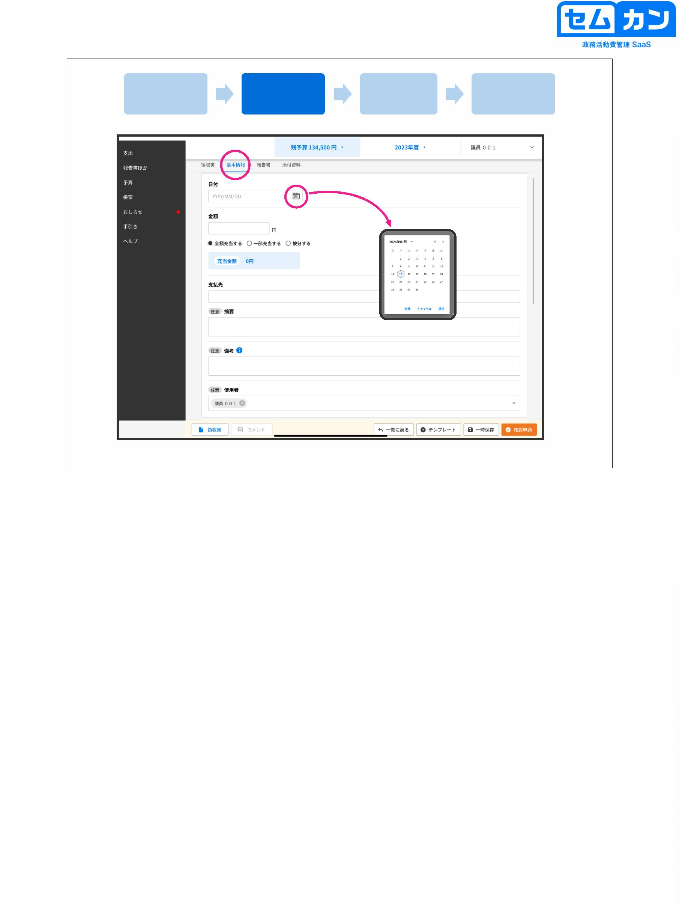

Add a receipt

Add basic information

Add a report

Add attachments

You can enter basic information while checking the receipt

②

①

40

• Basic information can be entered while checking the receipt

(1) Click the "Receipt" button at the bottom left of the screen to confirm the receipt.

It can be admitted

(2) If you want to close the receipt, click the "∨" button.

40

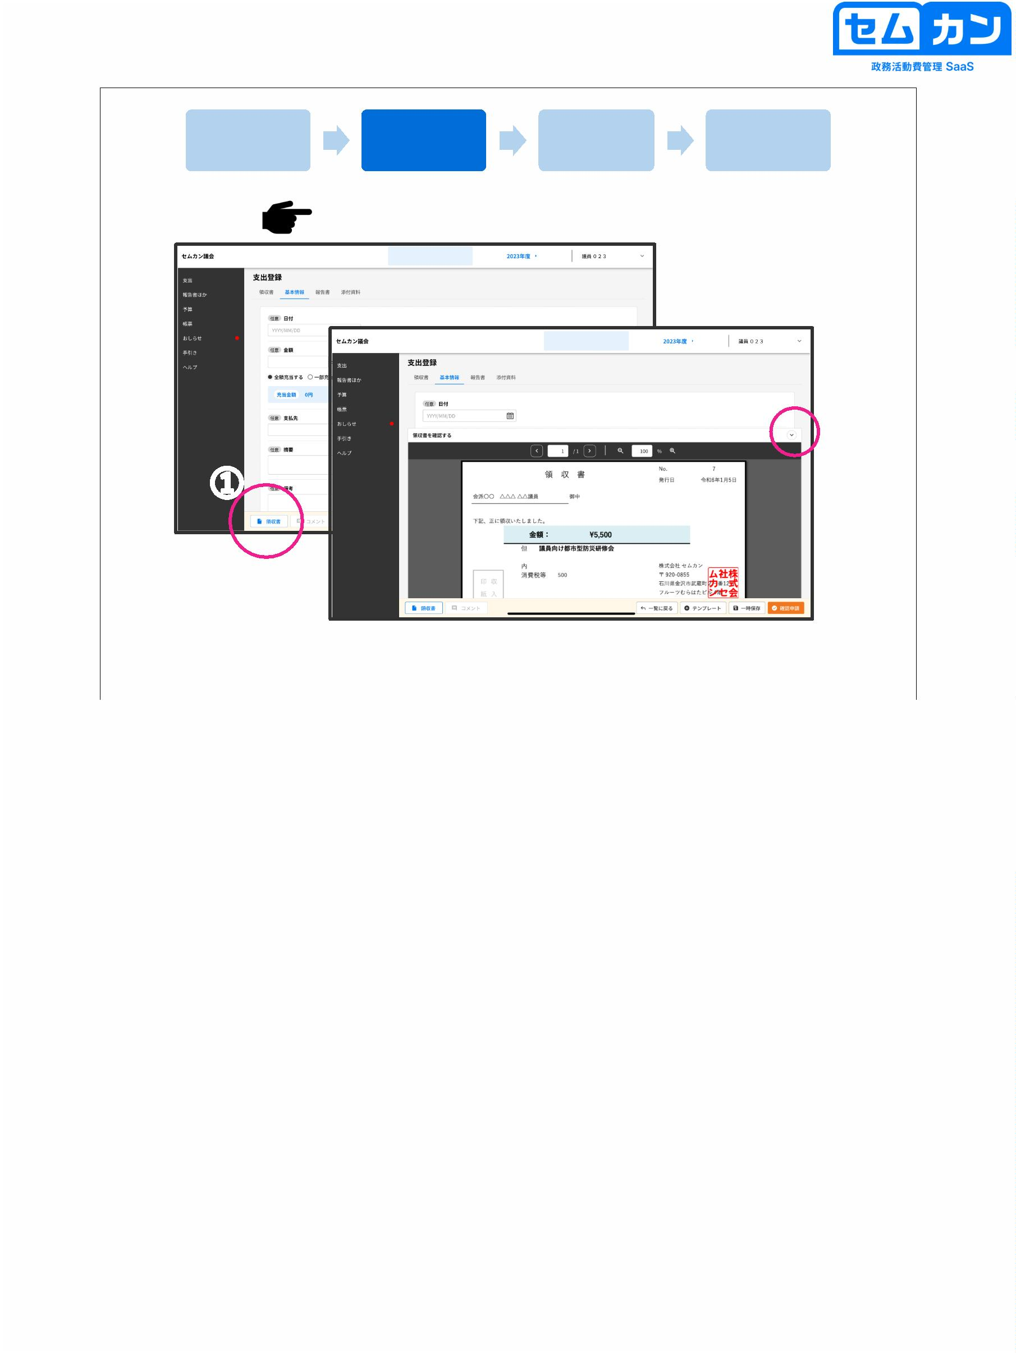

Add a receipt

Add basic information

Add a report

Add attachments

Add a receipt

Add basic information

Add a report

Add attachments

If you want to manually apportion the amount

41

• If you want to apportion the shares, select "Divide on-rata" and add the pro-rata percentage

• The amount of the allowance will be changed automatically

41

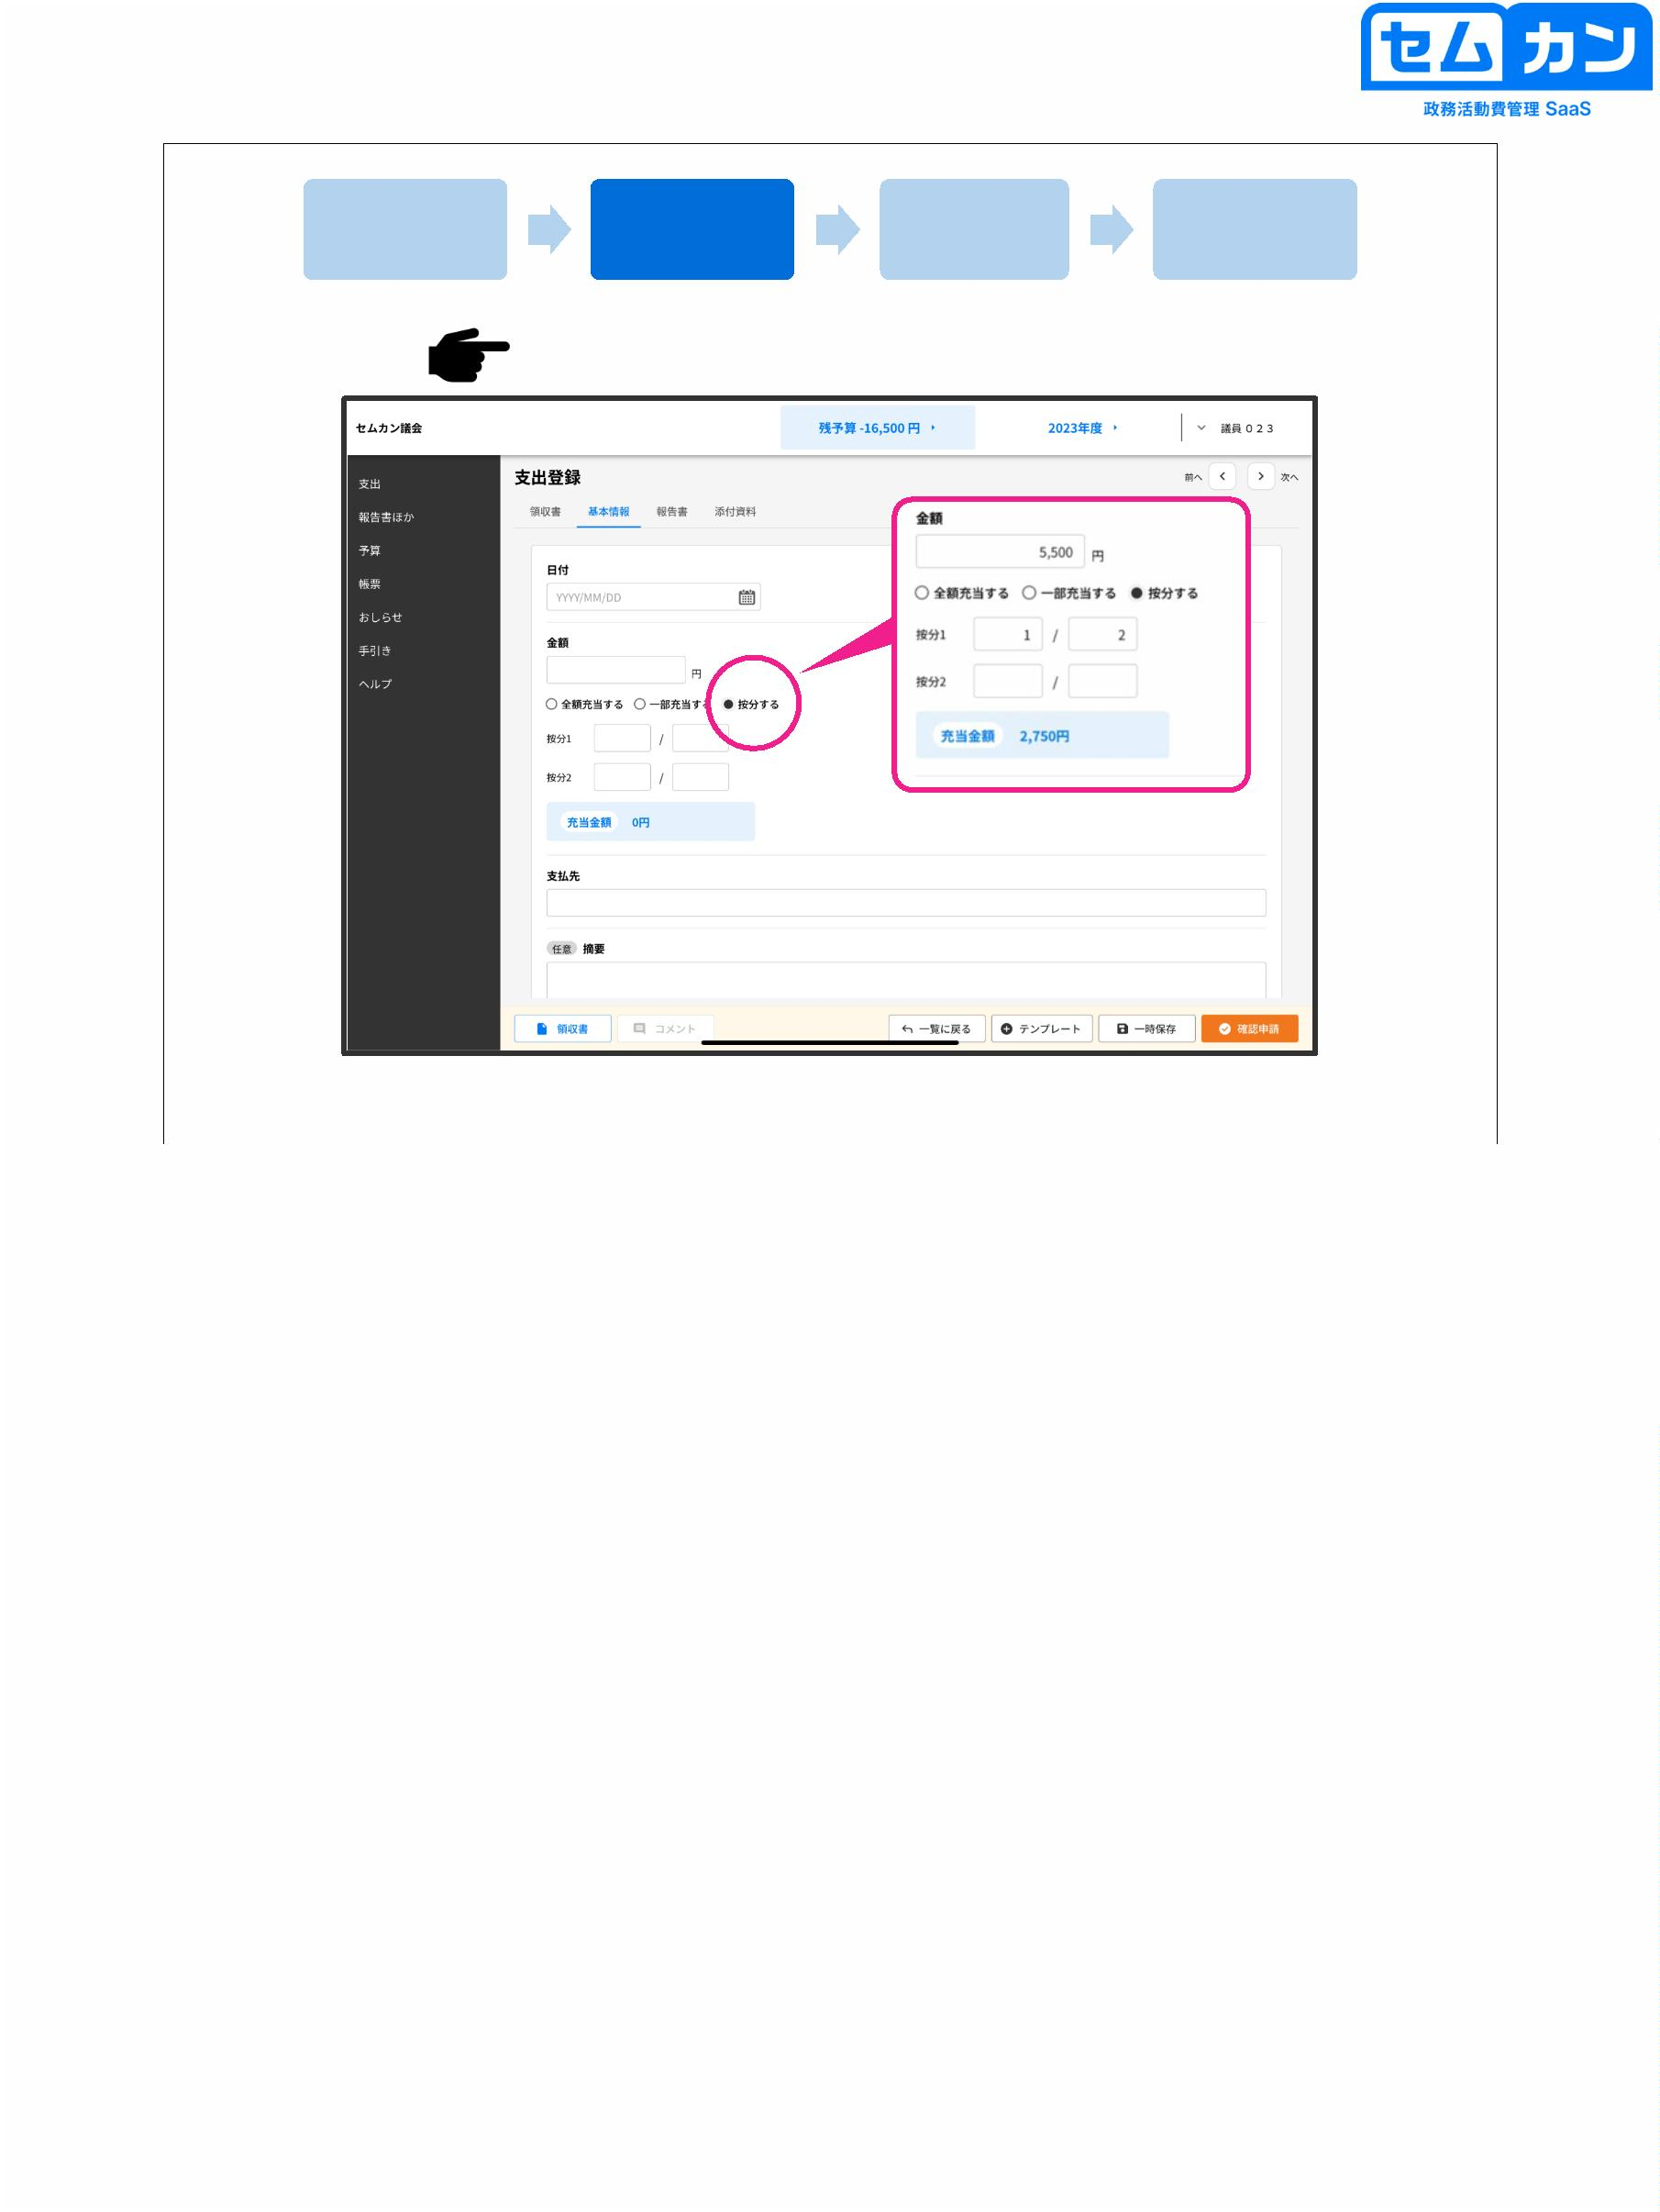

Add a receipt

Add basic information

Add a report

Add attachments

If the proration rate is registered in the template

In manuals and guides

Together for each item

If you set the apportionment, etc.

Can be entered automatically

42

• In advance, according to the manual and guide, each item and detail will be divided according to the manual and guide.

If you set the amount, you can automatically calculate the apportionment rate if you enter the amount.

There is also a function

42

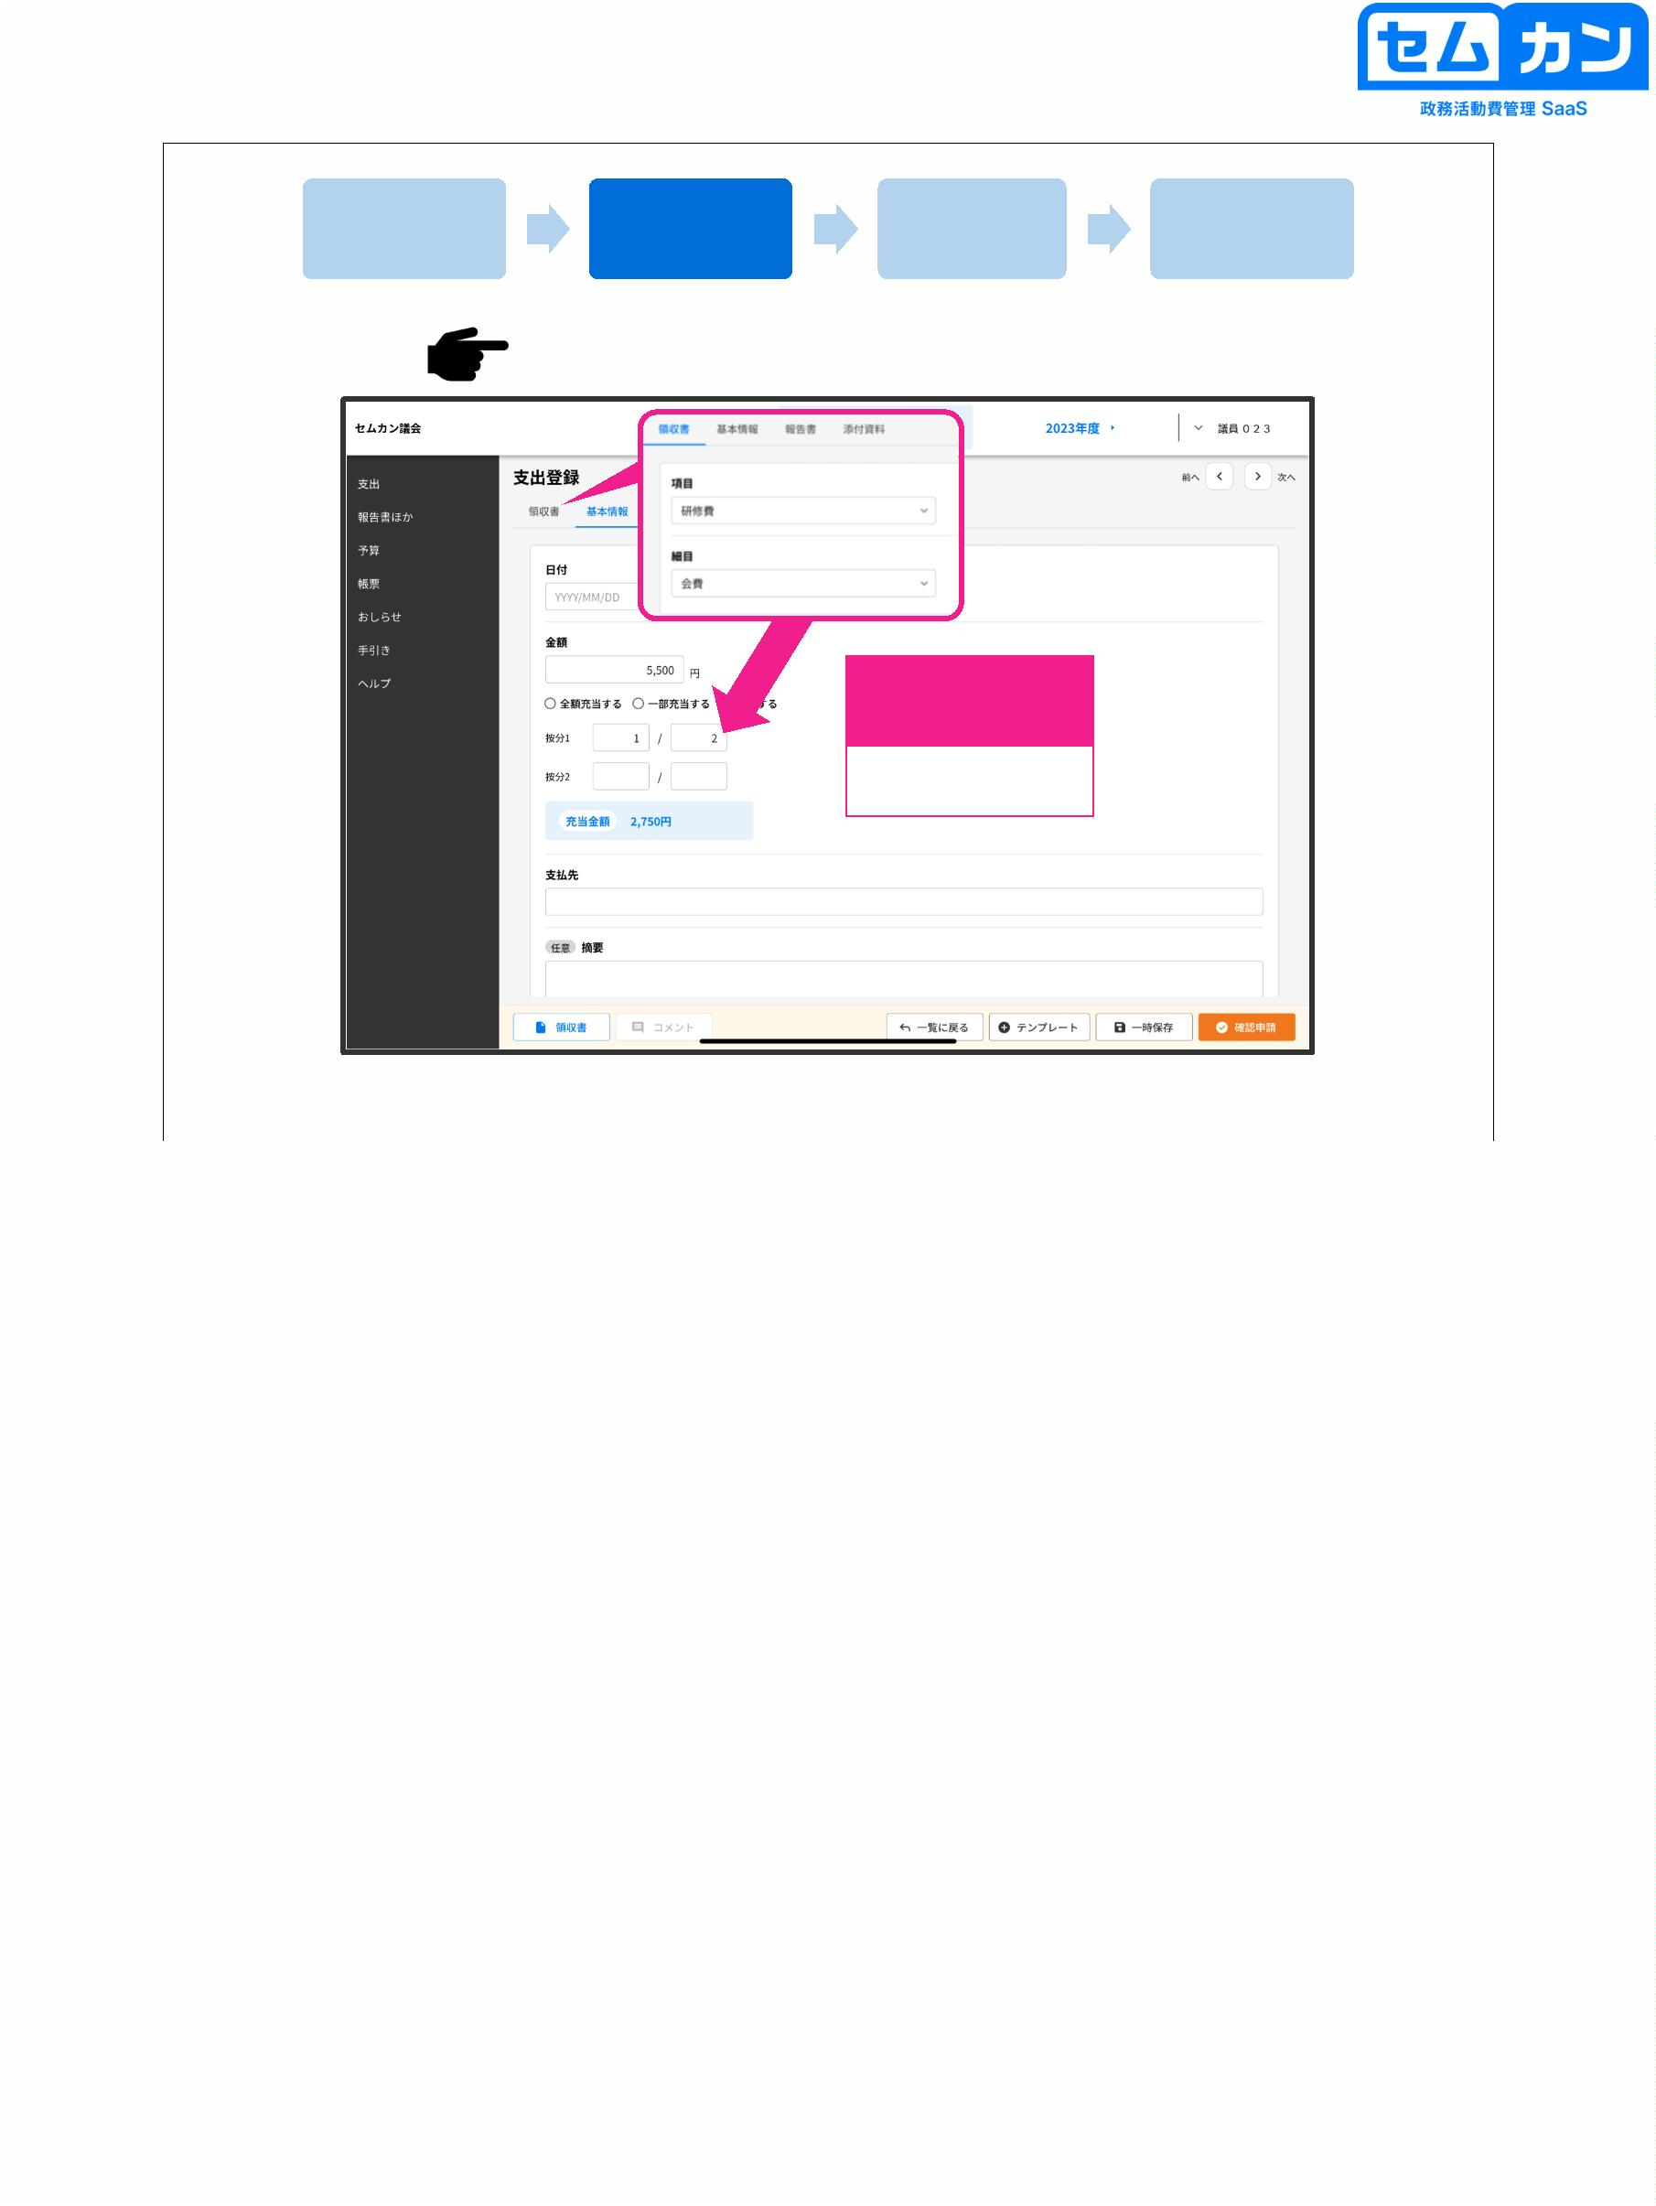

Add a receipt

Add basic information

Add a report

Add attachments

①

Name of Parliament

Personal name

Name of congregation or member

②

③

〇〇

〇〇

〇〇

〇〇

〇〇

43

(1) Click "Report"

(2) Click "Add Report" to attach a report

(3) Select the required report, if any, and register it

43

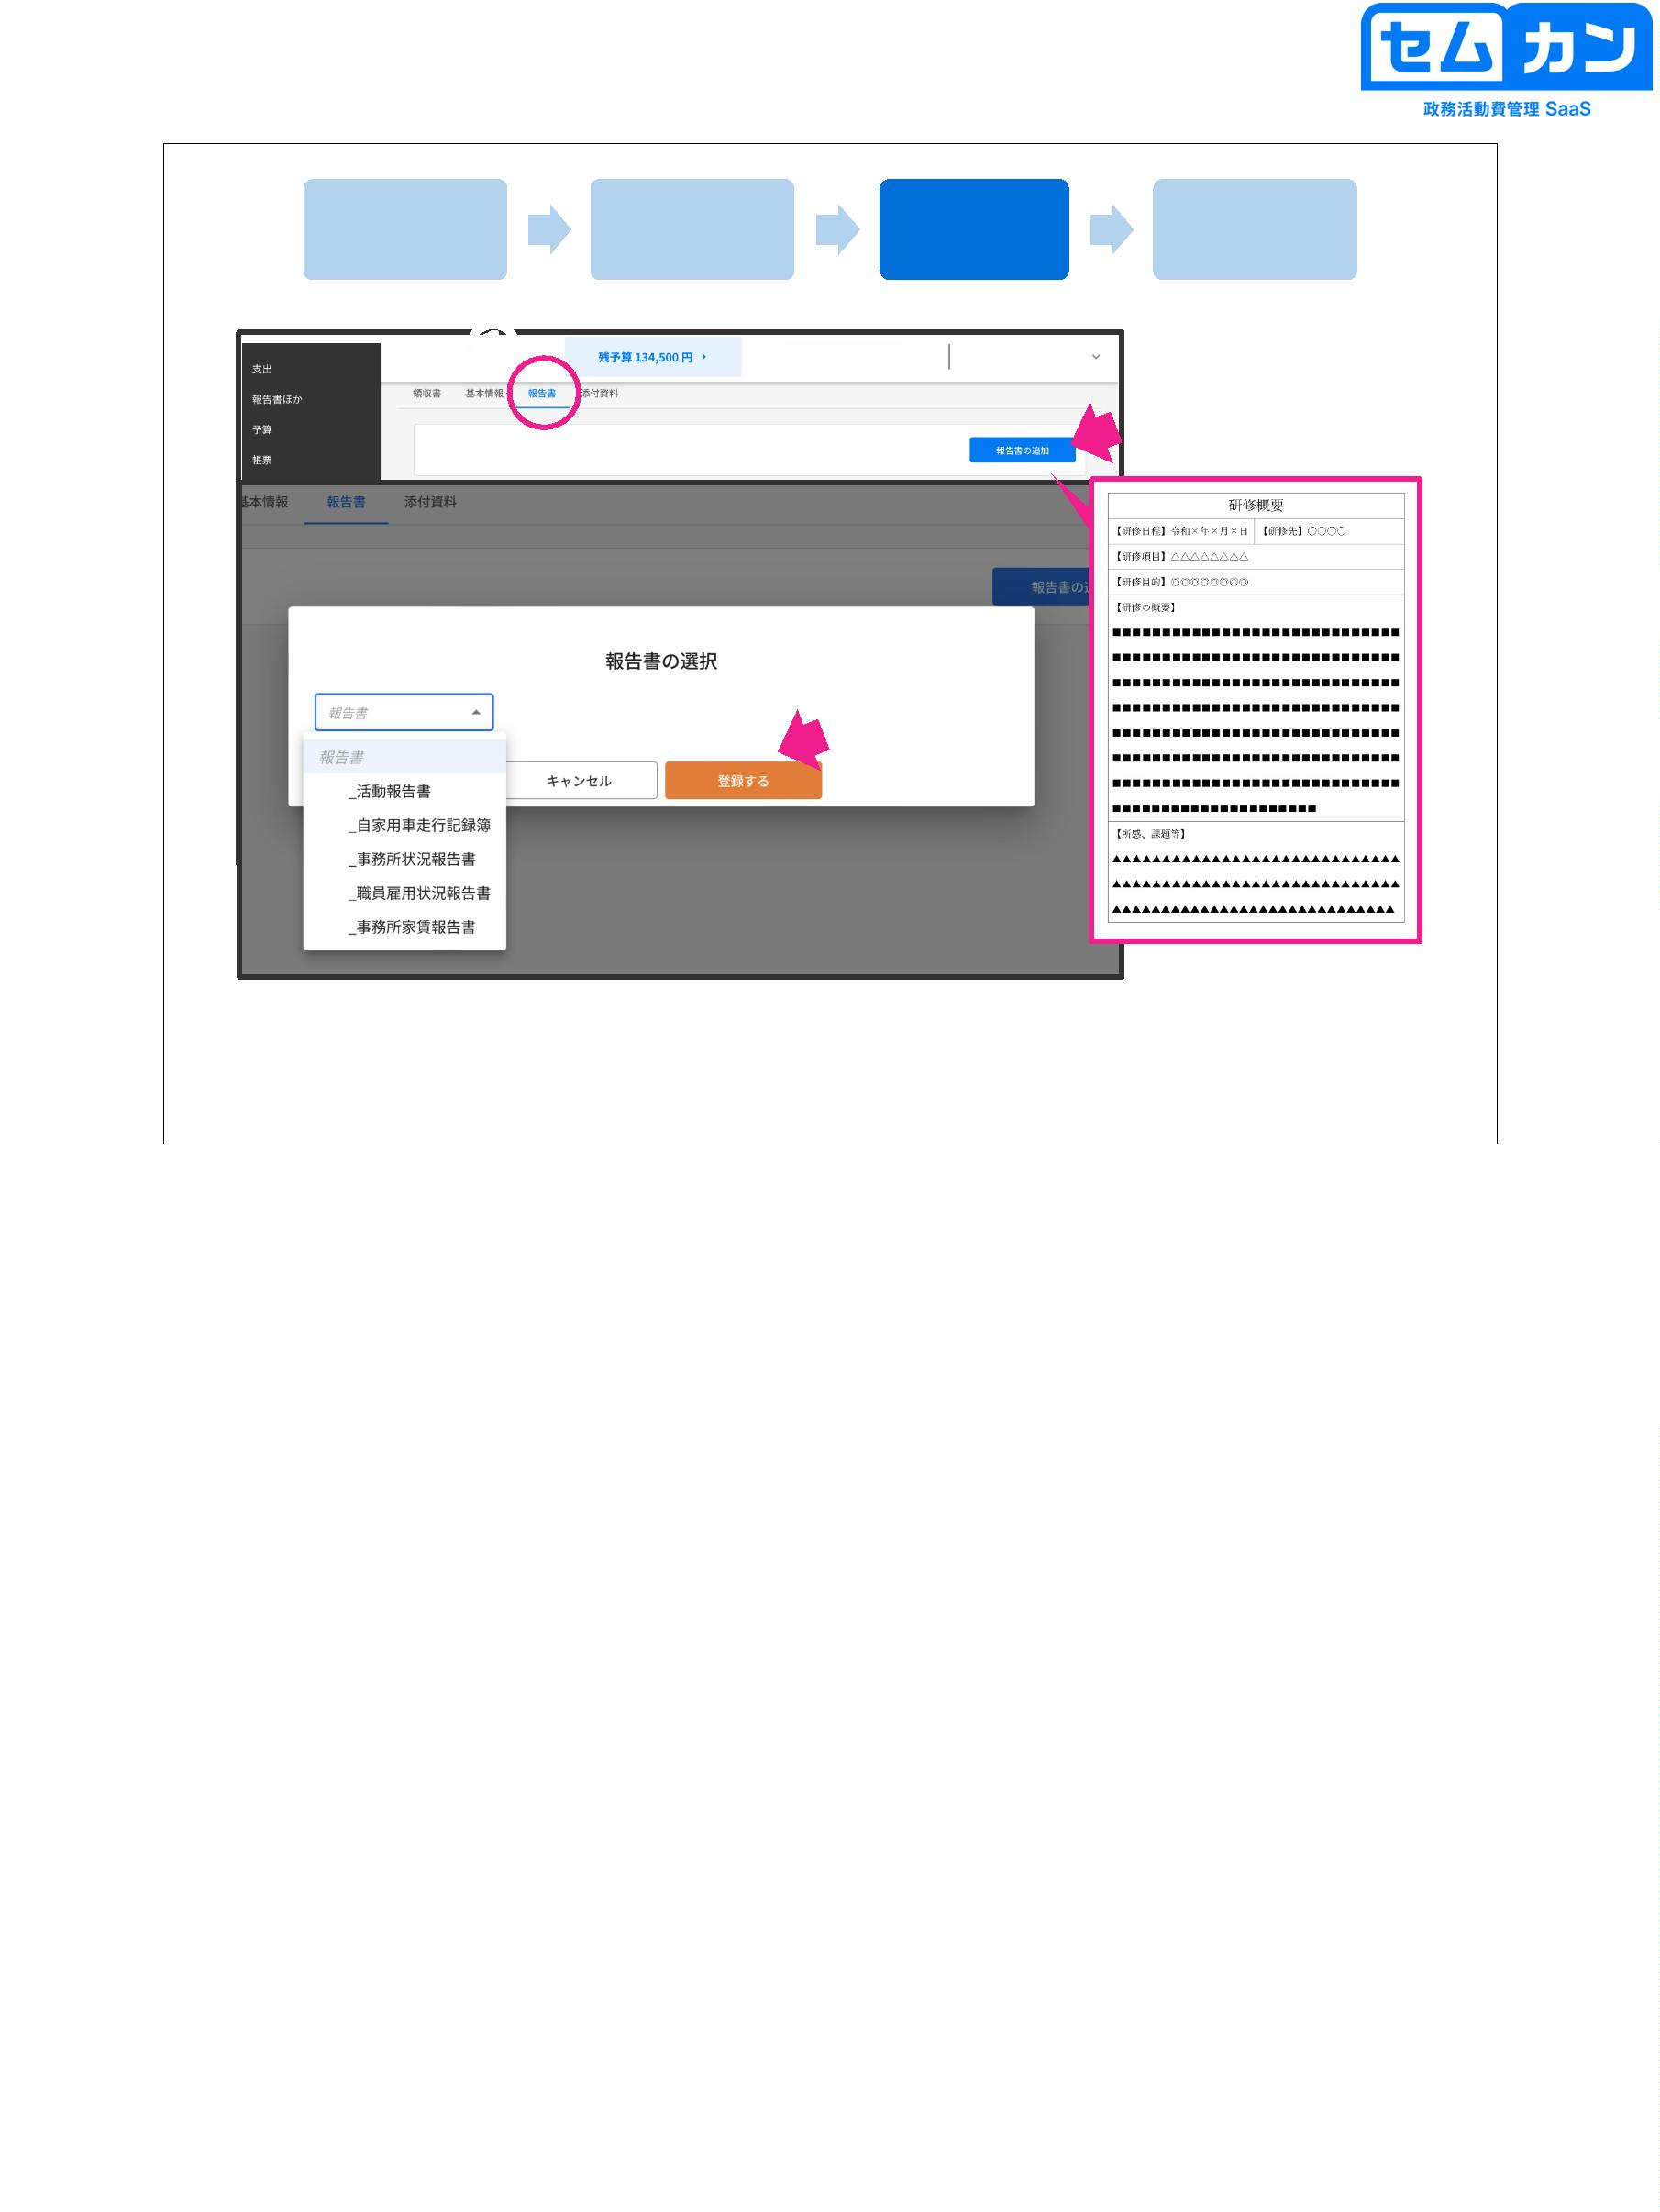

Add a receipt

Add basic information

Add a report

Add attachments

①

②

44

(1) Click "Attachments"

(2) If you have materials, upload the data from here.

\* PDF, JPEG, and PNG data can be registered.

"Drop File" and "Select File"

Choose an image

(10 attachments can be attached, and the total capacity is up to 50 MB)

44

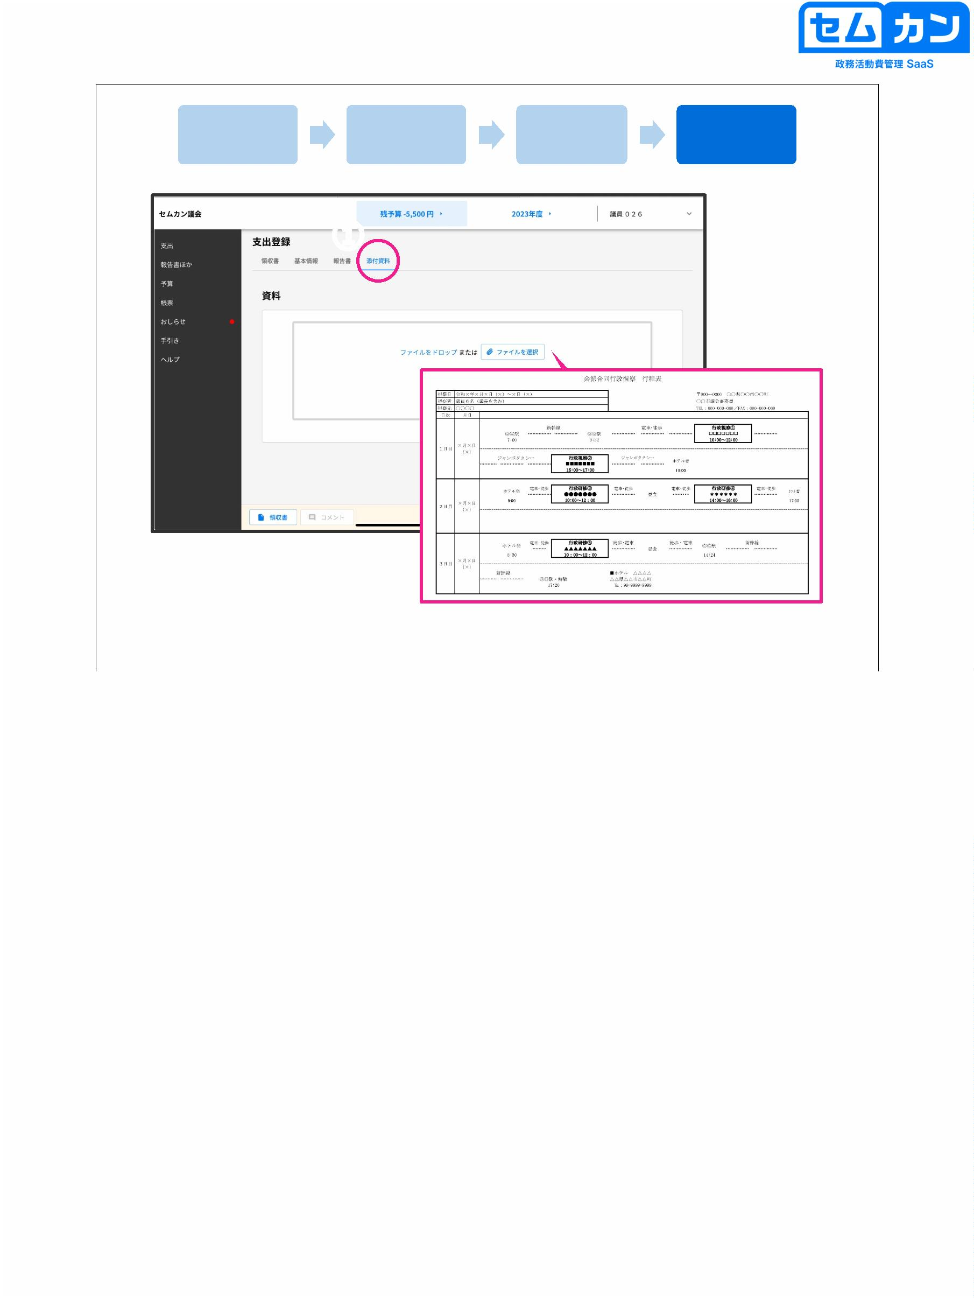

6-2. Use of Template

45



How to register for spending using a template

Procedure for creating a new one (1)

①

②

46

■ How to register using a template (create a new template)

Success)

(1) Click "Add Expenses"

(2) Click "New"

46

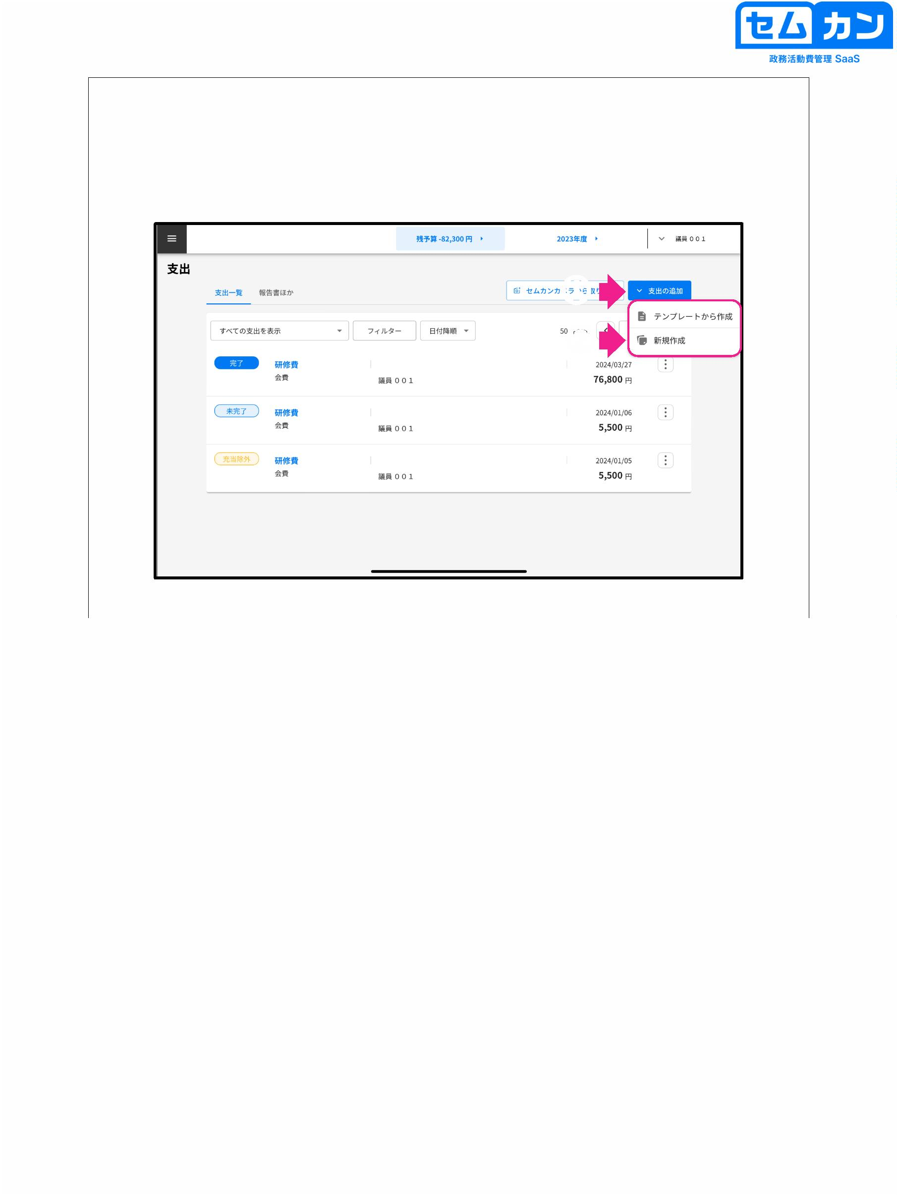

How to register for spending using a template

Procedure for creating a new one (2)

③

(4)

e.g. Newspaper fee

⑤

③

Tabs "Receipts", "Basic Information" Register with the template

Fill in the content

(4) Click "+ Template"

(5) When the template name registration screen is displayed, enter the name.

and click Register

47

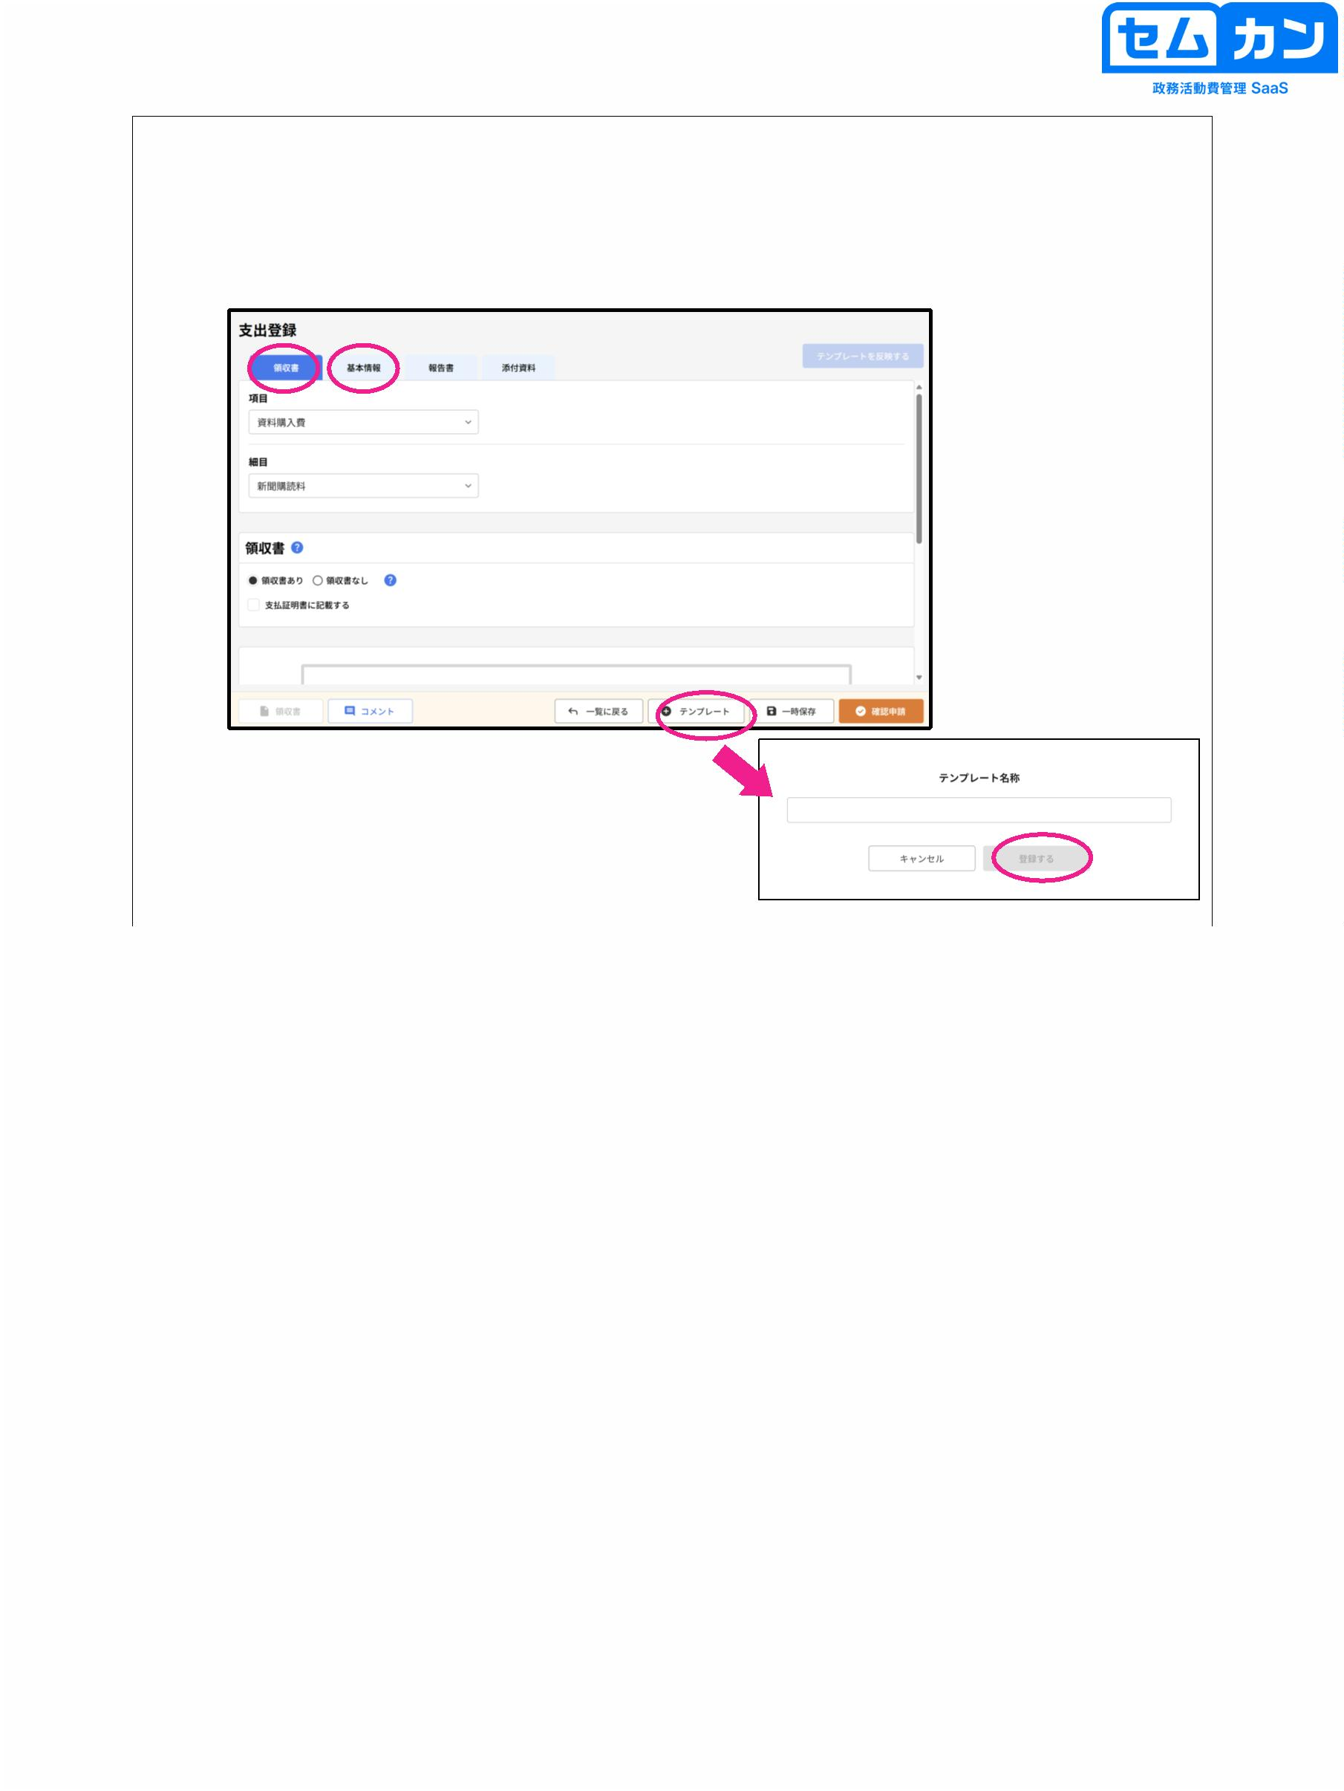

How to register for spending using a template

When creating from a template origin

①

②

③

(4)

48

■ How to register using a template (part 1)

(1) Click "Add Expenses"

(2) Click "Create from template"

(3) When the template selection screen is displayed, click "^",

Select the template you want to use from the list

(4) When you click Confirm, you will be redirected to the expenditure registration screen, and you will be prompted to enter the registration screen.

The contents of the network are reflected

48

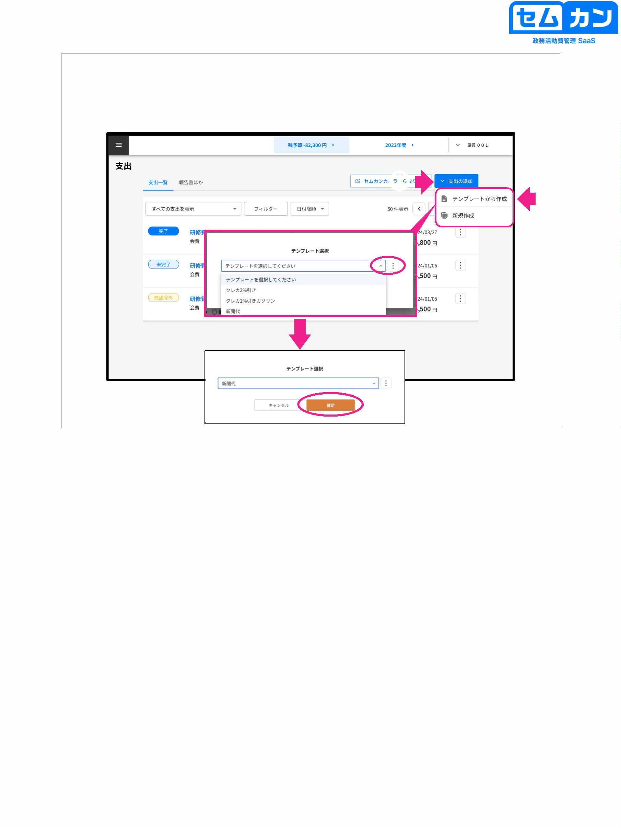

How to register for spending using a template

When reflecting the template in the registration of the starting point of the Semkan camera

①

②

(4)

③

③

Click Reflect Template

(4)

When the template selection screen is displayed, click "^",

Select the template you want to use from the list

⑤

When you click Confirm, a confirmation screen will appear

(6) Click "Overwrite" to display the template contents on the registration screen.

It will be reflected

49

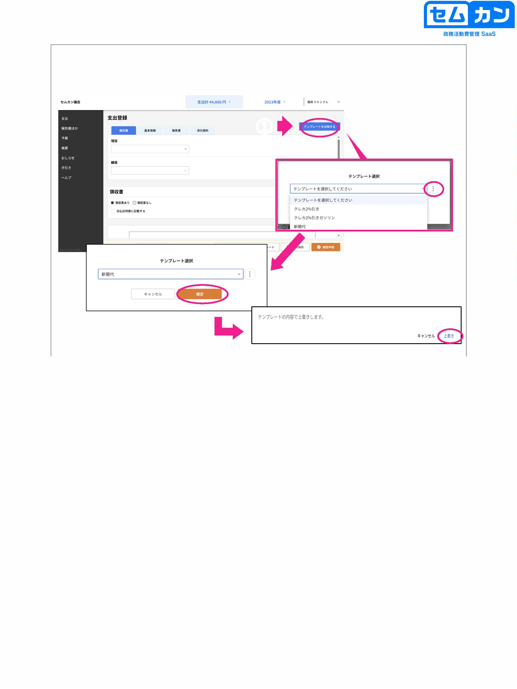

6-3. Use of Semkan Camera

50



How to register using Semkan Camera

For details on how to use the Semkan camera itself, see p.50-53

51

■ How to register using Semkan Camera

•

Click "Import from Semkan Camera"

51

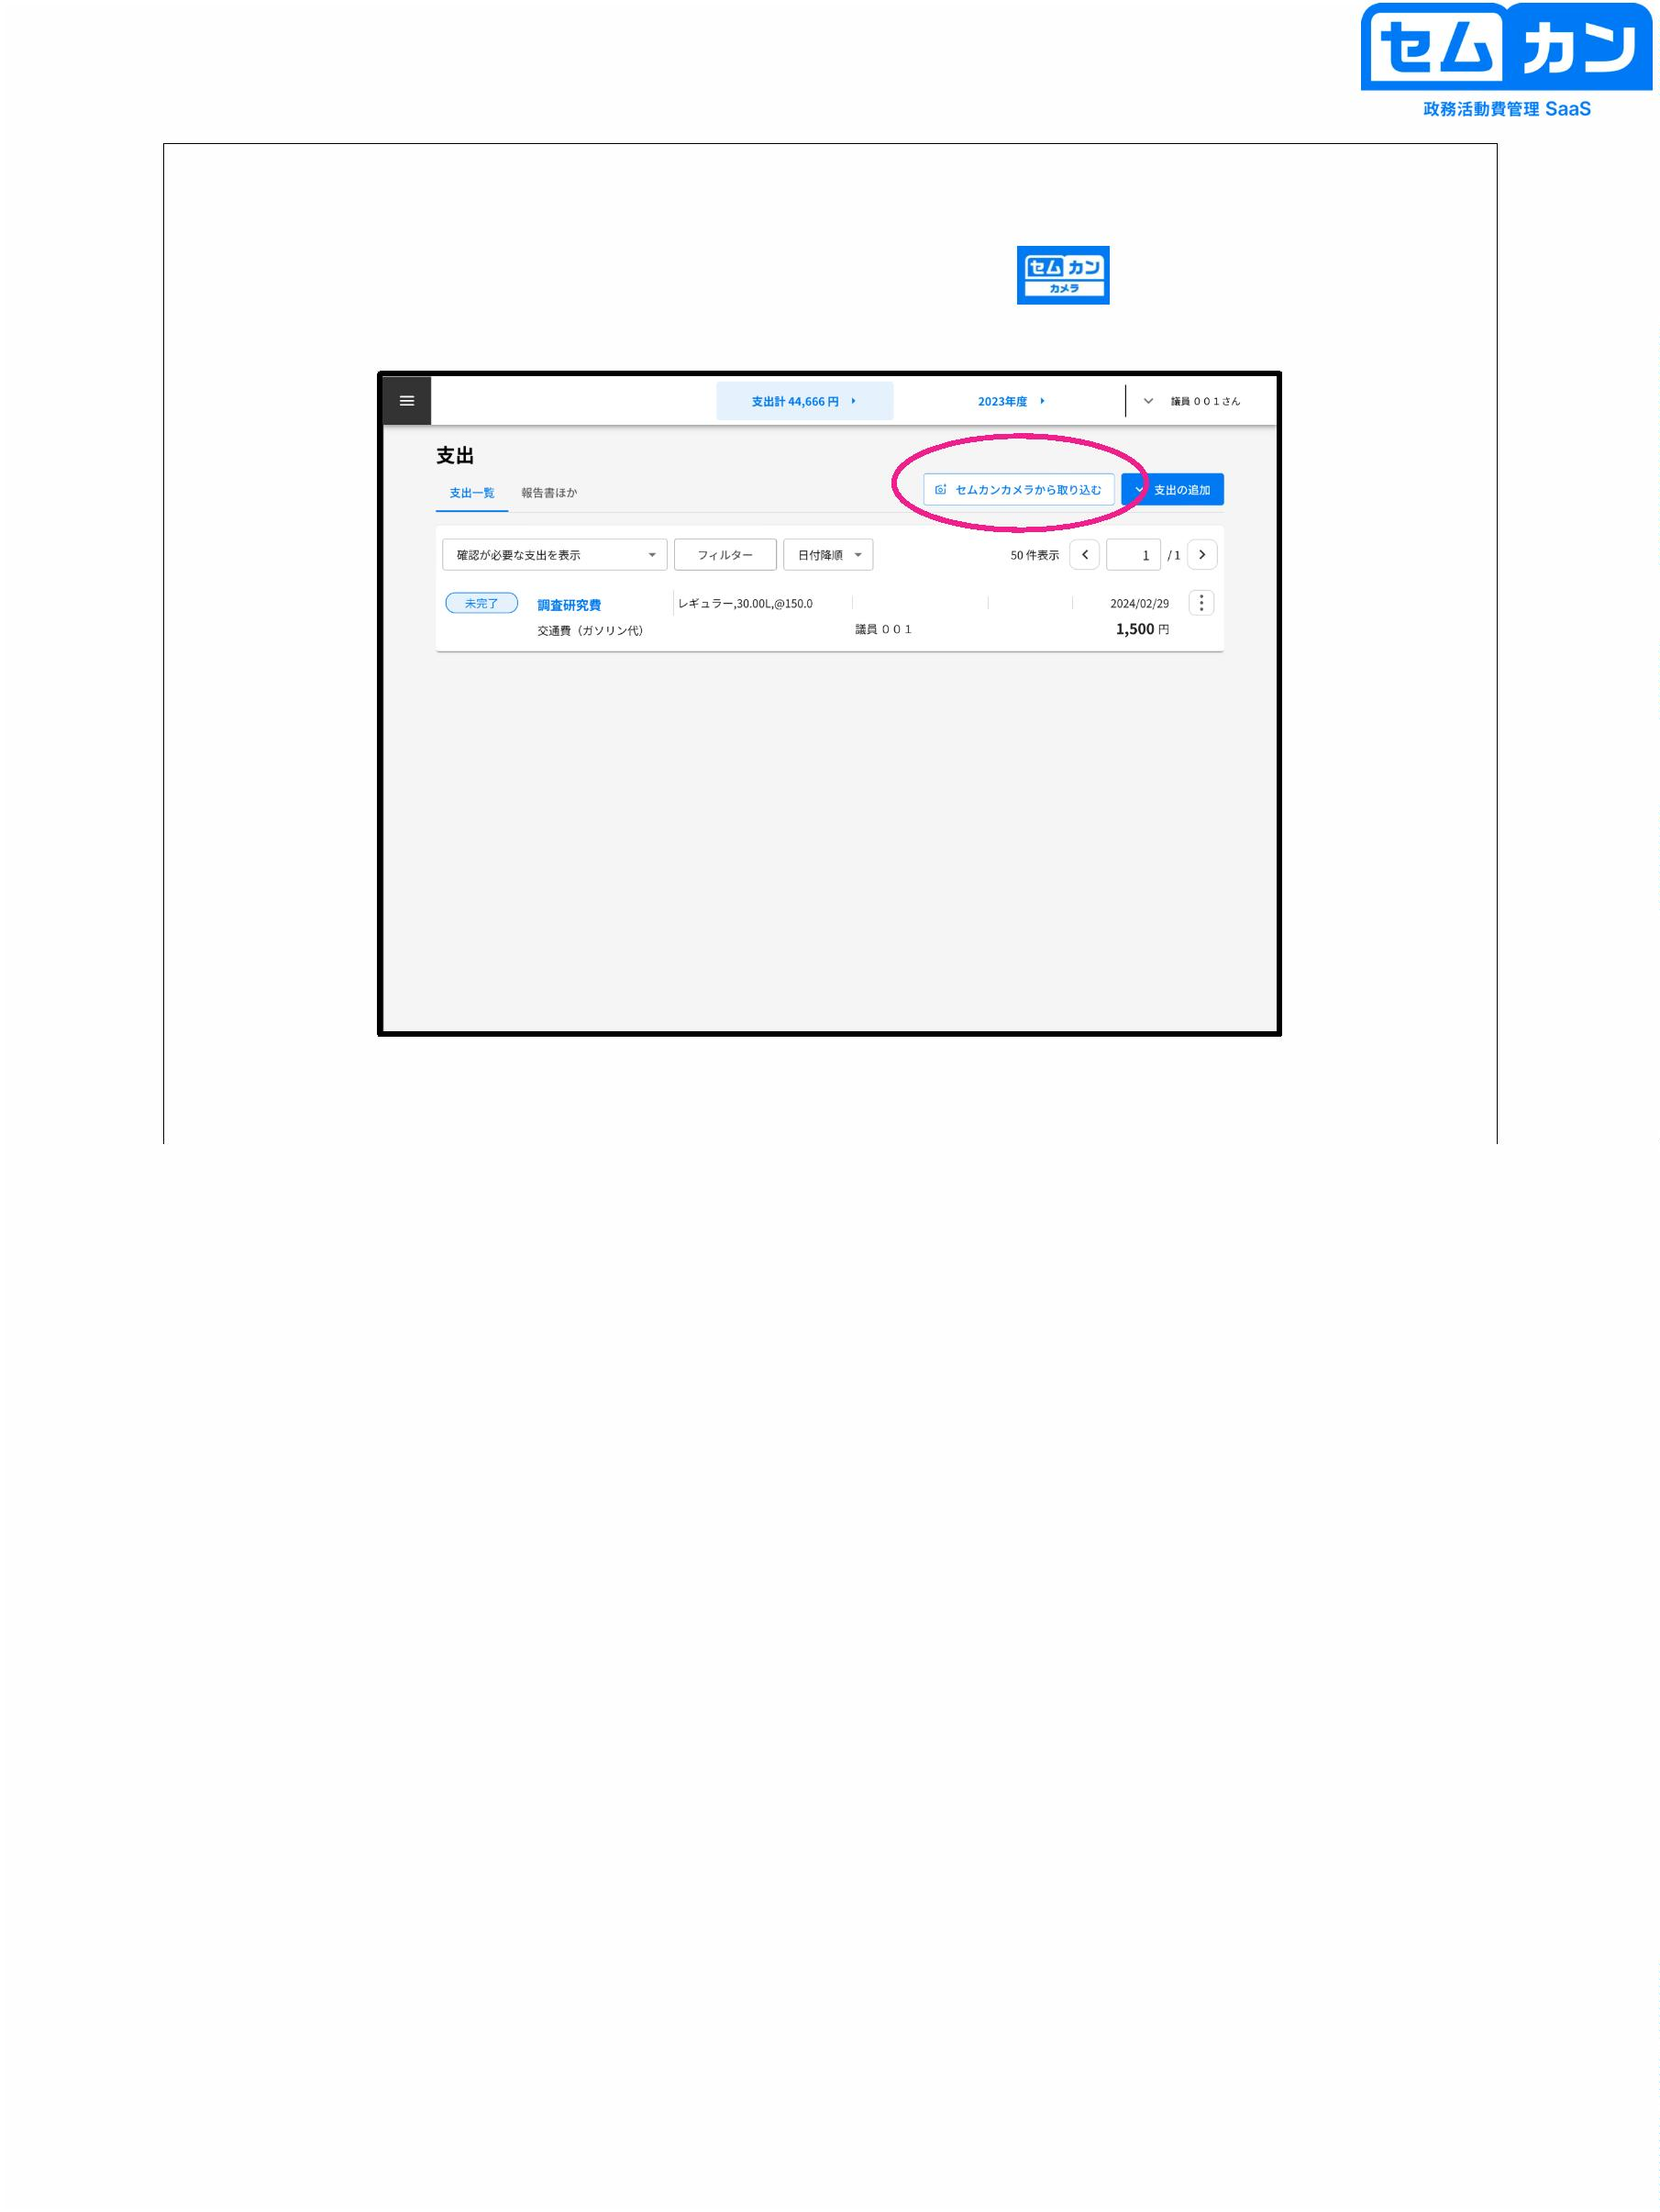

How to register using Semkan Camera

52

• Tick the target receipts

52

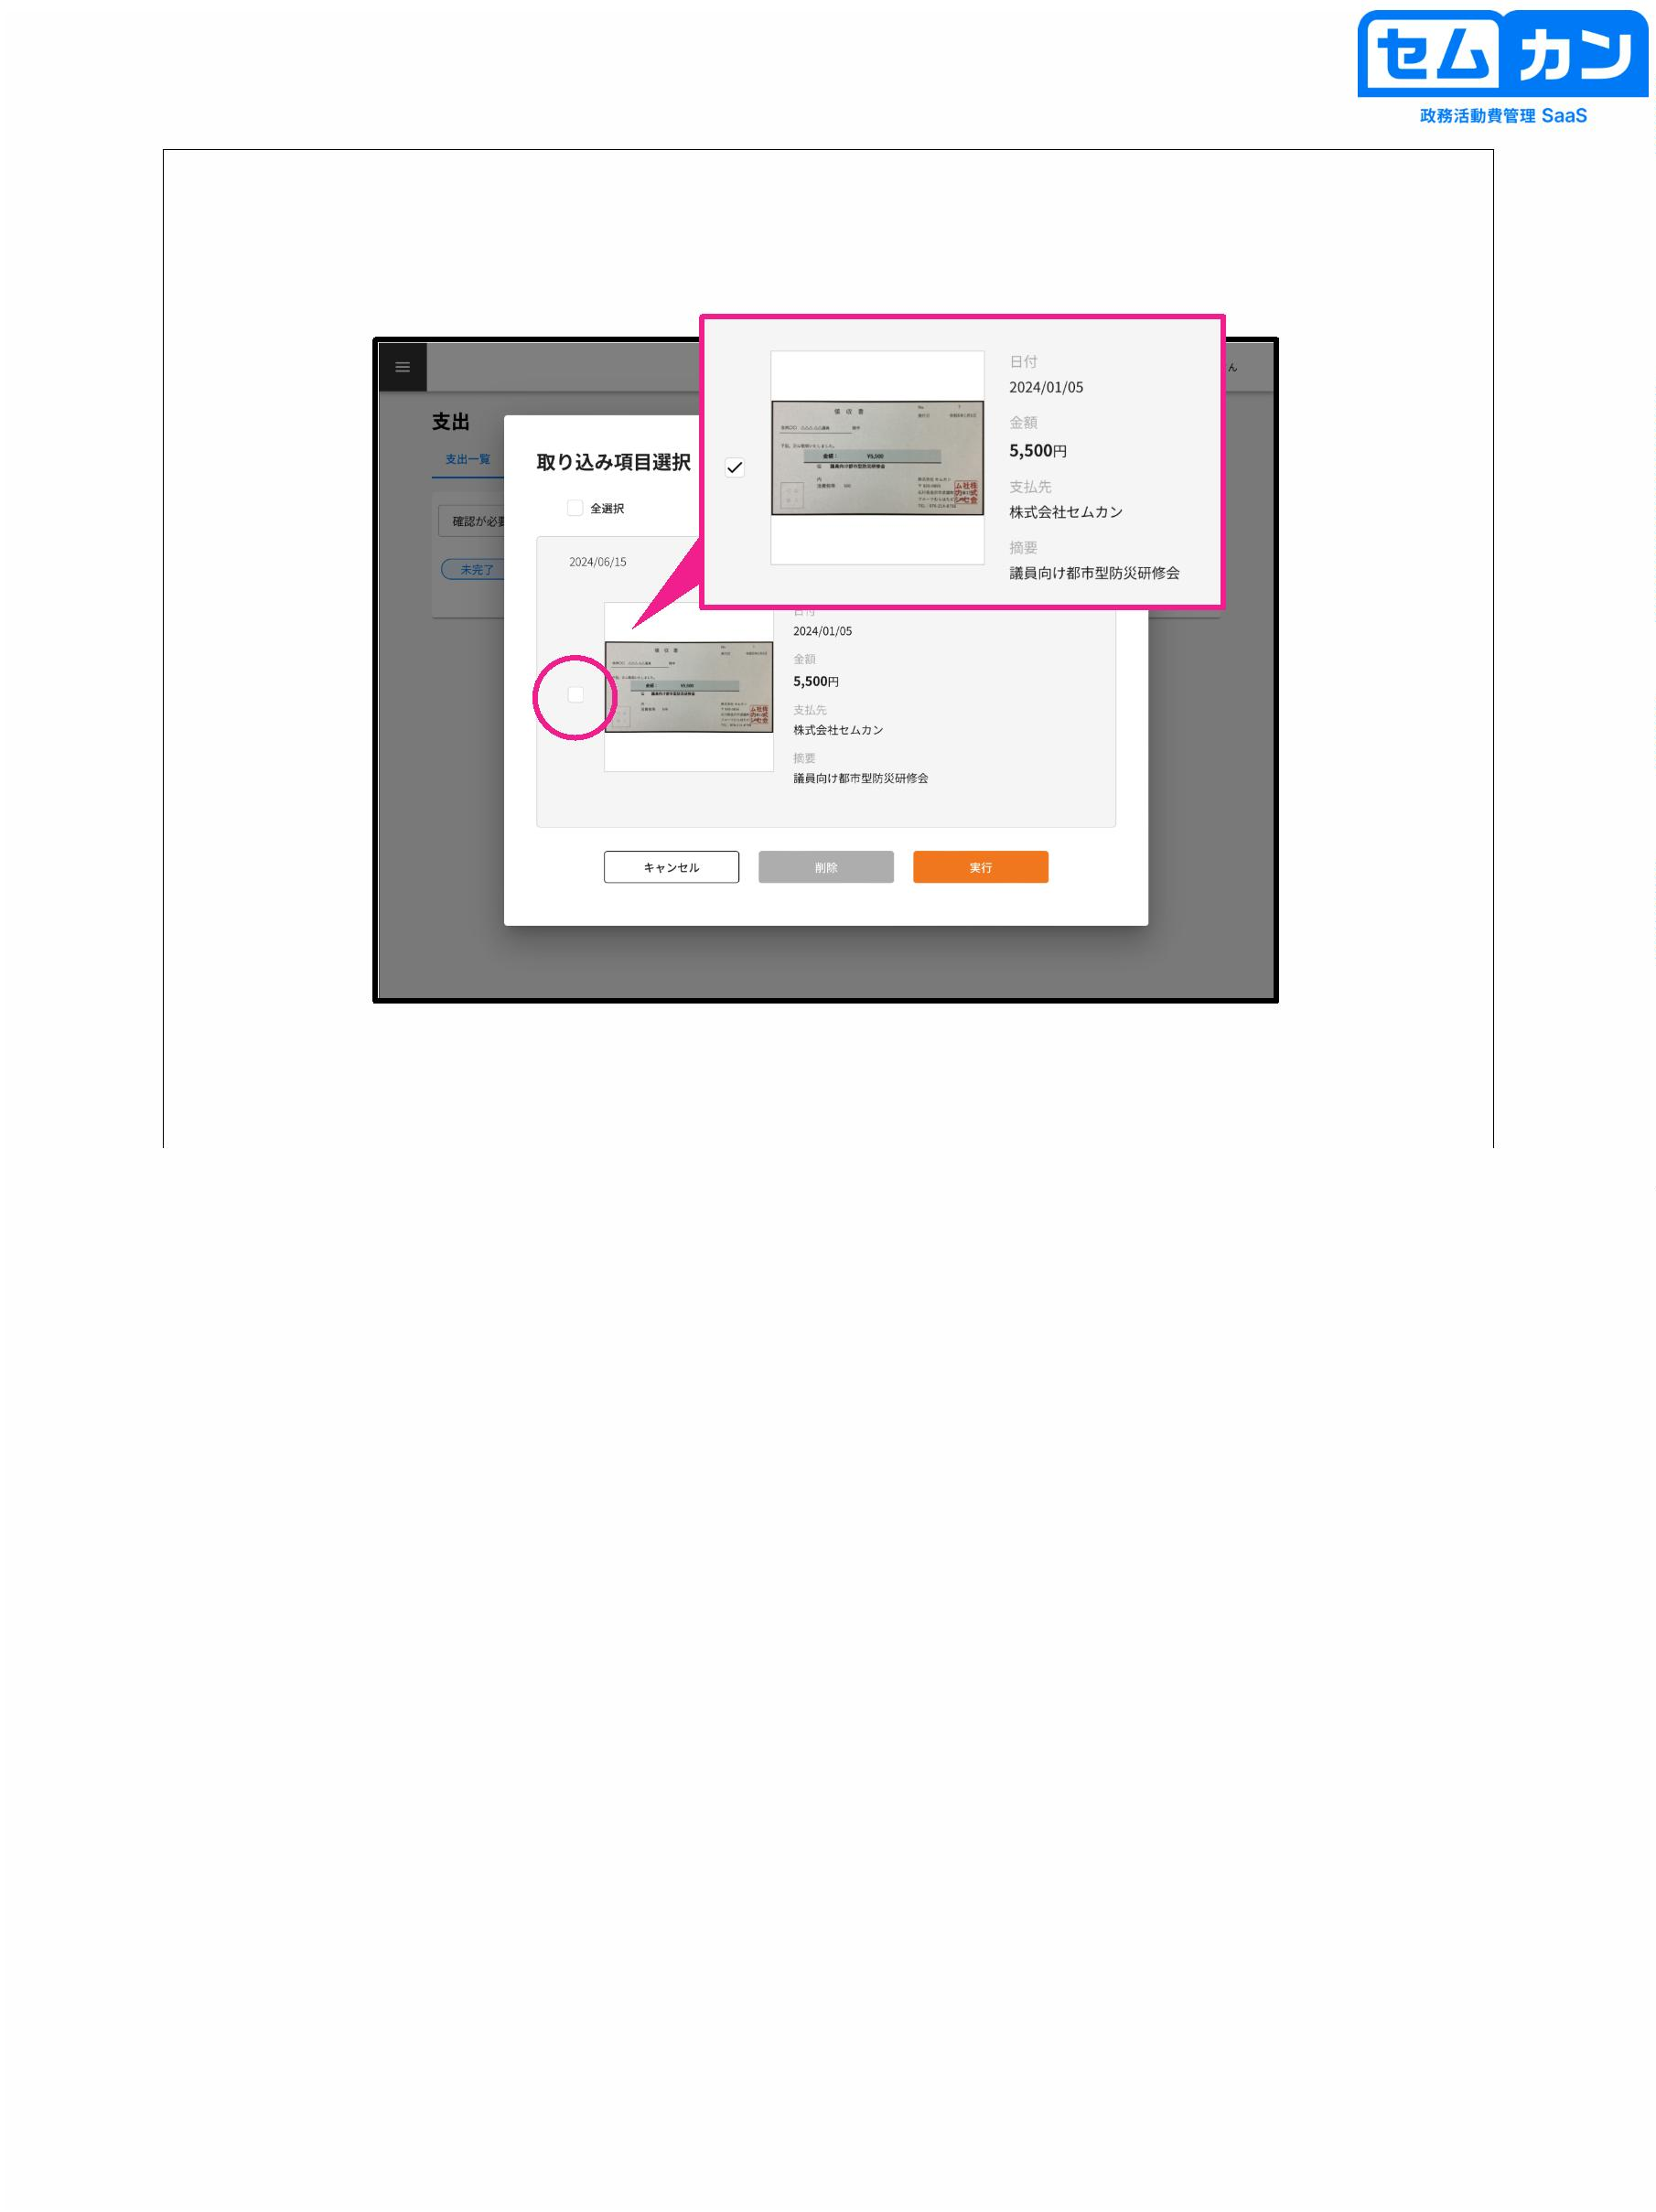

How to register using Semkan Camera

・ How to import and register from Semkan Camera

①

②

53

(1) Click "Import"

(2) A new expenditure will be added, so click this item

(3) Select the item name, etc. (see p.28 onwards)

\* Information such as the amount can be corrected after importing it into Semkan.

I can

53

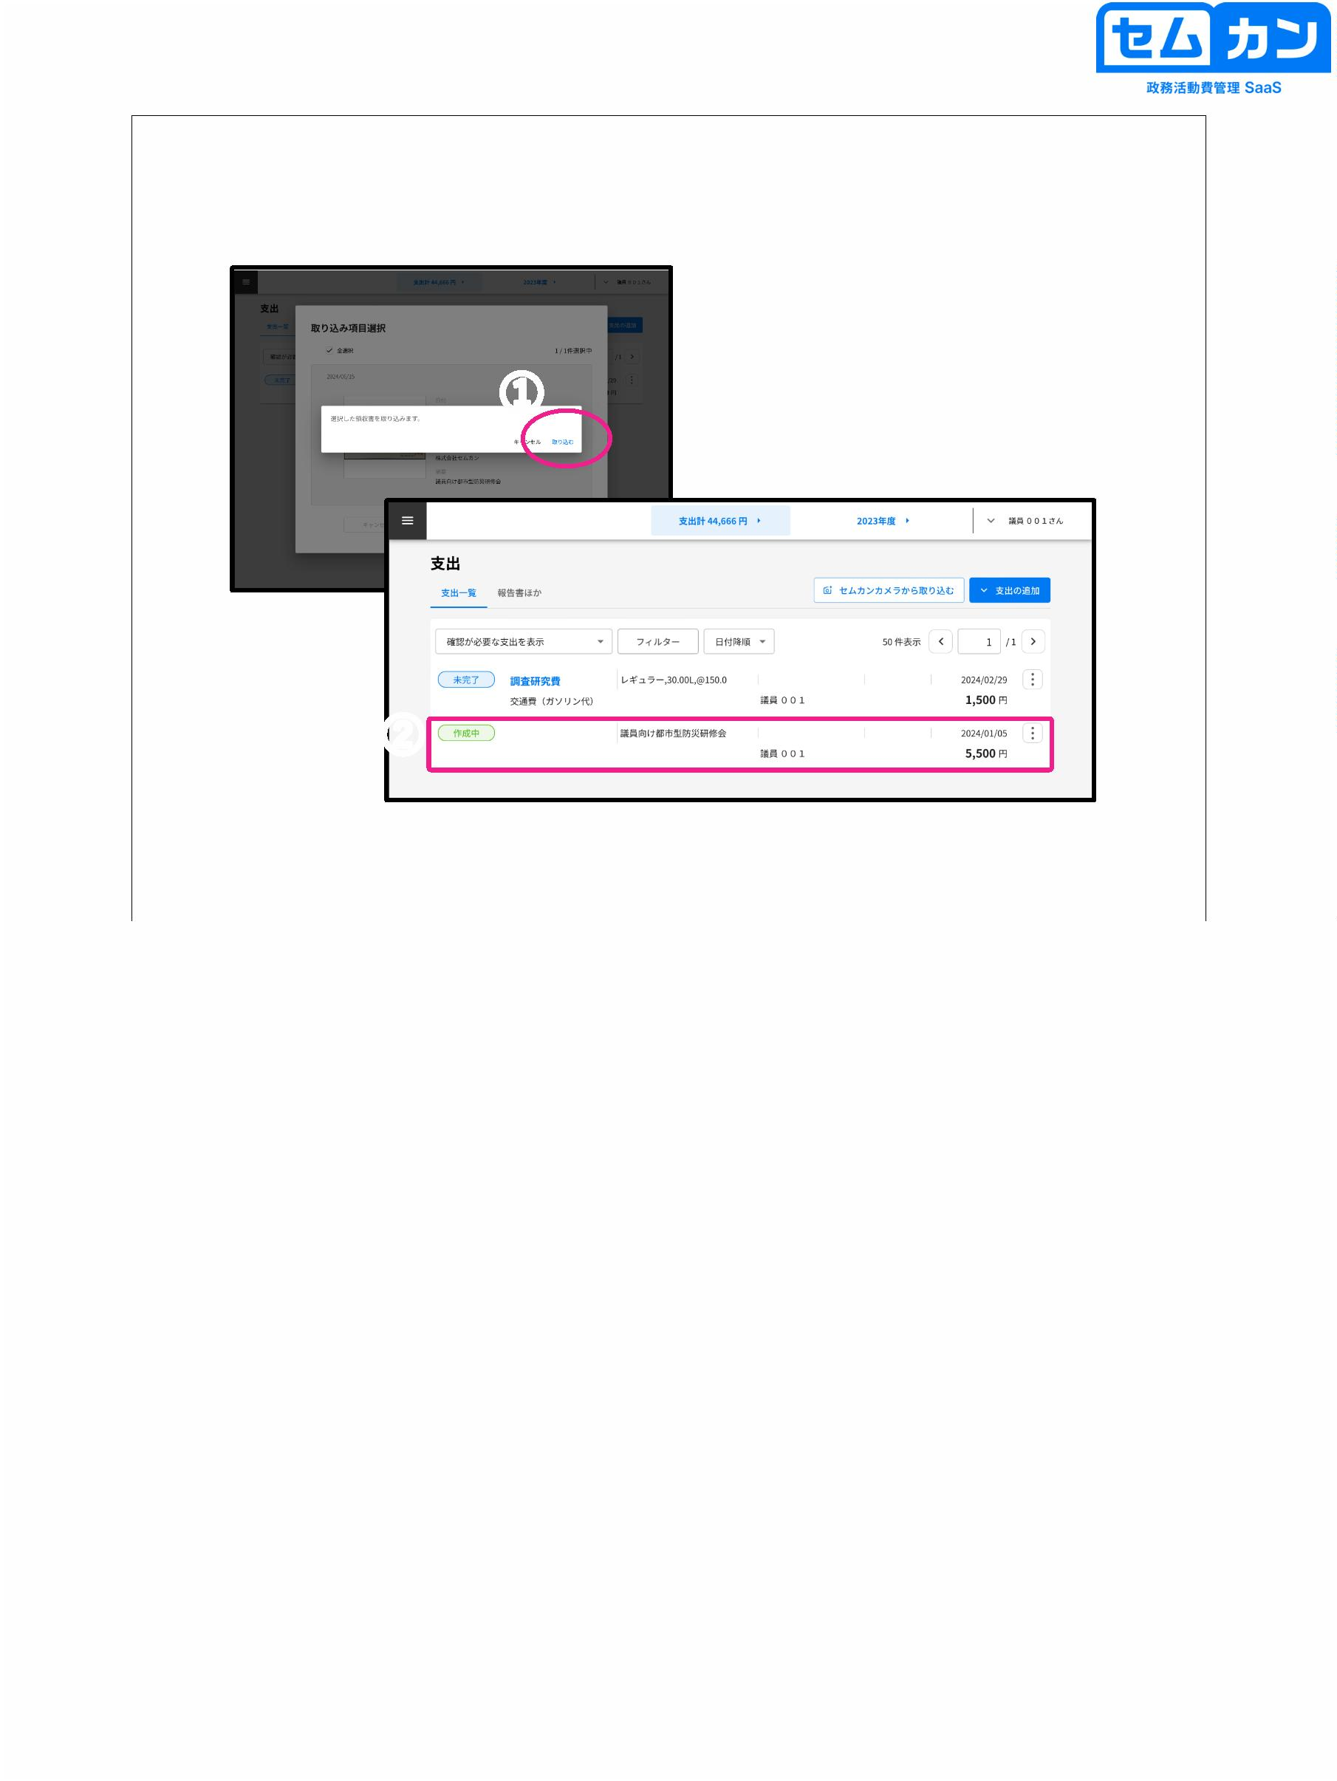

How to use the Semkan camera

①

\*\*\*\*\*

\*\*\*\*\*\*\*\*\*

②

54

Install "Semkan Camera" from the Apple Store or Google Play

Please Thor

(1) Start the Semkan camera and click "Log in and use".

Please chime

(2) When the login screen is displayed, enter the same ID and PW as Semkan.

and log in

54

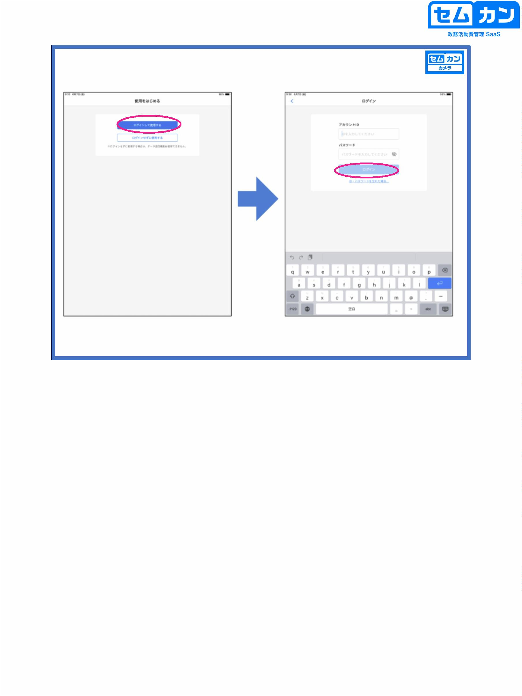

How to use the Semkan camera

②

①

③

55

There are two ways to read receipts using the Semkan camera

(1) Please check the explanation of (1) to (3) below → reading using the Semkan camera

(2) Use the camera function of your smartphone or tablet to read the saved receipt

be crowded

→ You can import from "Select Photos" on the screen after logging in

(1) Tap "Shoot" in the lower right corner to start the camera.

(2) Take a picture so that the four corners of the receipt fit well and appear as large as possible.

Hello

When the shooting is complete, make sure that only the receipt part is cut out

\* Correction is possible by moving the "●" in the four places of the image

\* You can adjust the orientation with the "image rotation button"

(3) When the image is clear, tap "Scan"

55

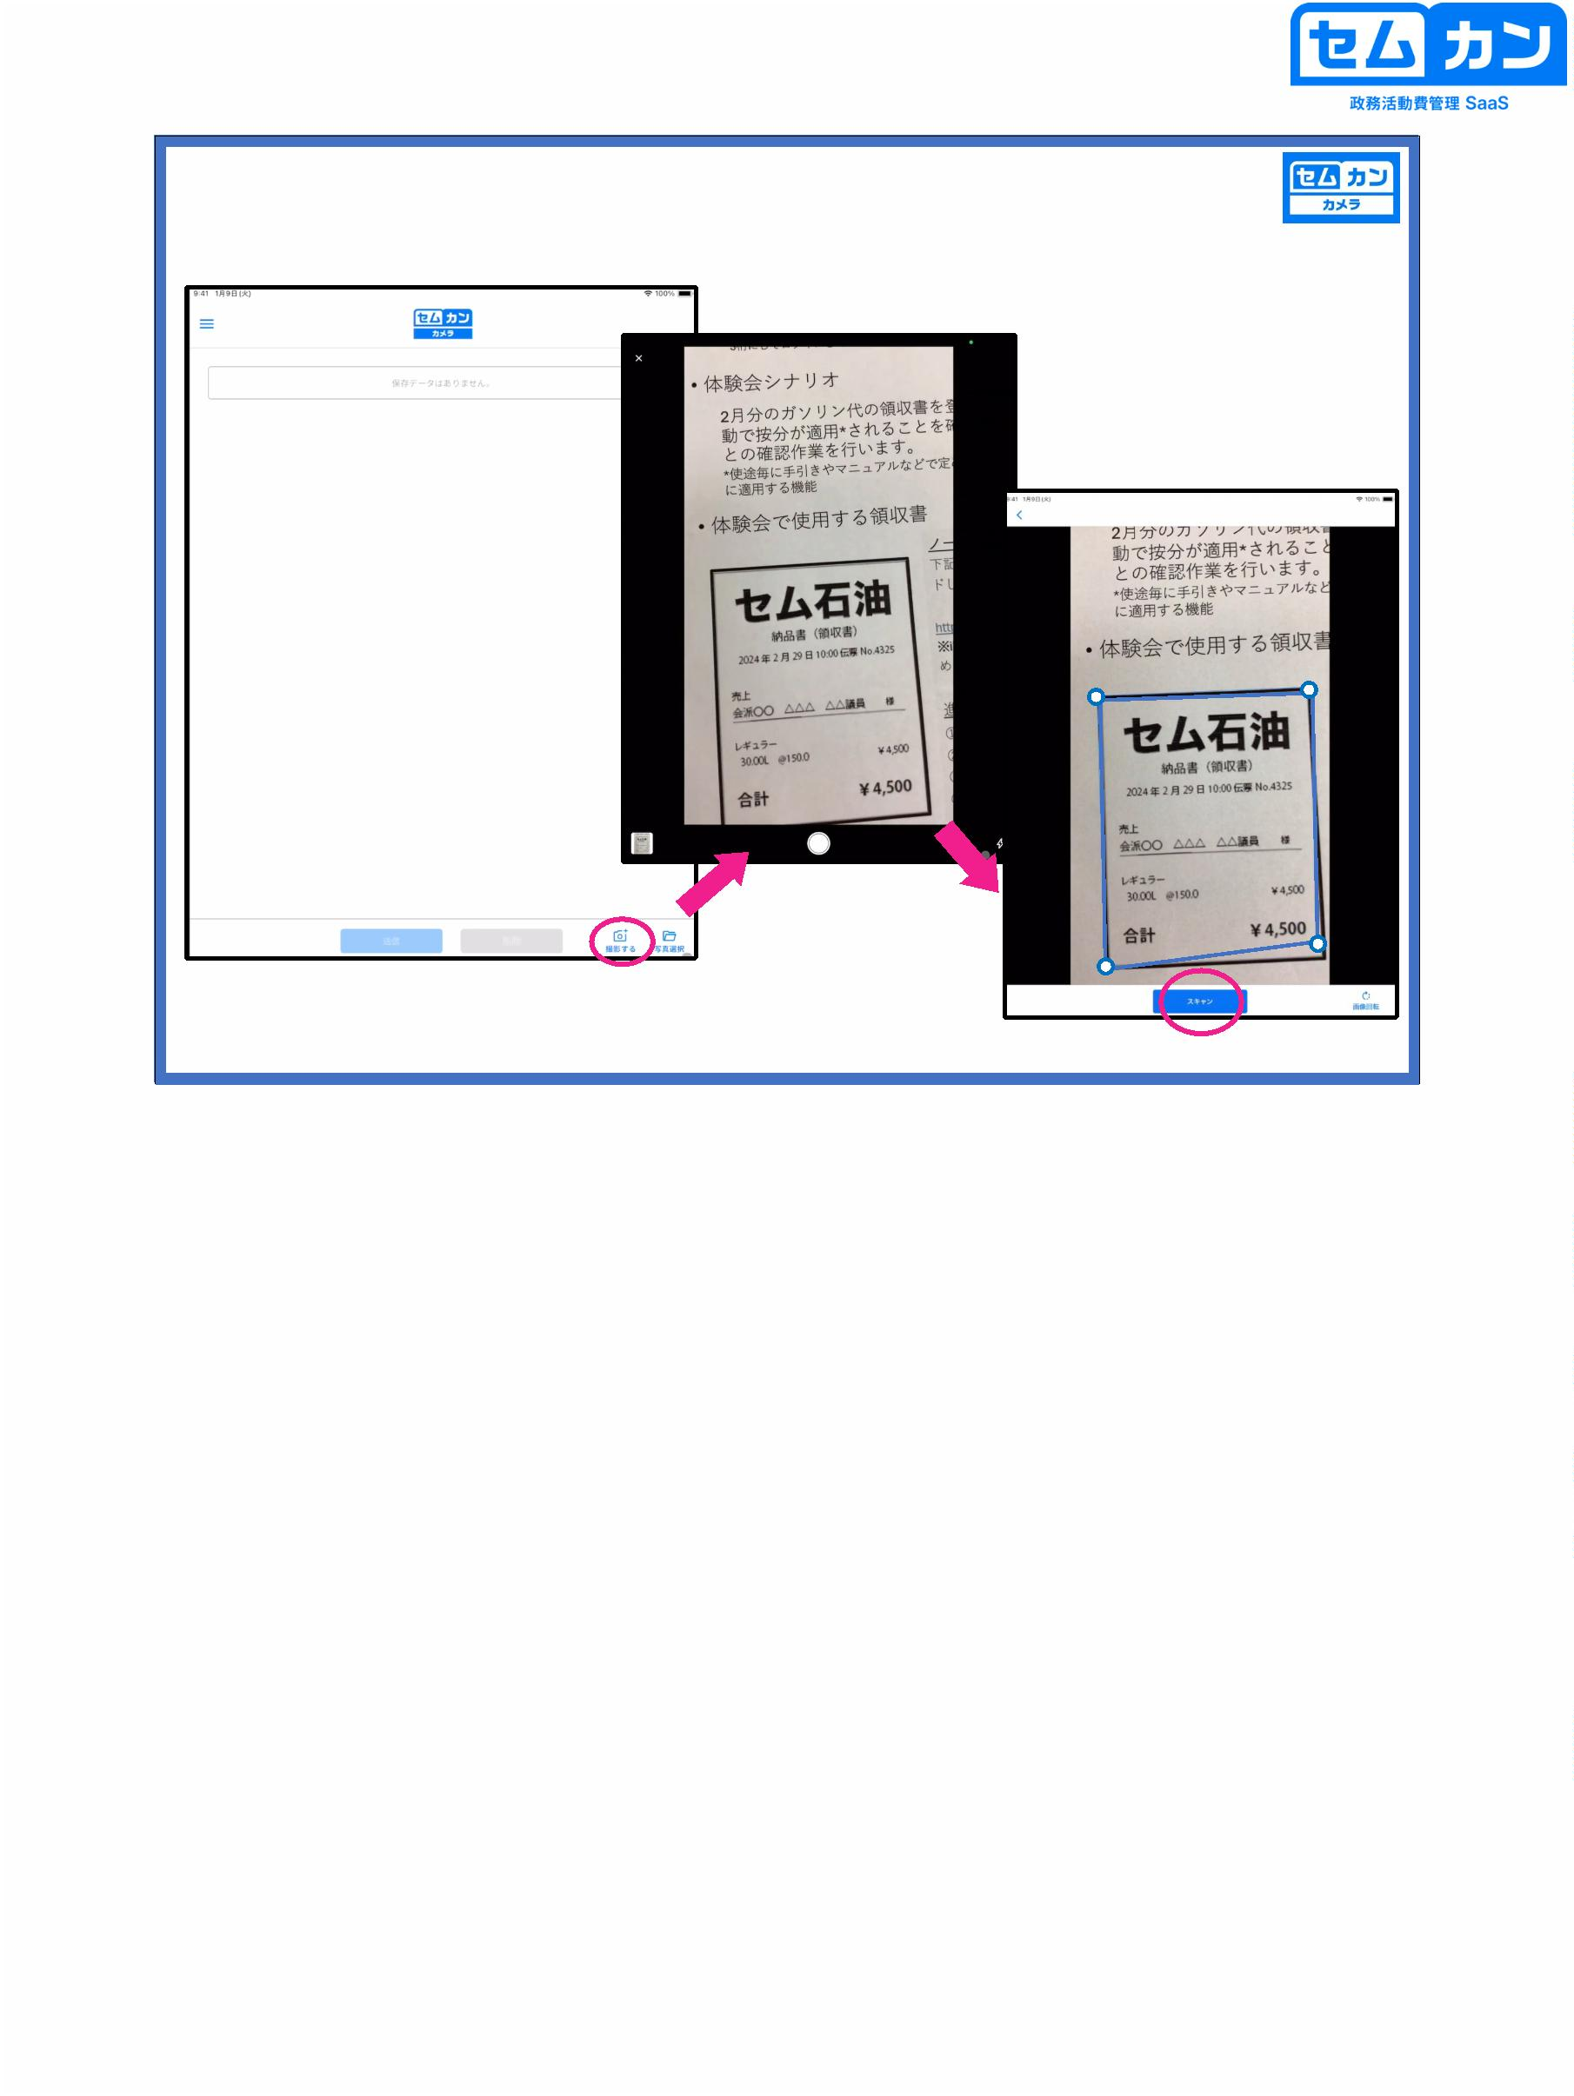

How to use the Semkan camera

③

②

56

(1) Click "Edit" to see "Date, Payment address, Description, Money"

The "forehead" input screen will be displayed

(2) Touch the selection at the right end of each frame to load the pressed item.

Switch to D

(3) You can read by touching the corresponding part of the image part.

\* If the characters you want to enter are divided, touch the order number you want to enter.

You can load it by

56

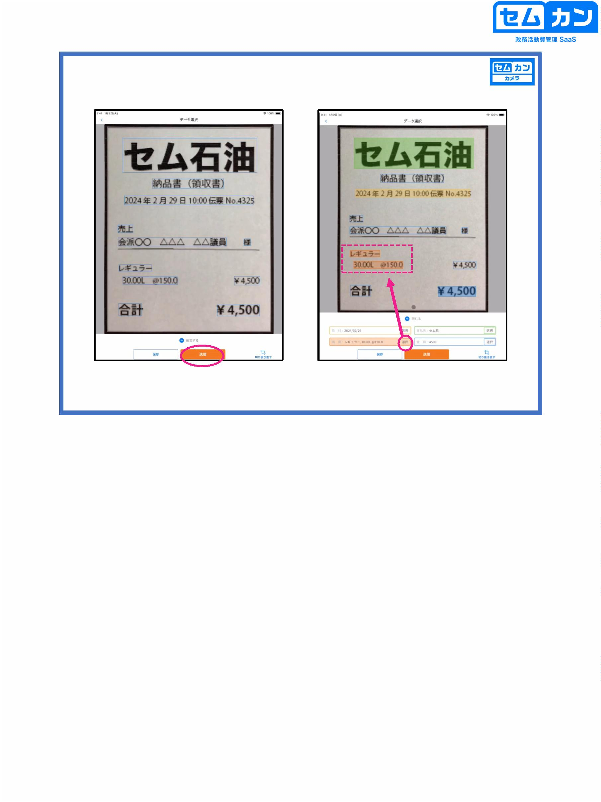

How to use the Semkan camera

①

②

(1) If you touch anything other than the selected part of the item, you can enter characters directly.

S

(2) When you press the orange send button, it will automatically be linked to your ID.

The data will be transmitted

\* If the communication is not completed, touch the save button and send it later.

You can believe

57

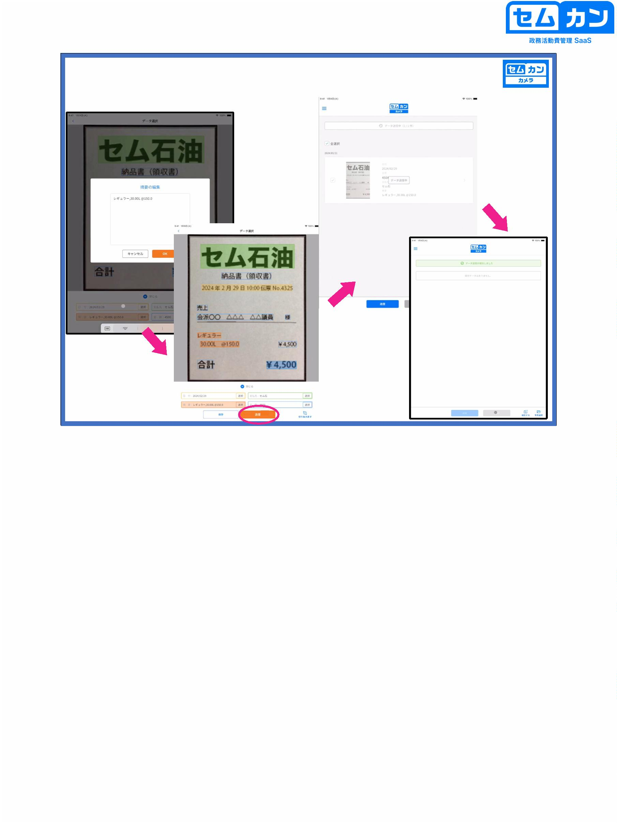

7. Application for Confirmation

58

58



Verification application

①

59

(1) When you have finished entering the items, you can apply for it.

In the "Confirmation Application", the expenditure data will be sent to the secretariat

\* If an error like the one shown in the figure below appears in the lower left, it is a required item.

Please check if the information is included

\* In the case of "primary save", it will be displayed as "in progress" in the expenditure list.

and will be temporarily stored in the expenditure data (transmitted to the secretariat).

No, I don't)

59

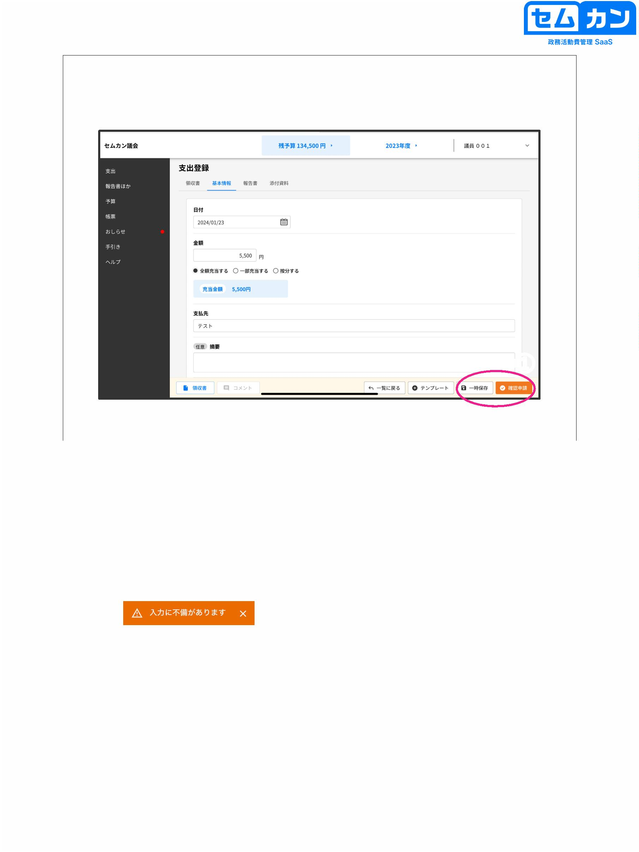

8. Pull back

60

60



Expenditure screen

①

②

61

(1) If you want to make corrections after applying for confirmation, you must first apply for all support

Select "Show Out"

(2) Select the target application

61

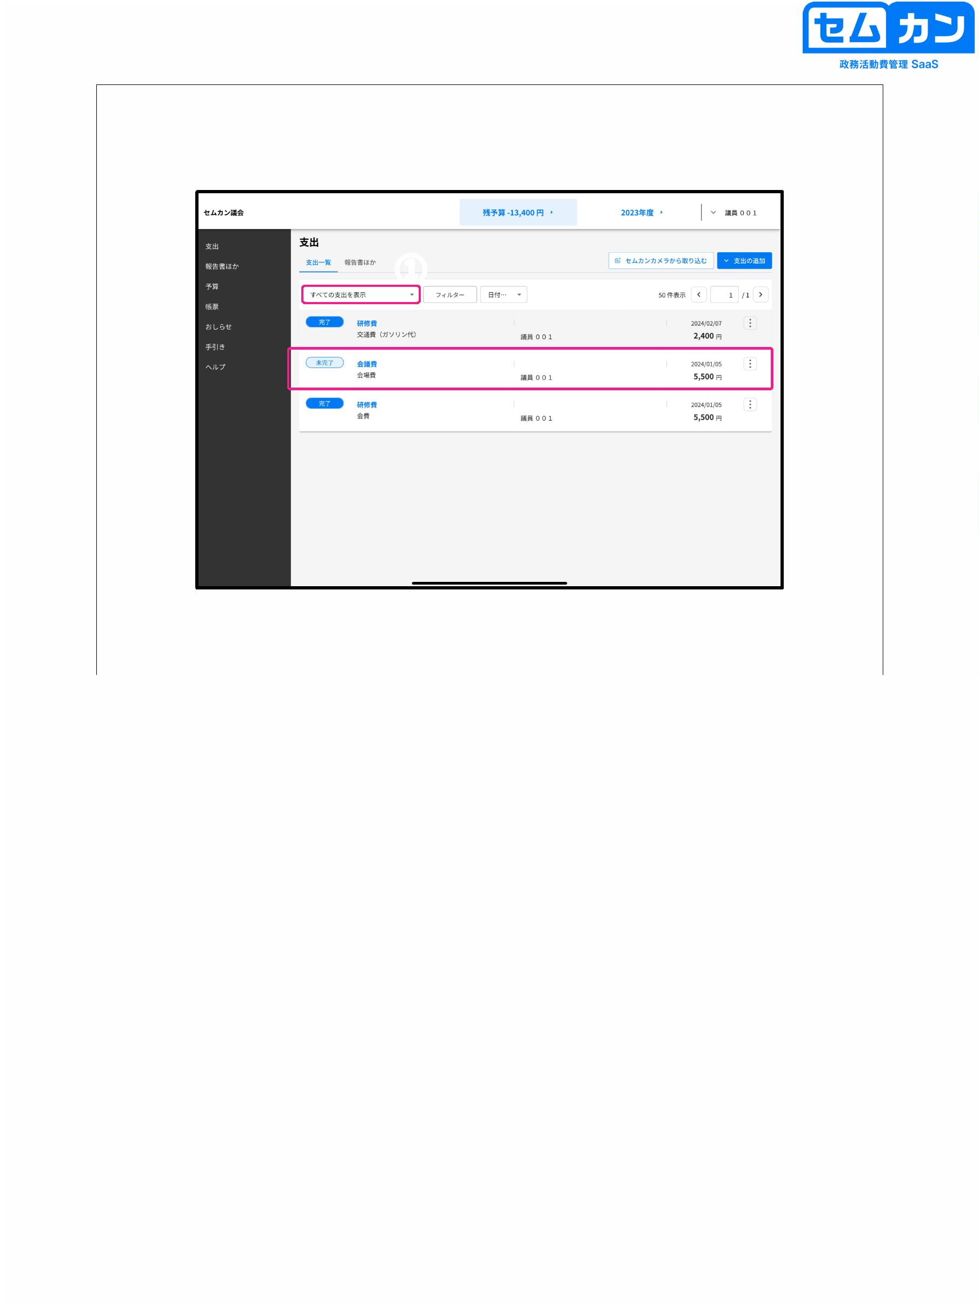

Expenditure screen

①

62

(1) Select "Pull Back"

62

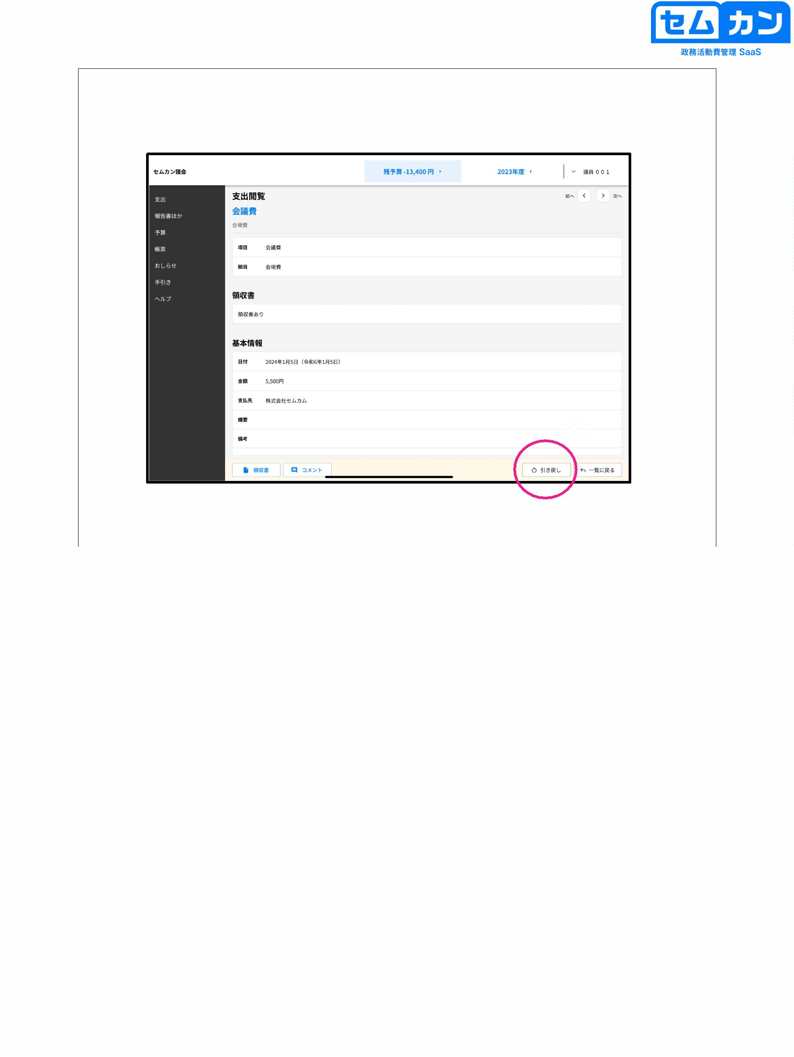

Expenditure screen

①

②

63

(1) Check "Show expenses that need to be confirmed" and the item you want to change is

Make sure it's "Incomplete"

(2) Select the target item again.

63

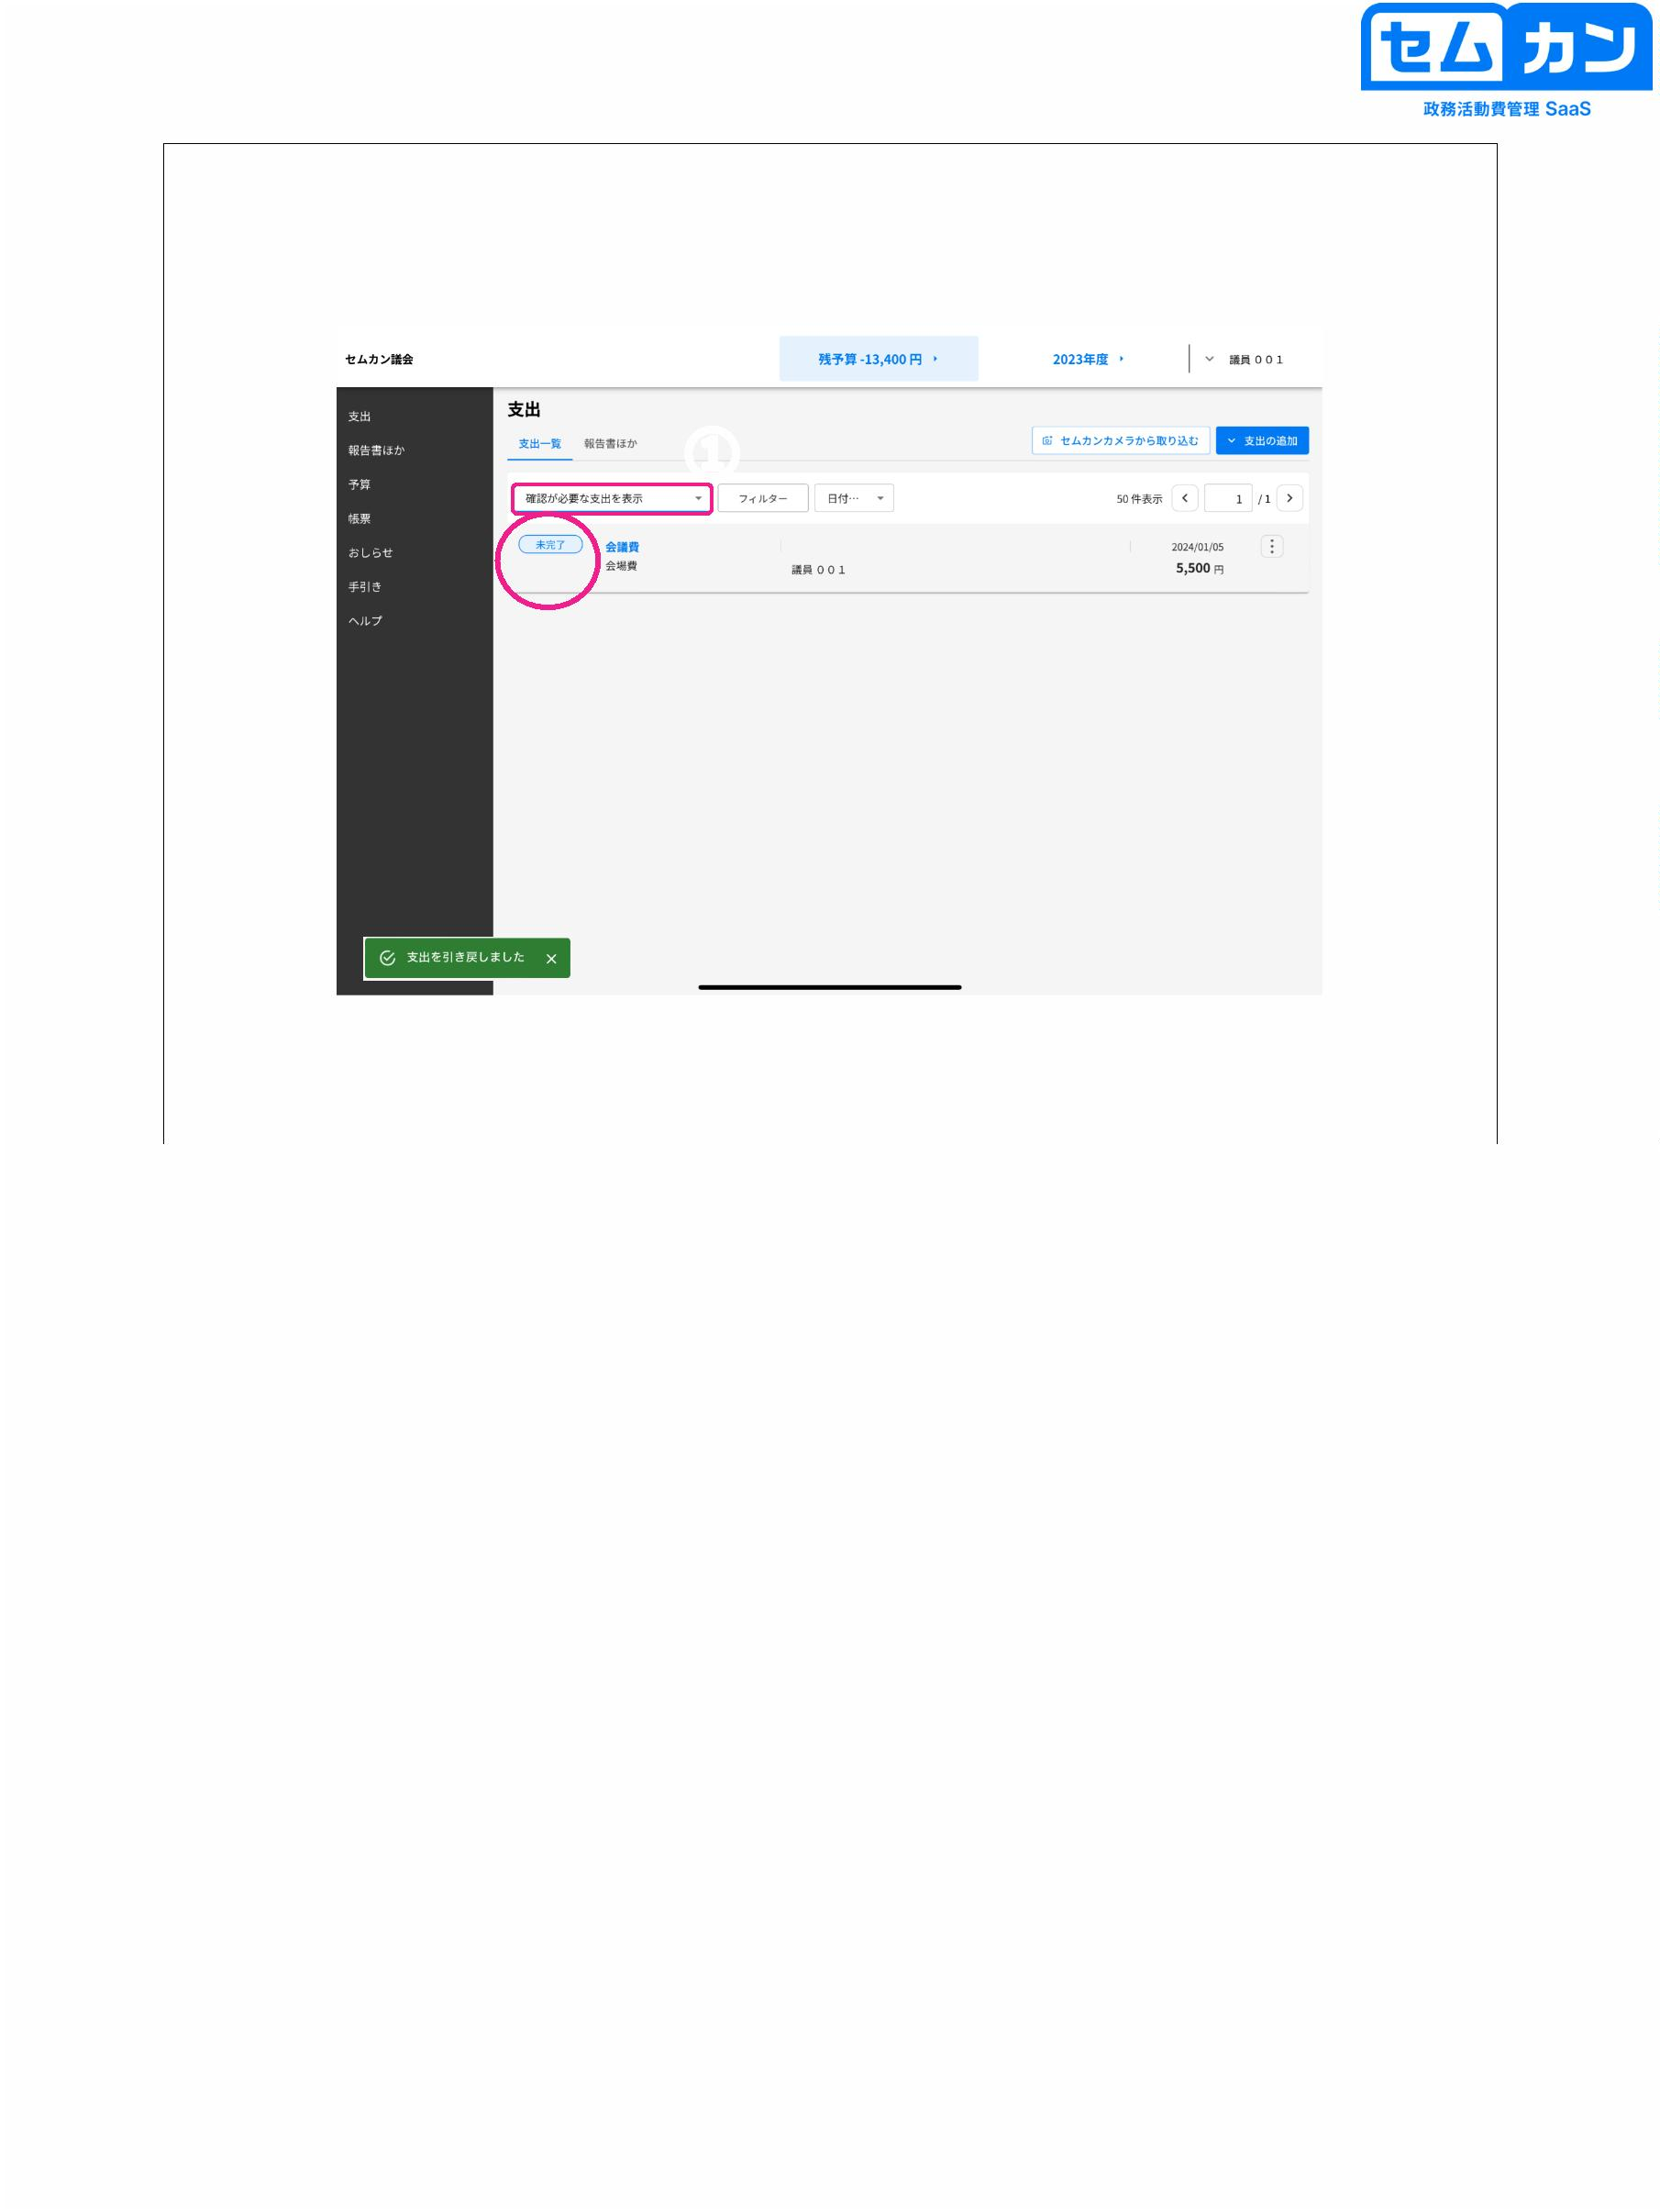

Expenditure screen

①

64

(1) Rewrite the content you want to modify, and click "Apply for confirmation" again.

64

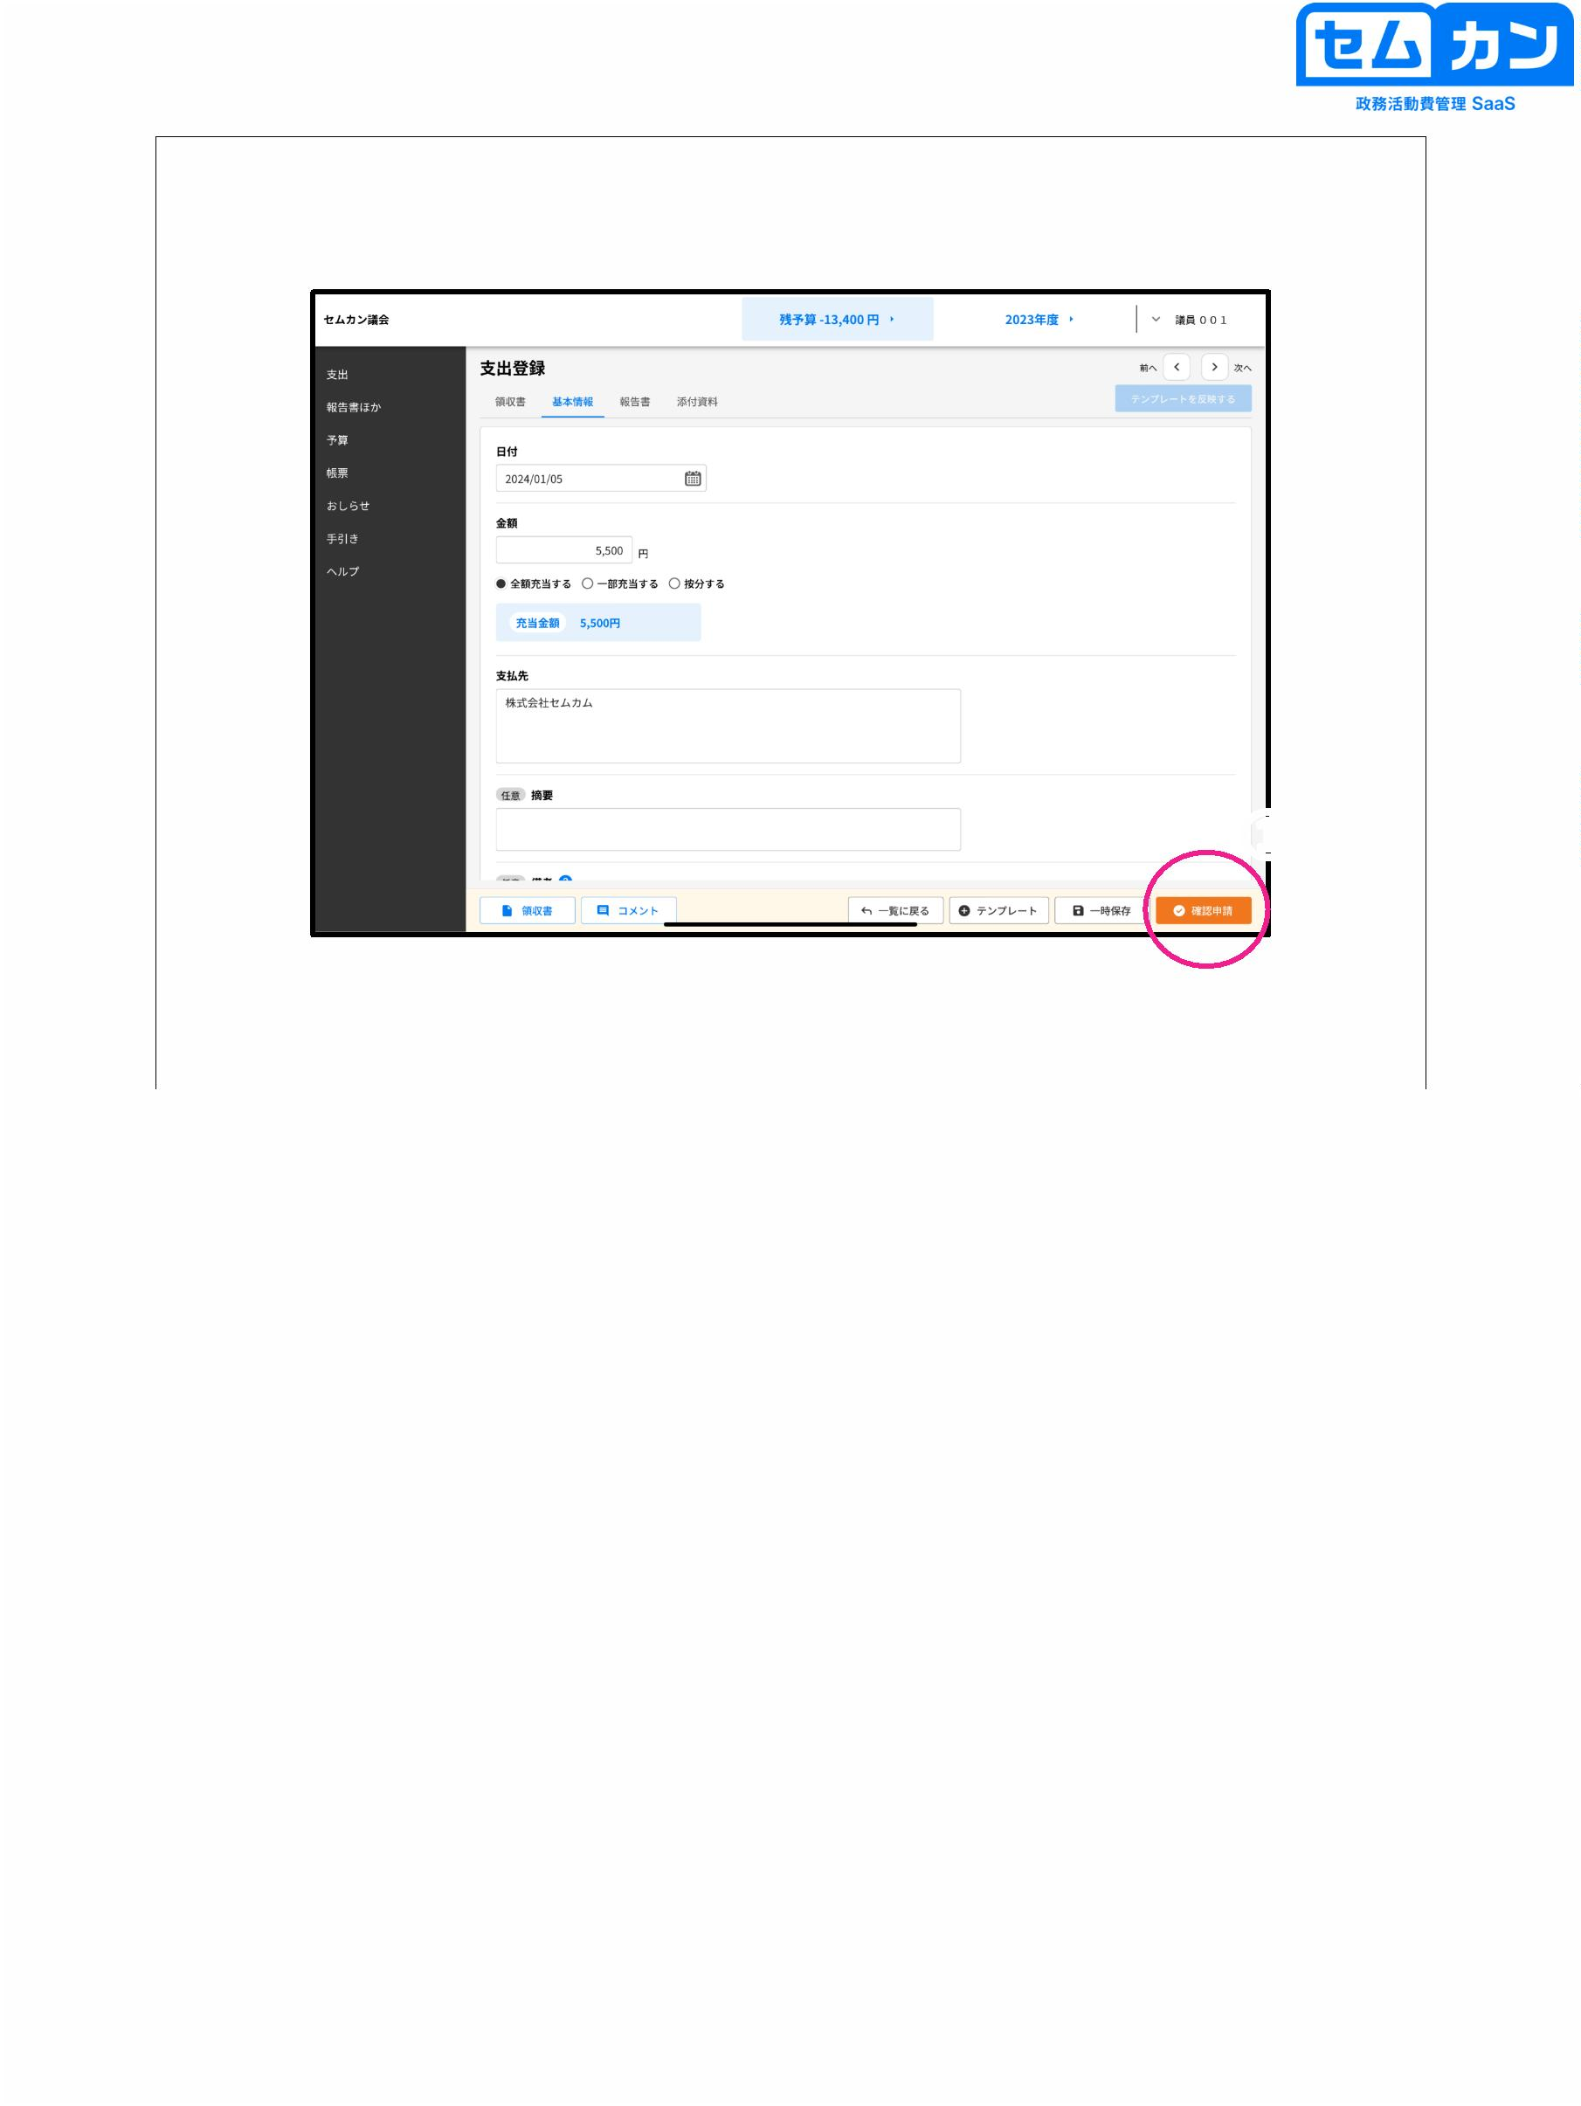

9. Amendment & Re-application

65

65



Correction & Reapplication

①

②

66

(1) Make sure that "Show expenditures that need to be reviewed" is set

\* If you select "Show all expenses", you have registered

You'll see all your spending

(2) Click on the item labeled "Incomplete"

66

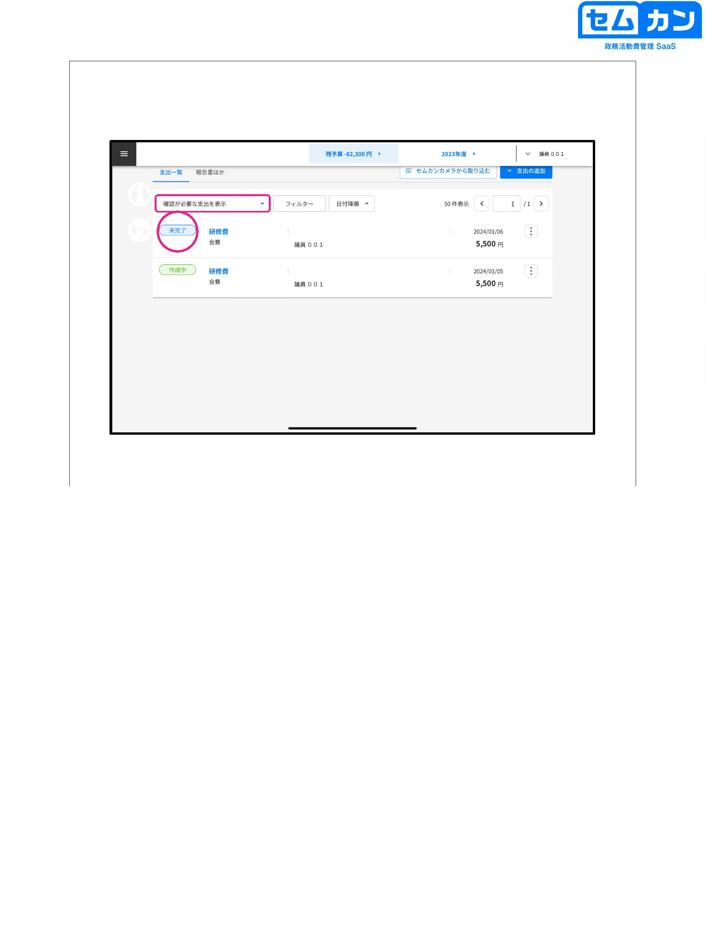

Correction & Reapplication

①

67

(1) Click "Comment"

67

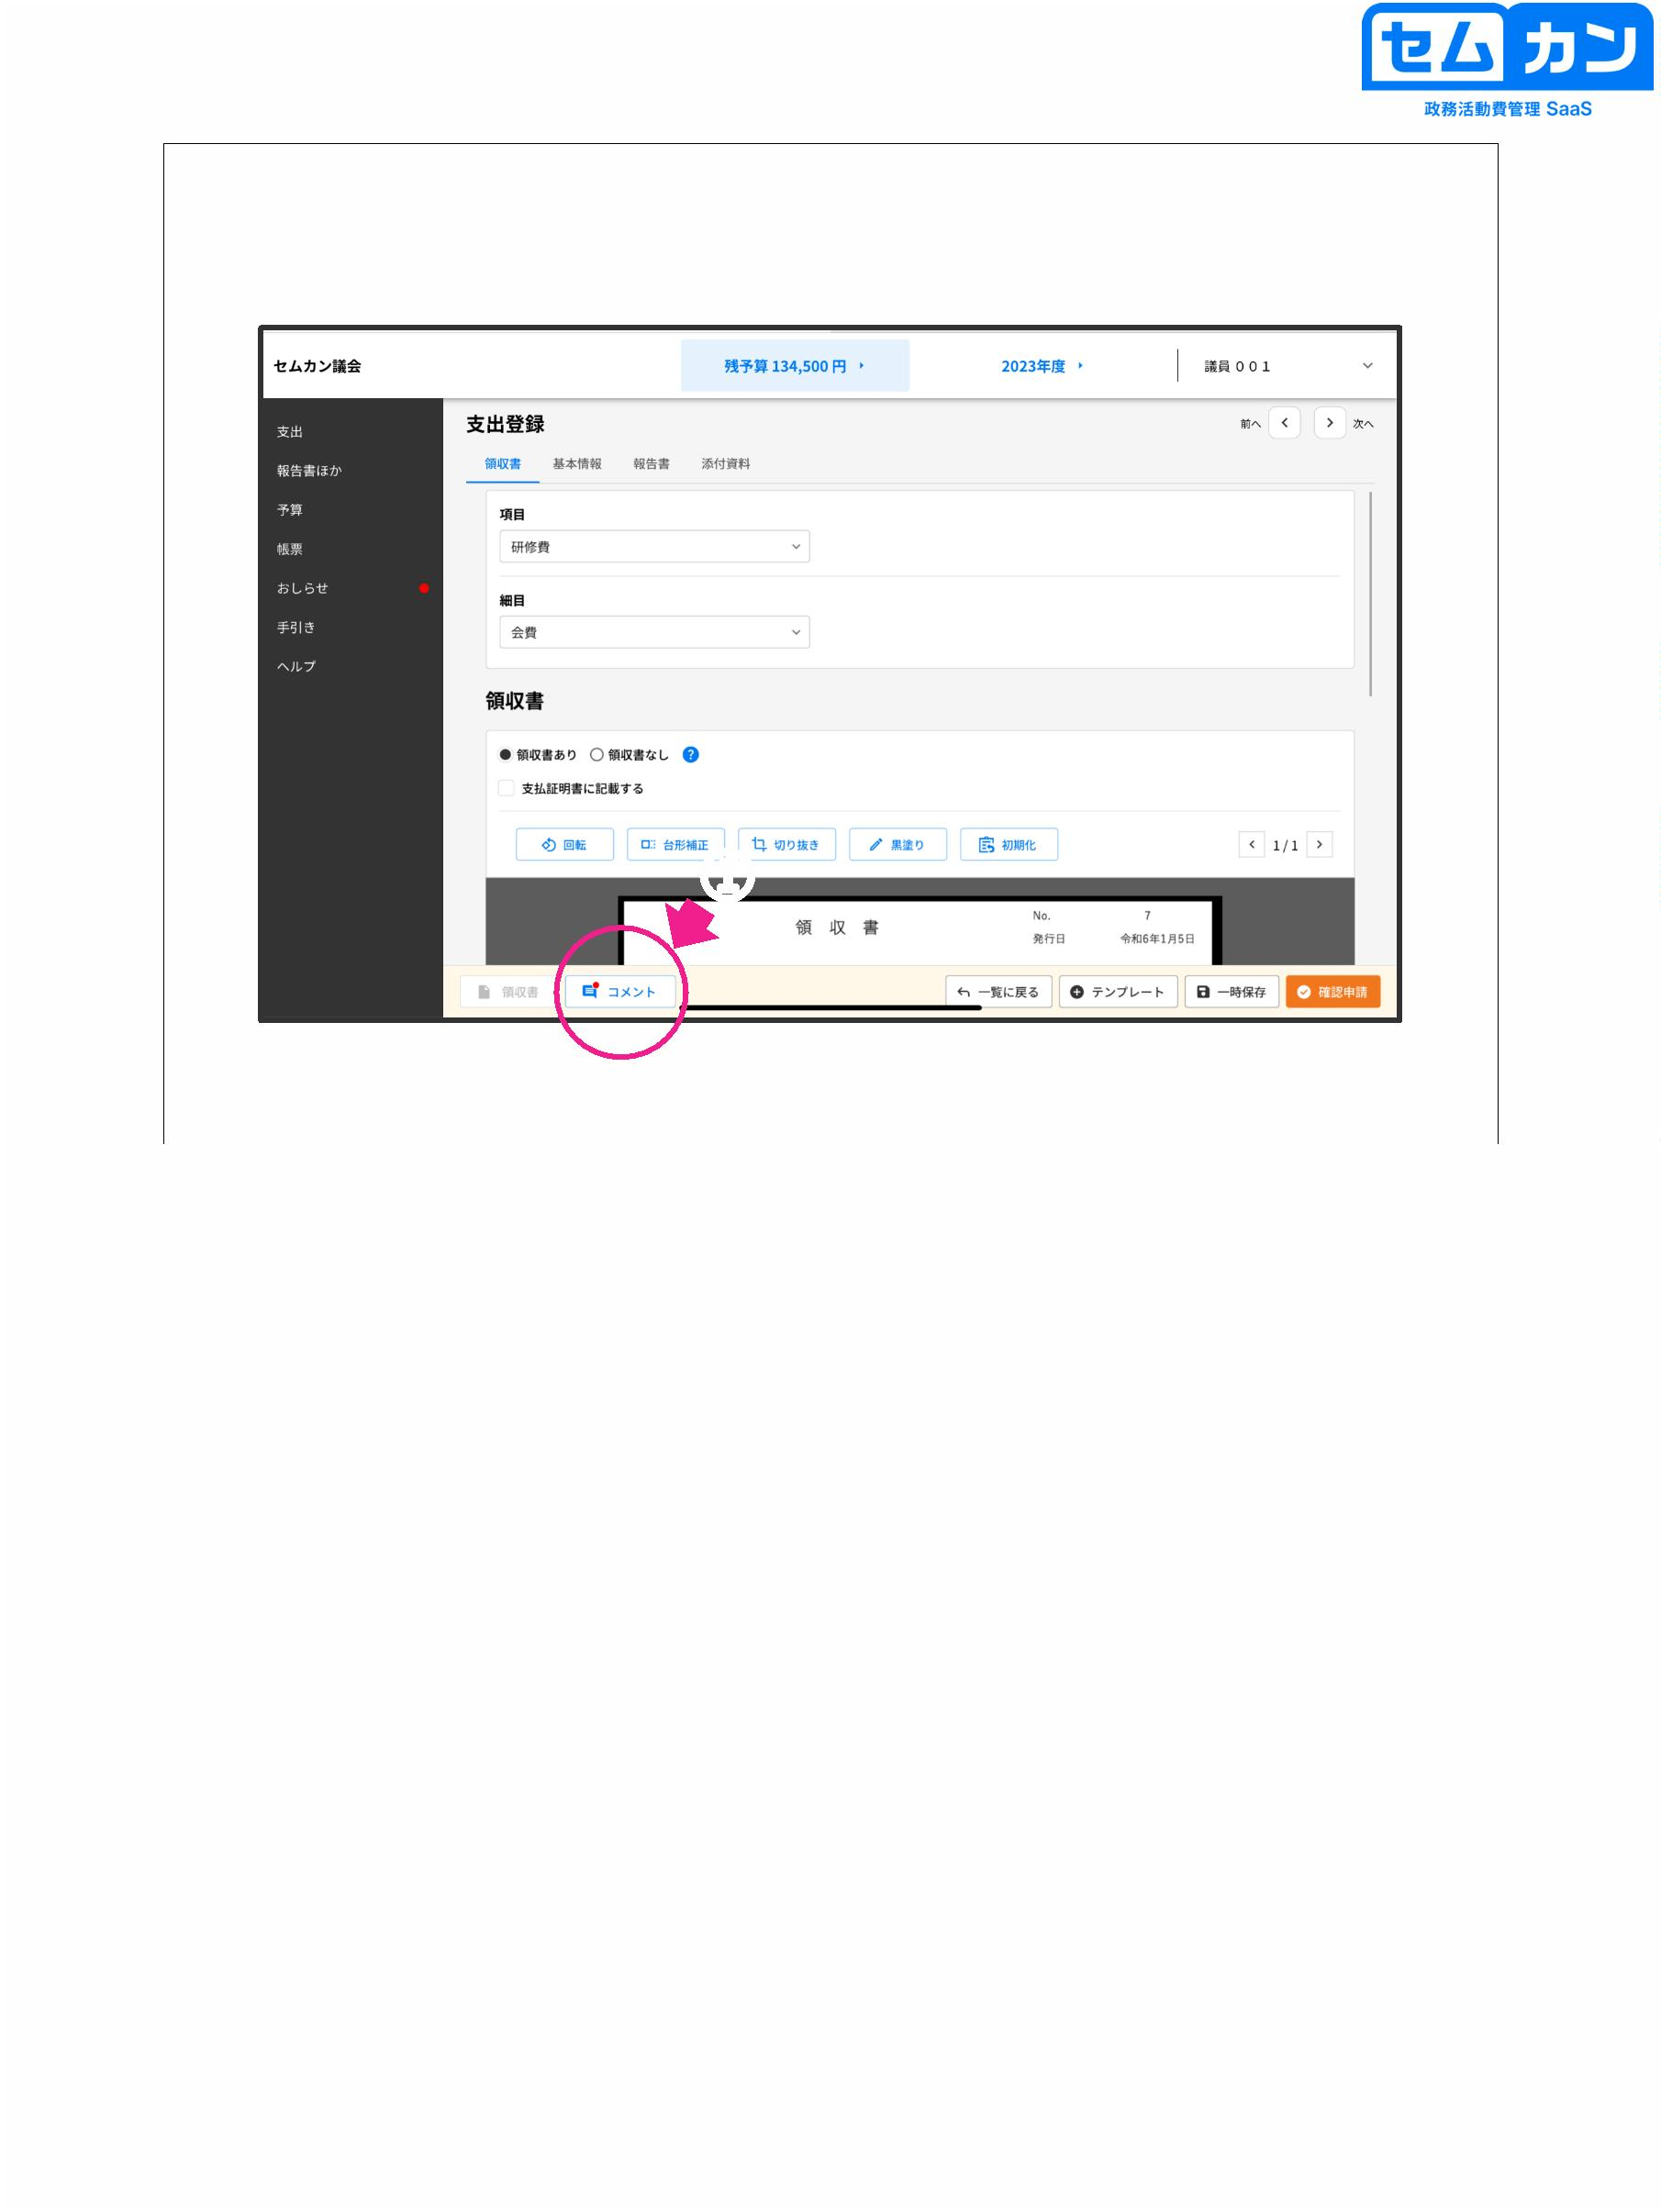

Correction & Reapplication

①

②

68

(1) Please check the comments and make corrections

(2) Click "Request Confirmation" again

68

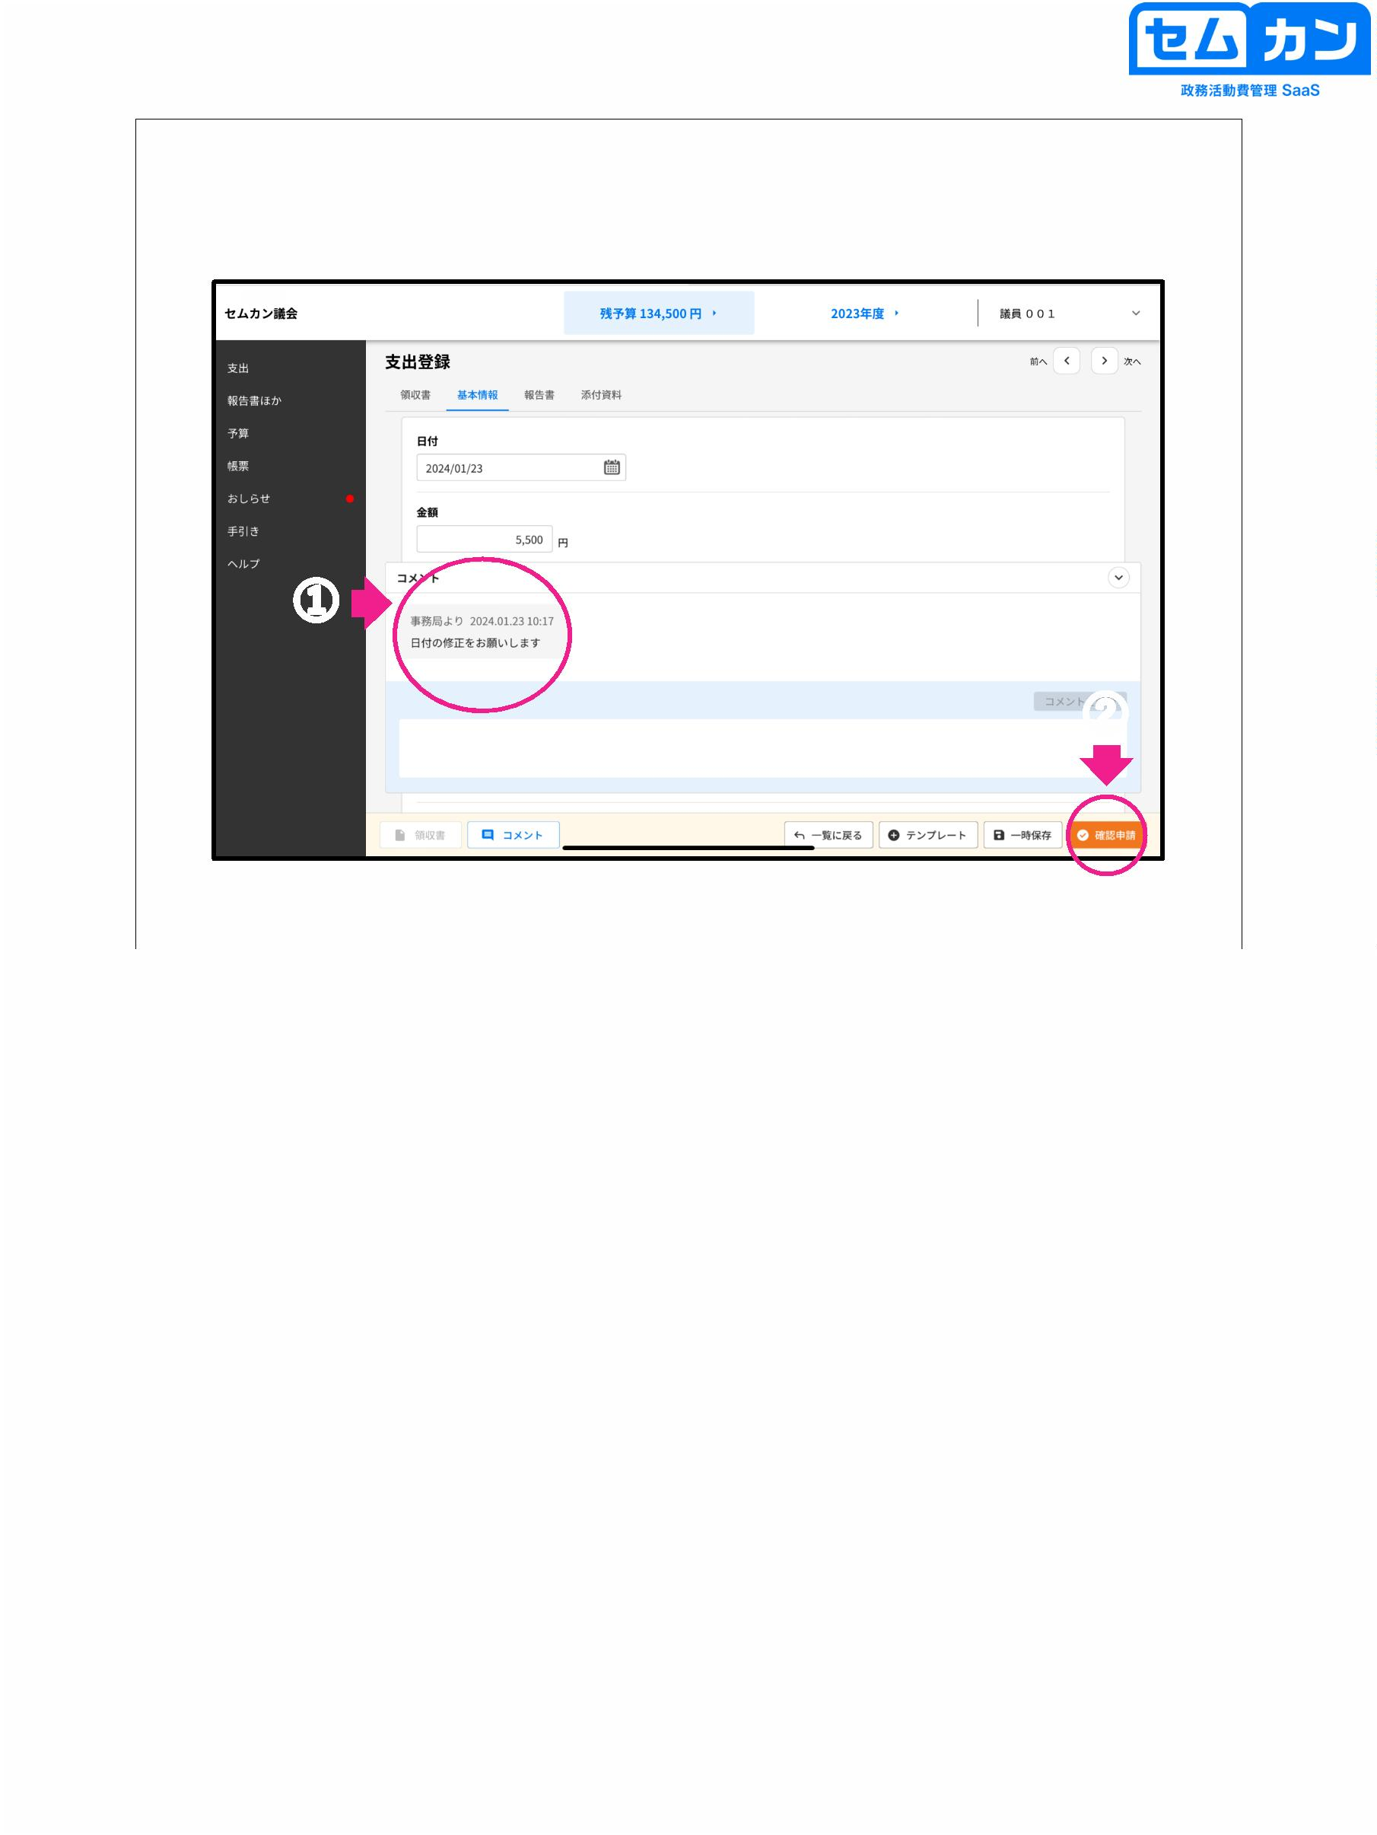

10. Done

69

69

